Real ale Mecca’s newest attraction

25/07/2024 by Timothy Hampson

Pub

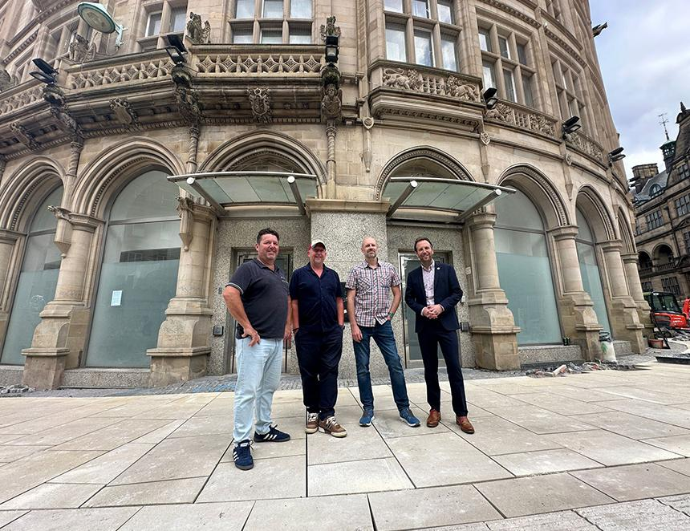

For many real ale fans Sheffield is already a must-visit city, and now there’s another reason to make the trip – Thornbridge’s upcoming Fargate pub. Thornbridge’s Jamie Hawksworth said: “The Fargate is going to be one of Sheffield’s most prominent pubs with more than a £1m investment being made in the new bespoke interior. “This is going to be a wonderful showcase for the brewery and its beers will be served over a beautiful polished oak island bar surrounded by handcrafted oak panelling and leather banquet seating. “We think it will be a great boost to the great work already been made to make the city centre great again. Work is expected to start on the fit-out later this year.” Fellow director Simon Webster said: “We have been working with Sheffield City Council for more than a year in identifying this site and then working together to offer outdoor seating as part of the new Fargate development. “The views from both inside and out of this prestigious building will add to the customer experience. Thornbridge is delighted to be able to invest in Sheffield city centre and is delighted to be part of the new development of Fargate and create a great gateway to the heart of the city.” Sheffield City Council Transport, Regeneration and Climate Policy Committee chair Cllr Ben Miskell said: “I’m delighted to welcome this fantastic addition of Thornbridge to our rapidly transforming city centre. “The Fargate will breathe new life into a beautiful building across from the town hall and will fit in brilliantly alongside the many new shops, offices and other hospitality venues that are opening up throughout the city centre. “The addition of outdoor seating, made possible thanks to the improvements to the surrounding area, along with the bespoke interior will add the Fargate to the list of must-visit places within Sheffield.” Pictured: Jamie Hawksworth, Simon Webster, Jon Holdsworth and Ben Miskell outside the Fargate