Brew York hits right note

19/07/2024 by Timothy Hampson

Industry

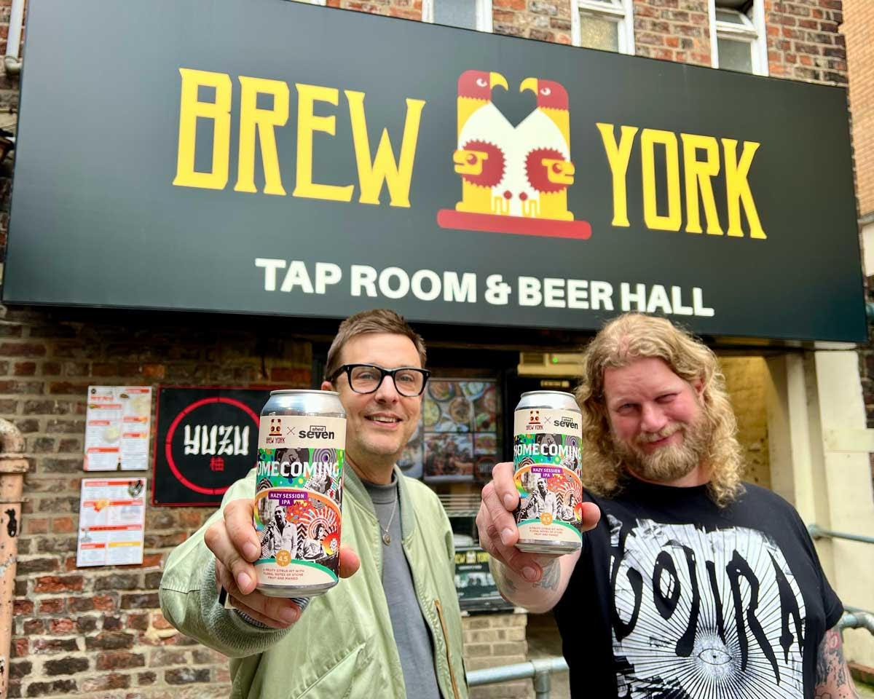

Brew York has announced a collaboration with York-based band Shed Seven to produce two new beers in celebration of their 30th-anniversary tour this winter and shows in the city during July. To celebrate the two York gigs, the brewery has created an exclusive pale ale, Homecoming. This limited-edition beer, 4.5 per cent ABV, is said to capture the spirit and energy of Shed Seven’s music and their connection to York. Brew York is also working with the band to release another beer for its nationwide 30th anniversary tour running between November and December.  Brew York co-founder Wayne Smith said: “We’re incredibly excited to partner with Shed Seven for this special occasion. “As long-time fans of the band, we wanted to create something that not only celebrates their incredible 30-year journey but also pays homage to their roots in York. “Homecoming is a beer that embodies the essence of their music and the vibrant community that has supported them over the years.” Shed Seven, known for their hit songs Chasing Rainbows and Going for Gold, have been a staple of the Britpop scene since the 1990s. The band’s bass player Tom Gladwin said: “I’m a big fan of Brew York’s beers and their beer hall on Walmgate so we’re thrilled to be working with them on this special beer. “It’s a perfect way to celebrate our 30th anniversary and create something fun and collectable for our fans in our home town. We can’t wait for everyone to taste Homecoming and join us for the shows at York Museum Gardens. The shows at York Museum Gardens are set to take place on 19-20 July. Pictured, from left, Tom Gladwin and Brew York’s Lee Grabham.