Thinking Drinkers set out to save the pub

18/07/2024 by Timothy Hampson

Pub

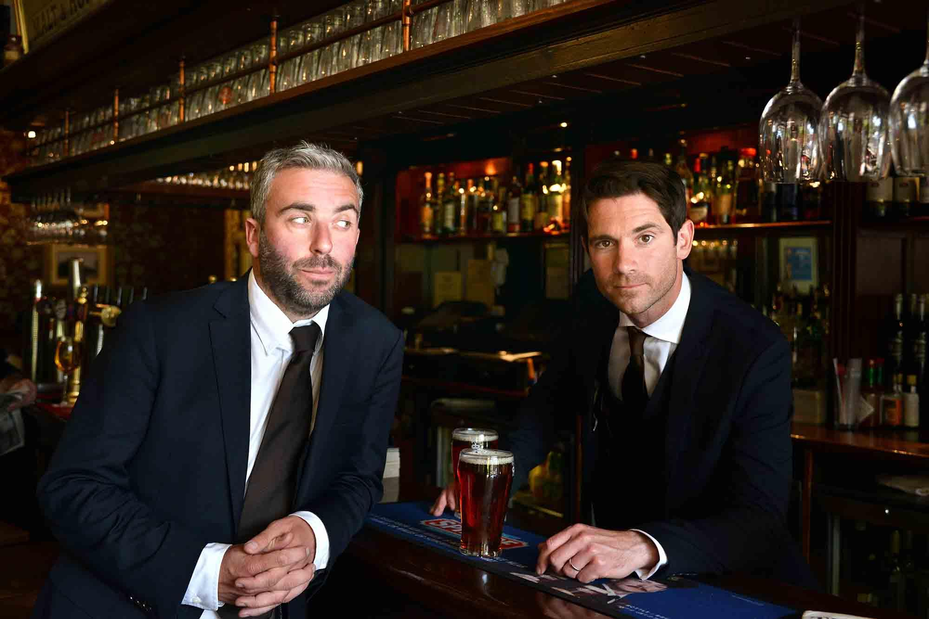

Comedy duo the Thinking Drinkers is throwing its support behind the beleaguered hospitality sector with the launch of a new show celebrating the pleasures of the pub. To recognise the hard graft of those on the frontline of pubs, bars and restaurants, there are discounted tickets available to hospitality workers at performances of Thinking Drinkers: The Booze-ical (sic), which premieres at the Edinburgh Festival Fringe this August. The show will see the duo Ben McFarland and Tom Sandham express their love for the local while serving up, and tasting, a quintet of beers and spirits. The award-winning entertainers are also urging their audience to sign their hard-hitting petition that demands all work lunches in pubs and restaurants become 100 per cent tax deductible as long as there's a decent drink on the receipt. Sandham said: “Ben and I first met when we worked on a pub trade newspaper and, frankly, most of our best – and only – work was done over a pint at lunchtime. “It’s heartbreaking that today’s generation of workers seem to rarely even get out of the office, let alone enjoy a cheeky craft ale and a cheese toastie courtesy of HMRC to set them up for the afternoon. “The Booze-ical was inspired by the daily battle pubs are currently facing to survive and thrive. Hit by a combination of Covid, rising energy costs, the cost-of-living crisis and crippling business rates, we thought what they clearly need is a musical written and performed by two people who can’t sing.” McFarland said: “The number of British boozers is shrinking like a crisp packet in a roaring pub fire and, according to some rough sums we scribbled down on a beer mat, in six years they will be outnumbered by soulless coffee chains and Greggs. It’s time to rise up against the pastry-archy. “Our last show put us in The Guinness Book of World Records for masterminding the World’s Biggest Pub Quiz, so it’s clear that our global influence is now huge. “We have high hopes that this show will tip the balance for pubs. Bringing back lunch at the local is just the start – we want to lead the nation back to the boozer.” Thinking Drinkers: The Booze-ical is a new, all-singing, all-dancing, lyrical love letter to the local. Set in a pub, it co-stars the super-talented West-End singers Flat and the Curves. Sandham said: “Thinking Drinkers: The Booze-ical has all the ingredients for the greatest lock-in of your lives: intoxicating anthems, a whole load of funny, liquor-laced history, a profound paean to the pub and, let’s not forget, five first-class free drinks. “We’re also giving something back to busy hospitality workers, helping them to unwind by offering discounted tickets at a show that constantly reminds them of their working environment." The show marks the duo’s 12th successive year at the Edinburgh Fringe Festival and runs from 1 July to 25 August at the Underbelly in Edinburgh, with plans for a UK tour later in the year. For the Hospitality Discount quote DRINKS20 when booking at underbellyedinburgh.co.uk, Monday to Thursday from 31 July to 25 August at the Edinburgh Fringe Festival. Not including 2-4-1 days (4 & 5 August). Pictured, from left, Ben McFarland and Tom Sandham