Brewers unite in Tripel Alliance

17/07/2024 by Timothy Hampson

Industry

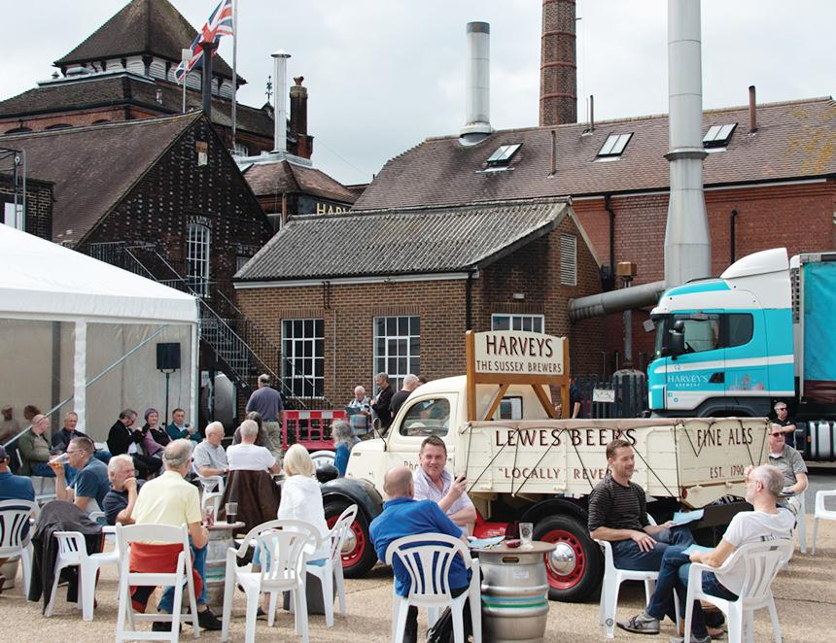

A pre-Covid meeting between three brewers that spawned the desire to create a collaborative beer will finally come to fruition at a two-day festival at Harvey’s brewery in Lewes, Sussex. The idea was formed when Mark Tranter of Burning Sky brewery and Yvan De Baets of Brasserie de la Senne dropped in on Miles Jenner at Harvey’s. When in the sample room the thought was voiced that they should plan a collaborative brew, entwining elements of all three breweries in a beer that would be entirely distinctive from anything they produced individually. Tripel Alliance (4.5 per cent ABV) will be mashed at the Bridge Wharf brewery, Lewes, later this month with all three brewers in attendance. The grist will comprise of pale and Munich malts, together with spelt and oats. Four German hops, encompassing traditional and new varieties, will be introduced at five stages. It will be brewed with Harvey’s spring water and yeast. The trio will be launching the collaborative brew at a festival that will showcase more than 20 cask and keg beers from the three breweries, including some rarely seen. Jenner said: “Brewers have always exchanged ideas – it is one of the delights of the industry – but the opportunity to brew together in this way and share a common passion is something very special indeed. It is proving a voyage of discovery for us all.” The Tripel Alliance Beer Festival will be held in the cellars and rear yard of Harvey’s at Lewes (pictured) 9-10 August. There will be three sessions over the two days. Tickets are available on Eventbrite. More details and links can be found here: https://www.harveys.org.uk/news/tripel-alliance-beer-festival-harveys