Cask beer remains city favourite

16/07/2024 by Timothy Hampson

Campaign

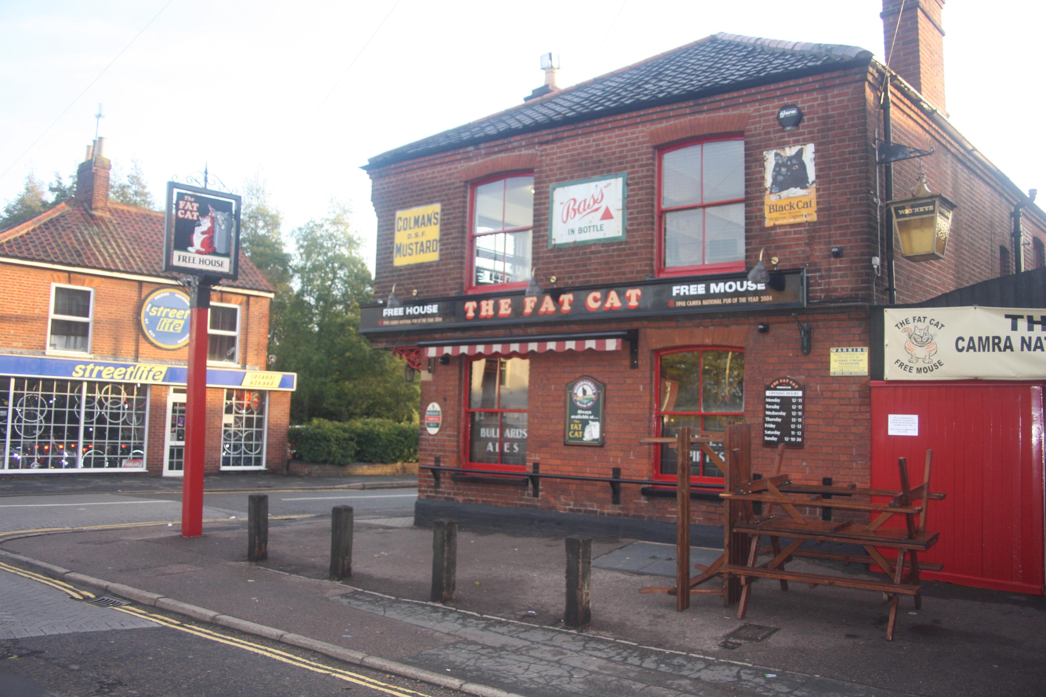

New Norwich & District branch figures reveal a vibrant cask beer and pub scene in its area, but also found pre-Covid levels have yet to be matched. The 2024 annual survey, conducted on 29 June with 29 volunteers visiting 169 pubs (including the Fat Cat above) across the branch’s district, revealed: – beer variety: volunteers discovered 264 cask beers available from a total of 491 on sale, whether on handpump or by gravity. In 2023 there were 265 cask beers out of a 464 total, though both are still below the pre-Covid levels of 2019, when 308 real ales out of 581 were recorded – real ale: out of the 169 pubs visited, 118 were serving one or more real ales, up by four from 2023. This means roughly two out of every three pubs now offer real ales, with many of the remaining venues being hotels or events bars – pricing: the average price of a pint has risen to £4.56, up from £4.30 in 2023 and £3.68 in 2019. This represents a six per cent increase over the past year and a 24 per cent rise over the past five years. Despite the price hike, real ale continues to offer excellent value compared to other options. This year’s survey also included the prices of Guinness and the cheapest keg lager, which were £5.60 and £4.75, respectively – beer strength: the average strength of beer remains unchanged at 4.3 per cent ABV, averaging roughly £1 for every one per cent. The most expensive beer was £6.55, while the cheapest was £1.79. – popular beers: Adnams Ghost Ship remains the most popular and found in 25 pubs, up from 23 in 2022. Other top choices include Sharp’s Doom Bar in 17 pubs and Greene King Abbot, Wolf Golden Jackal (a new entry), Greene King IPA, and Oakham Citra, each appearing in 10 pubs. Lacons Encore has dropped in popularity, now in nine pubs and Woodforde’s Wherry and Timothy Tailor Landlord currently appearing in eight pubs – diversity: the top five most popular beers accounted for 72 pumps on the bar, an improvement from 78 in 2023 and 89 in 2022, indicating a continued increase in beer diversity. This trend is even more pronounced when compared to 2013, where the top five beers occupied 128 slots. The branch thanks all the volunteers who participated in this extensive survey, with special appreciation to Craig Harmer for organising the effort and Martin Ward and Ian Stamp for data entry. Branch chair Ian Stamp said: “We will only see a rise to pre-Covid levels when people return to the pub, where the warm welcome, sociability and beer offering can’t be rivalled elsewhere. “There are many ways to enjoy life and a visit to the pub is certainly one of them.”