County pub trail returns after five year break

15/07/2024 by Timothy Hampson

Campaign

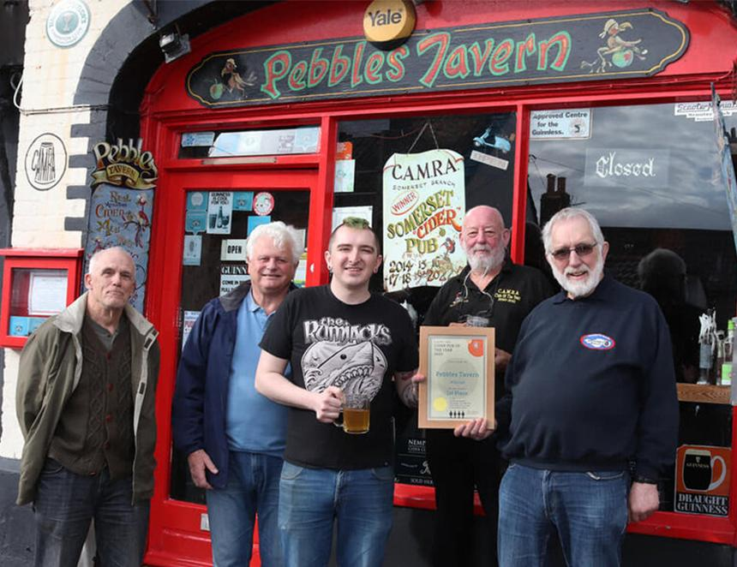

CAMRA’s Somerset Pub Trail is back this month with 50 pubs on the map following a five-year hiatus. The pub trail, now in its 18th year, has been revived by the county’s CAMRA branch and runs from 30 July 20 to 14 September. To take part, just visit any of the pubs on the CAMRA pub passport and buy a drink. which doesn't have to be beer. The branch said: “The last pub trail we attempted to run in 2020 was unfortunately called off because of the Covid lockdown. “We have had many requests to revive it, but the time had to be right. So many pubs have been lost completely, changed use or hands that we were waiting for the situation to stabilise in the hope that the 50 pubs participating would still be there to visit by the end of the trail.” All participating pubs serve a minimum of two real ales, most supporting at least one local brewery. “Many also have local ciders, including the Pebbles Tavern [pictured] in Watchet which has won Somerset Cider Pub of the Year for the last 10 years. “But there are other gems out there to be discovered. And don’t forget to visit those furthest from the centre, they are all worth a visit,” added the branch. Drinkers can ask the bar staff for a passport sticker and the aim is to visit as many pubs as possible over the eight weeks. Passports can then be sent to the branch to receive a CAMRA polo shirt. Download your passport and get planning your pub visits here: www.somerset.camra.org.uk/viewnode.php?id=64759