CAMRA Pub Heritage Group update – June

14/07/2024 by Tom Chapman

Campaign

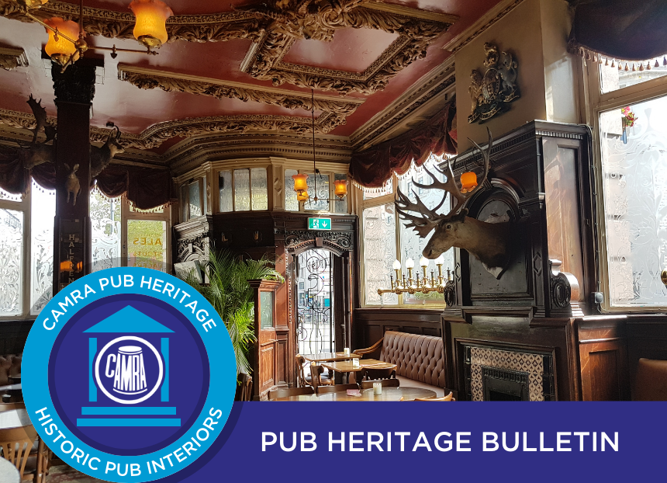

CAMRA’s Pub Heritage Group shares news and updates about pubs with historically significant interiors across the country. For further news, see the Pub Heritage webpage here. Three Star Heritage Pubs Vines, Liverpool, Merseyside The winners of CAMRA’s Pub Design Awards were revealed in the opulent surroundings of the Vines (pictured above). The Grade II\* pub won the Historic England Conservation category for the high-quality restoration work undertaken by the 1936 Pub Company, which took over the lease in early 2023. The Vines was built in 1907 in a flamboyant baroque style and is one of the country’s great show pubs. After years of neglect, it now looks fabulous. Find all the Pub Design Awards winners here.

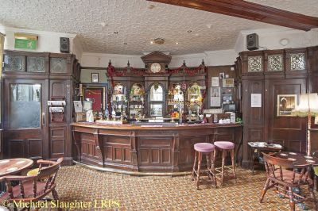

Paul Pry, Worcester, Worcestershire (above) Following the sudden death of landlord Alex Pope in January this year, the family has made the difficult decision to sell the pub. The Pope family took on the lease in 2017 and then bought the freehold in 2022. It is committed to finding a suitable buyer and the pub remains open until then. It is being marketed by Sidney Phillips at £495,000.

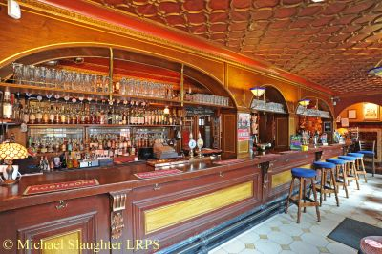

Britons Protection, Manchester, Greater Manchester (above) The legal battle between licensee Allan Hudd and Star Pubs & Bars (Heineken) was last covered in the March bulletin. Star wants to take the pub into its managed portfolio and the hearing was due to be concluded during the week of 17 June. This has now been deferred due to a “technical point of procedure”. More information about the ongoing battle can be found on the Manchester Evening News website here.

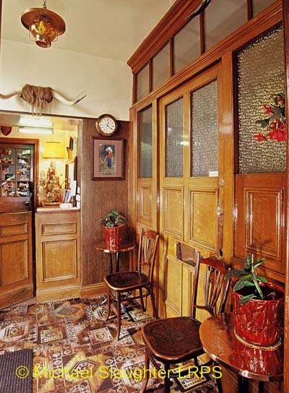

Star Inn, Netherton, Northumberland (above) It is with great sadness that the Pub Heritage Group reports the passing of Vera Wilson-Morton, the landlady and owner of the Star Inn, at the age of 91. The pub itself has been closed for well over a year due to Vera’s failing health, and at the time of writing, its future is unknown. Two Star Heritage Pubs

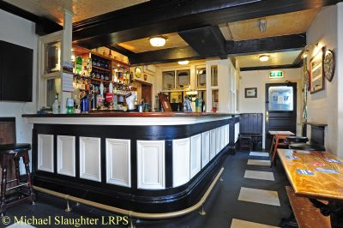

Queens Arms, Patricroft, Greater Manchester (above) Following the previous licensee retiring after 31 years, owner Punch Taverns has put the pub on the market. The Queens Arms, built in 1828 with a mainly late-Victorian interior, is now up for sale at £150,000. There is local interest in renewing the pub’s expired Asset of Community Value (ACV) status. More information about the sale can be found on the Savills website here.

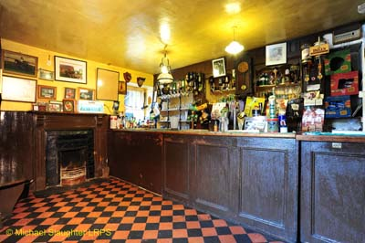

Cresselly Arms, Cresswell Quay, West Wales (above) The Cresselly Arms has been named CAMRA’s Wales Pub of the Year. The delightful riverside pub with its simple, unspoilt Victorian interior was run by the same family for nearly 100 years until 1981. The Pub Heritage Group congratulates current landlord Steve Adams and all at the Cresselly Arms. One Star Heritage Pubs

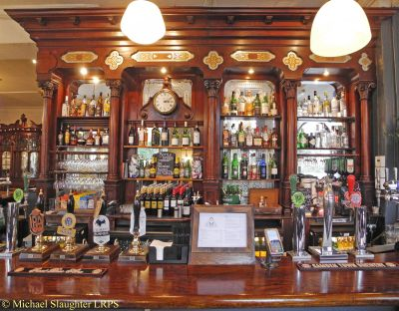

Masons Arms, Harlesden, Greater London North West (above) The Masons Arms shut on 28 May and has been put on the market with an asking price of £1,750,000. The pub still retains plenty of late-Victorian fittings including a magnificent bar back. More information about the sale can be found on the Right Move website here.

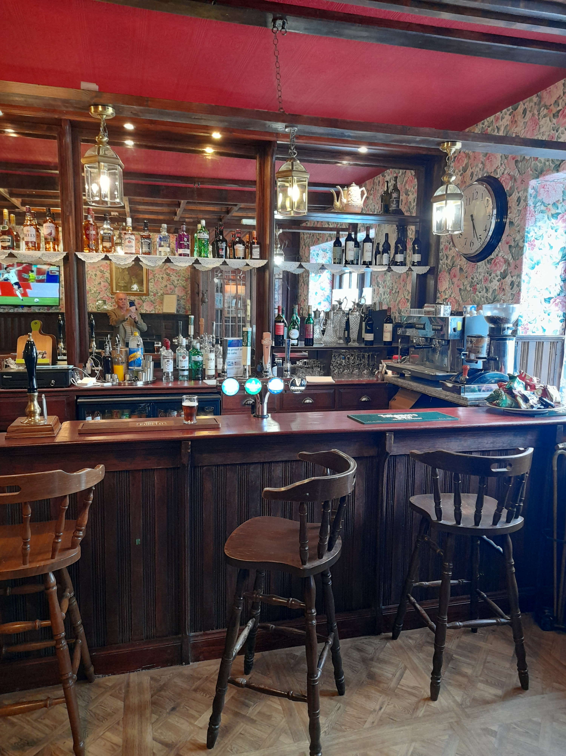

Tower Hotel, Oxton, Borders (above) The Tower Hotel, built in 1903, reopened in June following a refurbishment, having been shut for five years. It survived a planning application in 2020 to turn it into offices and was sold to a new owner a year later. The Pub Heritage Group is pleased the historic features of the public bar have been retained.

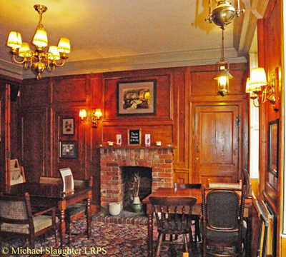

Tower Arms, South Weald, Essex (above) Built in 1704, The Tower Arms has been a pub since 1921 and retains fittings from that period. It has been shut since 2014 but is reported to reopen soon. Unfortunately, the planned refurbishment, which has planning permission, includes the removal of all the 20th-century fittings.

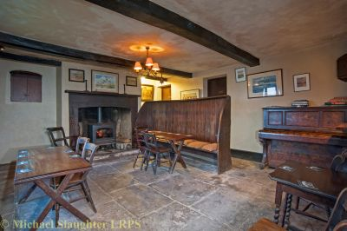

Berkeley Arms, Purton, Gloucestershire (above) The Pub Heritage Group last reported on the Berkeley Arms in March 2022, when Historic England decided not to list it. This was not surprising as the owner, Berkeley Castle Estates, had ripped out the bar and bar back prior to Historic England’s visit. It is reported the owner is intending to reopen the Berkeley Arms, but its Inventory credentials are now greatly diminished. There are four new additions to the National Inventory of Historic Pub Interiors at One Star status.

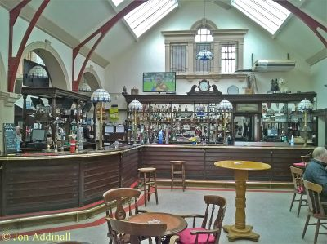

Dean Tavern, Newtongrange, Edinburgh & The Lothians (above) The Dean Tavern was rebuilt in 1910 and is one of only five pubs in Scotland still operating on the Gothenburg System. The Gothenburg System originated in Sweden in 1865 as a means of encouraging temperance, where the managers gained no profit from alcohol sales but only from food and non-alcoholic drinks. Profits above a certain level were then used to fund projects benefitting the community. The other Inventory pub operating the Gothenburg system is the Prestoungrange Gothenburg (Three Star) in Prestonpans. The Dean Tavern has been included in the Inventory for its multi-room layout with much remaining from a 1962 refurbishment. Of note is the impressive arched public bar which has been carefully modernised over the years.

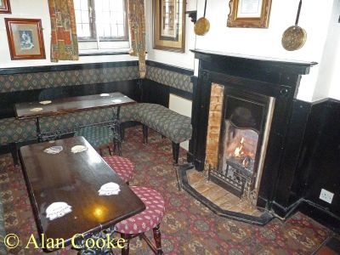

Queens Head, Barwell, Leicestershire (above) A timber framed 17th-century pub which has a multi-room layout of three small rooms at the front with fixed seating, old fireplaces and other features.

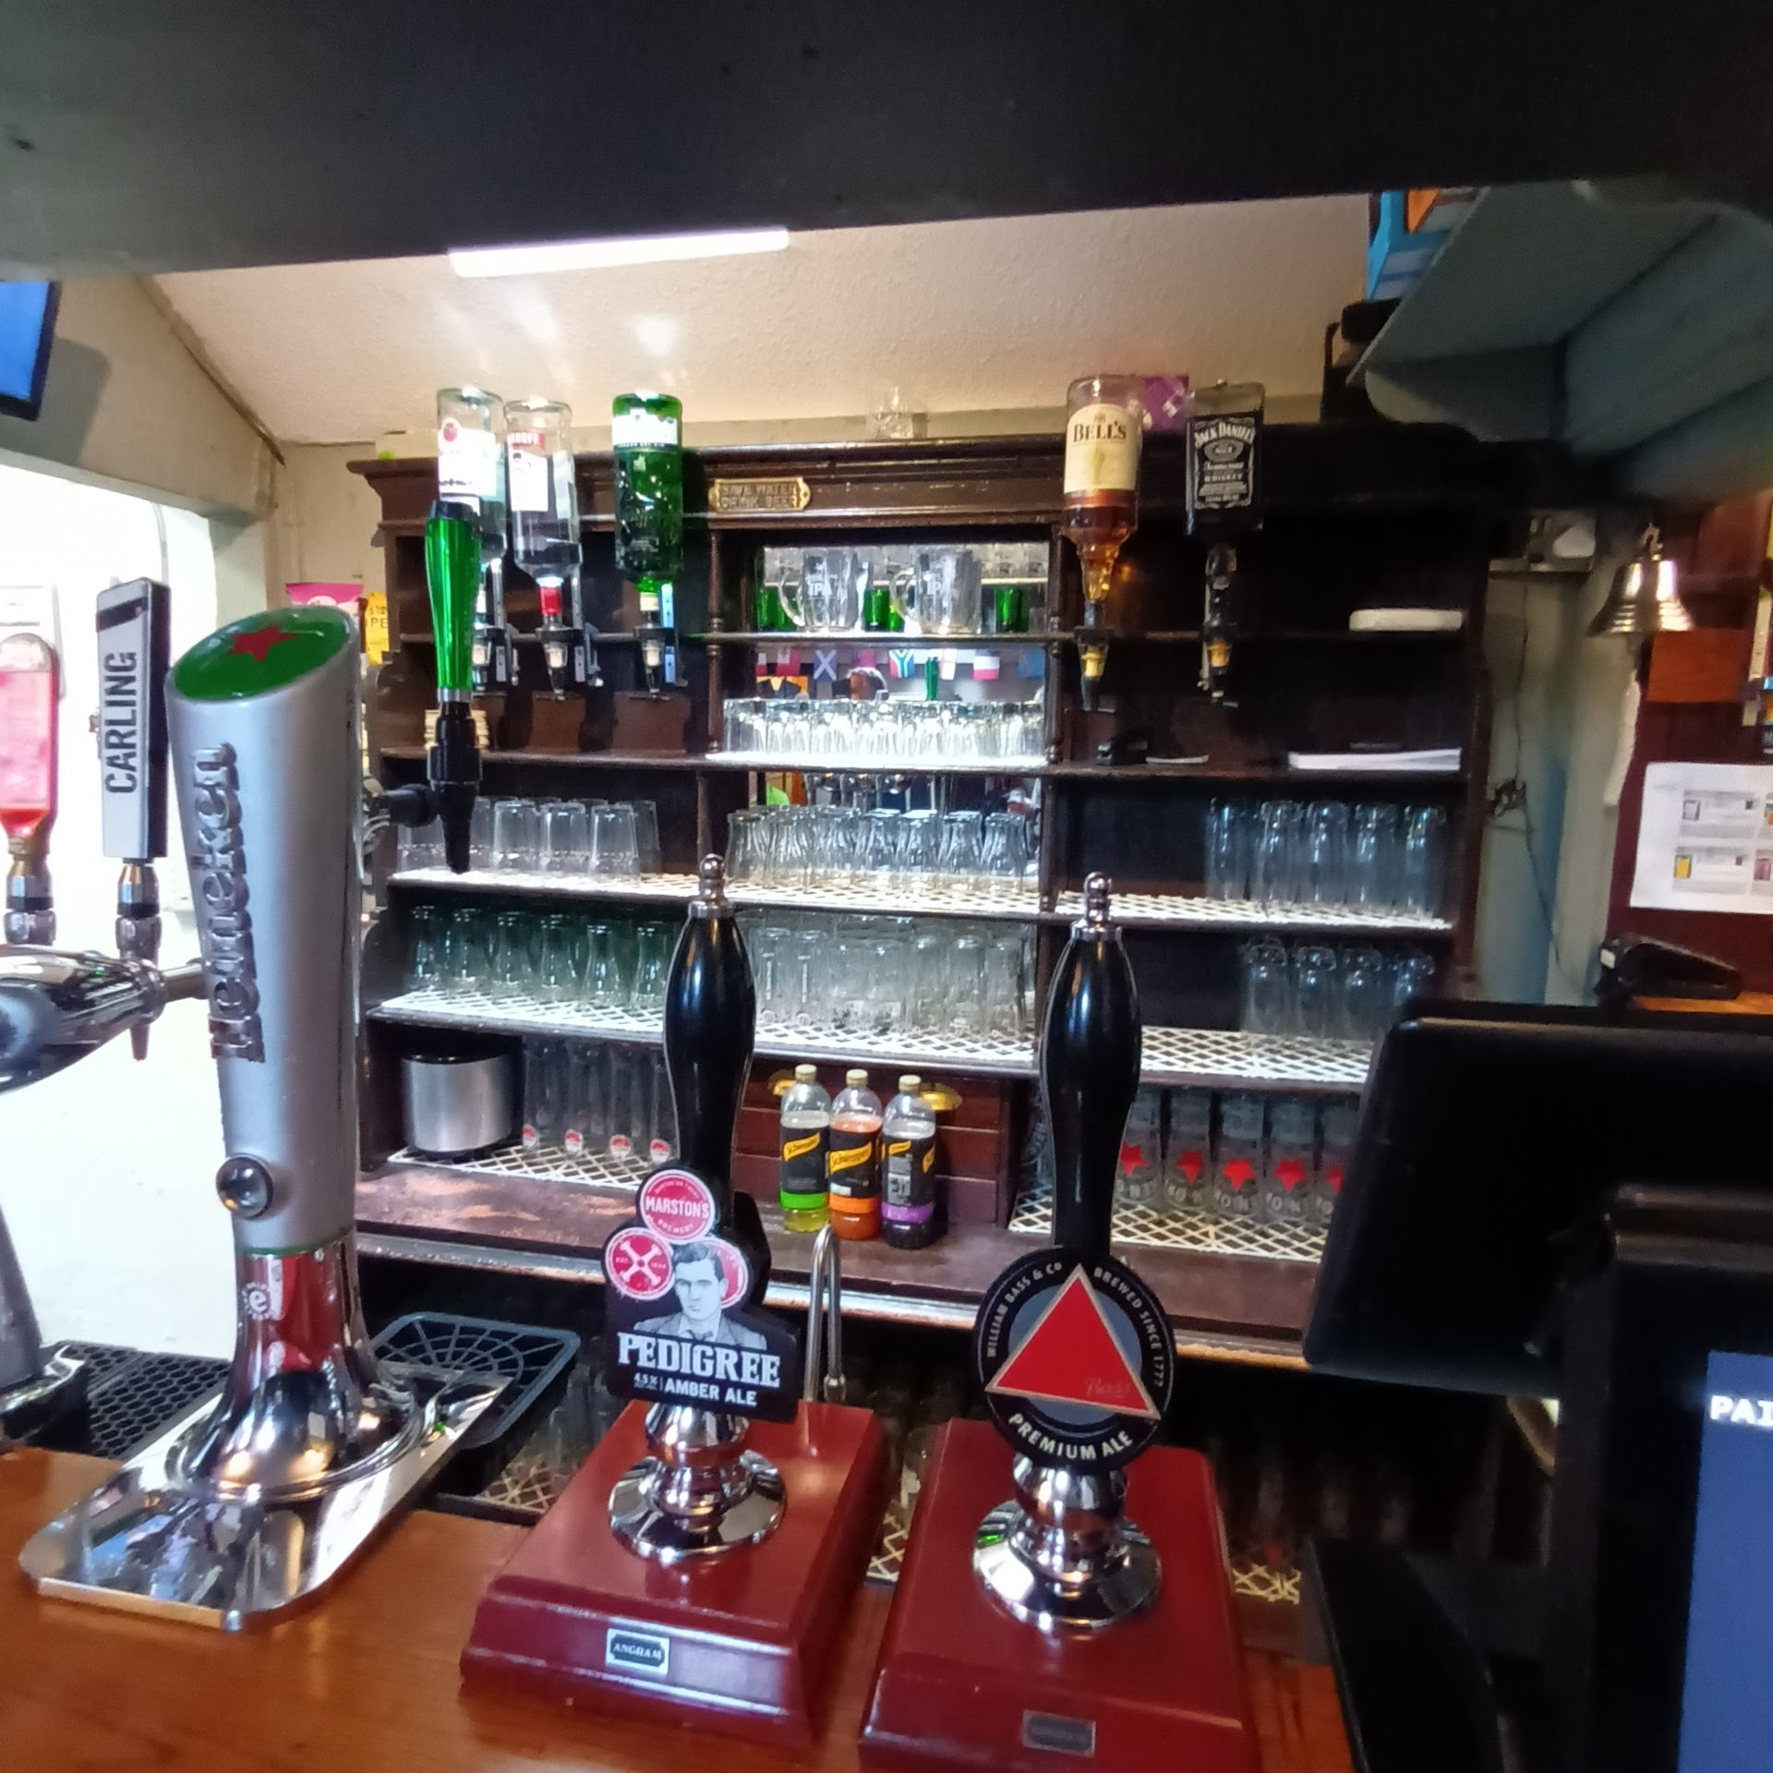

Vine Inn, Derby, Derbyshire (above) The Vine has an unusual multi-room layout with three small original rooms and fittings that are at least 50 years old.

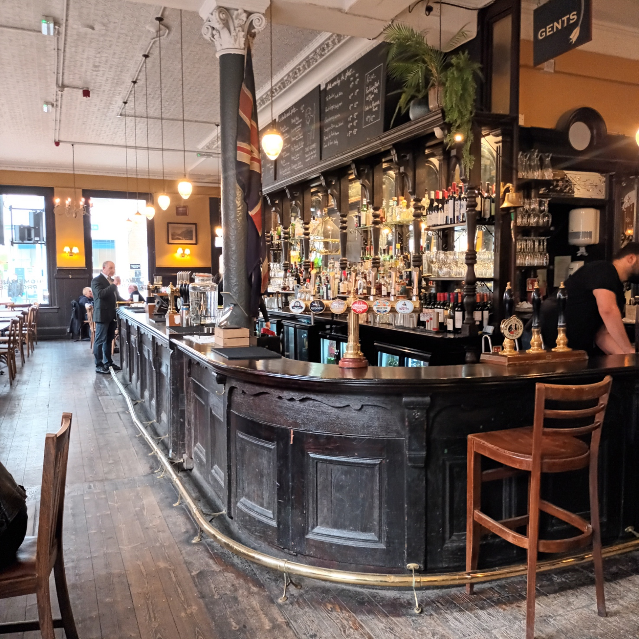

Latchmere, Battersea, Greater London South West (above) The Latchmere is a long-standing theatre pub (the stage is on the first floor). The large L-shaped bar on the ground floor has an early 20th-century bar counter and back, along with other fittings from this period. Other news Heritage Open Days 2024 - Sheffield Pub Heritage Walk As part of Heritage Open Days 2024, Sheffield and District CAMRA branch is leading a pub heritage walk on 15 September at 2pm from Kelham Island in Sheffield. The walk will include Victorian tilework, terrazzo flooring, art deco glasswork, a mention of long-gone Sheffield breweries and much more. Full details and booking information are available on the Sheffield and District CAMRA website here. If you can’t wait until September, the latest edition of Sheffield’s Real Heritage Pubs book is available here. Chesterfield: Historical Tales & Traditional Ales A new Chesterfield pub walk booklet has been produced by the Chesterfield CAMRA branch. Written, compiled and designed by Chesterfield CAMRA’s InnSpire magazine editor Chris Fox and local history enthusiast Shaun Stevenson, Historical Tales & Traditional Ales includes copious historical information. View the booklet here. If you have any news for CAMRA’s Heritage Pubs team, send to: info@pubheritage.camra.org.uk. If you wish to receive the bulletins directly, sign up by sending an email to bulletin@pubheritage.camra.org.uk with the word “subscribe” as the subject or “unsubscribe” if you wish to stop receiving bulletins. Photos by Matthew Rogers, Michael Slaughter, Alan Cooke, Jon Addinall.