Real ale could do with a little democracy

13/07/2024 by Matthew Curtis

Opinion

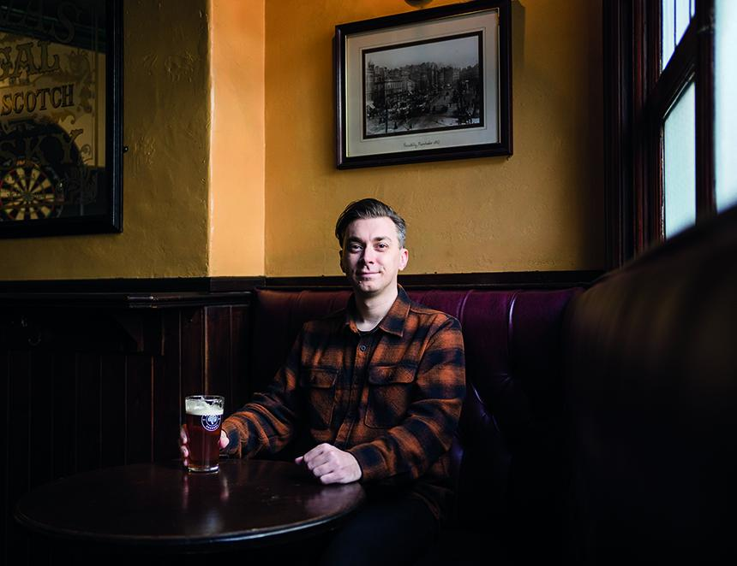

There are more than 1,800 breweries in the UK, but the beer we actually see on tap in most of our local pubs and on supermarket shelves provides a damning representation of this diversity.  Around 80 per cent of the beer sold in the UK is produced by a handful of internationally owned brands, including Carlsberg, Heineken, AB InBev, Molson Coors and Asahi. And let’s not forget the ubiquitous Guinness – parent-company Diageo claims it is now the best-selling beer in the country by value. Through a combination of clever marketing and shrewd acquisition of smaller breweries over a number of years, these multinational entities have pulled the wool over the eyes of the consumer-at-large, creating the illusion of choice, when in reality they’re limiting it.  Energetically marketed, contemporary brands like Brixton, Beavertown and Camden Town have allowed the largest operators within the British beer market to court an entirely new generation of drinkers. Trends such as the emergence of Madri – a faux-Spanish lager brand produced by Molson Coors has generated revenue totalling £430m since it was launched in 2024 – have helped them mop up existing consumers as popularity of some larger brands has waned over time. Although several legacy brands including Carling, Budweiser and Stella Artois still dominate to this day.  The real ale market doesn’t look much better. Double-digit decline in the sector over the past two decades means that cask beer now only accounts for 4.3 per cent of beer produced in the UK, occupying just 15 per cent of the draught beer market. Again, much of this category is dominated by a handful of brands, such as Doom Bar, produced by the Molson Coors-owned Sharp’s. The multinationals have continued to eat into this sector, with Asahi taking on Fuller’s in 2019. This July, Carlsberg took on the full portfolio of Marston’s brands, which includes Pedigree, Hobgoblin, Wainwrights and several others, as the legacy British brand moves solely into the management of its pubs.  This leaves true independents with a pittance of a market share, and even among them larger companies such as Adnams, St Austell and Timothy Taylor’s make up the majority of the real ale category that isn’t occupied by internationally owned breweries. This leaves well over 1,000 small breweries with just tattered shreds of the market to work with. These are the brands without marketing budgets, or sales staff, but in many instances are producing some of the best beer in the country.  There are organisations, however, with the power to provide these breweries with the platform they need to present themselves. CAMRA does this thanks to its local, branch-led beer festivals, as does SIBA, the Society for Independent Brewers, which represents around 700 small independents within the UK, and champions them via its regional and national beer awards.  We Are Beer, the company behind successful events including the London Craft Beer Festival, and sister events in Manchester, Bristol and Edinburgh has also recently platformed a number of independent breweries. In July 2024 the company unveiled a list of the UK’s Top 50 Beers which features 46 UK breweries, selected by a panel of 150 industry insiders. Full disclosure, I was one of them, but none of the five beers I picked (and only one of the breweries) made the final list. Looking at how the list breaks down, it’s an interesting mix, once again largely focusing on brands that have managed to expand, and in many cases enter into the supermarket trade including BrewDog, Northern Monk, Vocation and Lost and Grounded. A huge positive is that real ale has remarkably strong representation, with 11 of the final 50 beers appearing regularly in cask. It should come as no surprise that Timothy Taylor’s Landlord and Harvey’s Best both feature, as does Theakston’s Old Peculier. But it's refreshing to see modern real ales from smaller breweries like Fyne Ales and Manchester’s Track Brewing also on the list. Where it falls apart, however, is through its heavy regional bias, largely focusing on breweries from London. Despite around five per cent of the breweries currently operating in the UK being based there, 26 per cent of the beers on the list are from London-based beer makers. Greater Manchester features just twice, despite having 70 breweries to London’s 105. Yorkshire, which has more breweries per capita than anywhere else in the UK, features six times, less than half of the 13 instances in which London breweries appear. It’s another example of how many small breweries are so often ignored, either through their lack of access to market, or because of the geographical position they’re tied to. Where are the RedWillows or the Rudgates? The Goose Eyes or the St Mars of the Deserts? The Black Iris’ or the Good Chemistrys? I actually feel like the publication of an arbitrarily selected list such as this example from We Are Beer has as much capacity to damage the independent beer market as it does to boost the fortunes of those lucky enough to make the cut. In February this year we lost Elland, winner of the Champion Beer of Britain award in both 2013 and 2023 for its exceptional 1872 Porter. And yet it was rarely part of the conversation, and certainly not making lists like the one represented above. How many more world-class breweries do we need to lose before we realise that in order to promote good beer, and indeed preserve the fortunes of cask in the UK, that we need to be more democratic with our praise and ensure that it is not just evenly distributed around the country, but to the small, exceptional breweries who truly deserve it.