CAMRA calls for urgent action to save pubs

11/07/2024 by Timothy Hampson

Campaign

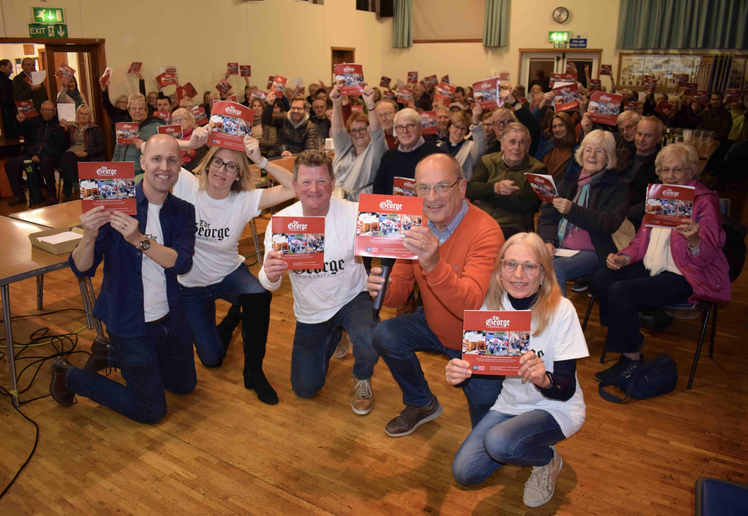

CAMRA is urging the minister for Housing and Communities to ensure community groups’ efforts to save pubs won’t be wasted. The Campaign has written to secretary of state Angela Rayner to ask for urgent action on the payment of grants from the Community Ownership Fund. During the run-up to the General Election, incomplete grant funding agreements from the Community Ownership Fund have meant payments to community groups have not been made, despite the cash having already been agreed by the previous government. Community projects up and down the country have been impacted by this, with bids to turn their locals into community-owned pubs now in significant danger. Owners selling the property may be put off by the delay and Assets of Community Value moratoriums could expire before community groups can finalise the purchase. CAMRA is urging government to make this a priority of its first weeks in power. Pub and Club Campaigns director Gary Timmins said: “We are disappointed by this mix-up. Community groups with plans to improve their communities and rescue their local have been left in limbo and are now unsure what the future holds for their campaigns. “Groups have been working tirelessly, sometimes for years, to secure funding from various sources to save their local pubs. Securing Community Ownership Fund grants gave groups hopes of achieving their campaigns, this has currently been cruelly snatched away from them. “Community groups are now unsure if they will be able to buy their local pubs, with years of work potentially wasted. I urge the secretary of state to ensure that agreed funds are followed through and acted on urgently.” Pictured: In 2022 residents of Bethersden in Kent celebrated raising £300,000 in just over three weeks to buy their pub, the George, and reopen it as a community enterprise and village hub.