Record-breaking Mild Magic

10/07/2024 by Timothy Hampson

Campaign

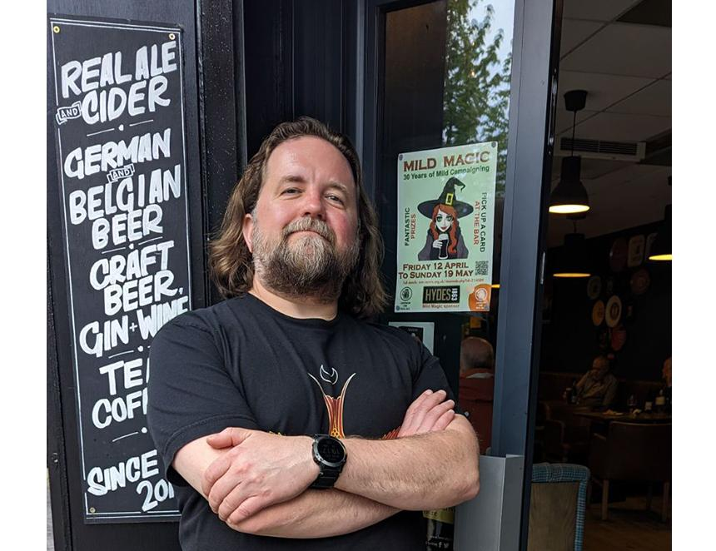

The Mild Magic Ale Trail, organised by Stockport CAMRA, in conjunction with the High Peak and Macclesfield & East Cheshire branches, has been smashing records. No less than 97 pubs were involved this year and, despite being a week shorter than usual, more than 200 drinkers took on the challenge to visit at least 12 pubs and try mild – an increase of 35 per cent over 2023. Run in support of Mild Month, it is estimated that around 4,000 pub visits took place during the five weeks of the trail, and participants sunk around 3,000 pints of this rare beer style. Everyone won an item of clothing, ranging from a T-shirt to a sweatshirt, all featuring this year’s Mild Magic logo. More than 80 milds were reported, 15 more than last year. They ranged from light, low-gravity milds, to strong versions including the classic Sarah Hughes Dark Ruby, which was voted the trail’s best mild. Pubs stocking it included the Castle in Macclesfield, which was voted Champion Pub of the Trail, and Ye Olde Vic in Edgeley, Stockport where the cask was put on for the final weekend and only lasted a couple of hours. People came from across Greater Manchester, the North and Midlands to participate, but none could compete with Justin Smith who travelled 5,000 miles from his home of Bellingham, near Seattle on the US West Coast. Beer lover Smith managed to visit 20 qualifying pubs during his visit to the Manchester area, as well as visiting other independent bars in the city. He also made trips out to Macclesfield and Liverpool, and still had time to take in the Elbow concert at Co-op Live! Smith said: “I'm a big fan of places with a strong beer culture, especially if the local beer scene offers something traditional. In Manchester, it has long supported the mild beer style, which is very rare in the USA. “I had never made it to the UK before, so when I heard about the Mild Magic Ale Trail, I decided this was an ideal opportunity for a visit. “The variety of pubs and bars was amazing; they are great social meeting places. I enjoyed the light and dark milds from the traditional Manchester family breweries Hydes and Holts, as well as the offerings from other local brewers such as Marble, Blackjack and Track. “This was a great promotion for CAMRA, and I will proudly wear my special Mild Magic T-shirt in bars back home and on my future travels.” Organiser Darren Berry said: “There was a great buzz about the ale trail this year and my thanks go to all the pubs who joined in and went to great lengths to source beers from local independent brewers. “Many brand-new milds were noted, and these included some speciality versions, such as the RedWillow Dubbel Mild using Abbaye yeast, as well as a Rhubarb and Custard Mild from Brass Castle. “Thanks also to everyone who took part and helped us break records. We are planning to run the event again in 2025, when we hope even more people will join us on this beer adventure.” Pictured: Justin Smith finishes his Mild Magic tour at the Petersgate Tap, Stockport.