End of an era as Marston’s quits brewing

09/07/2024 by Timothy Hampson

Industry

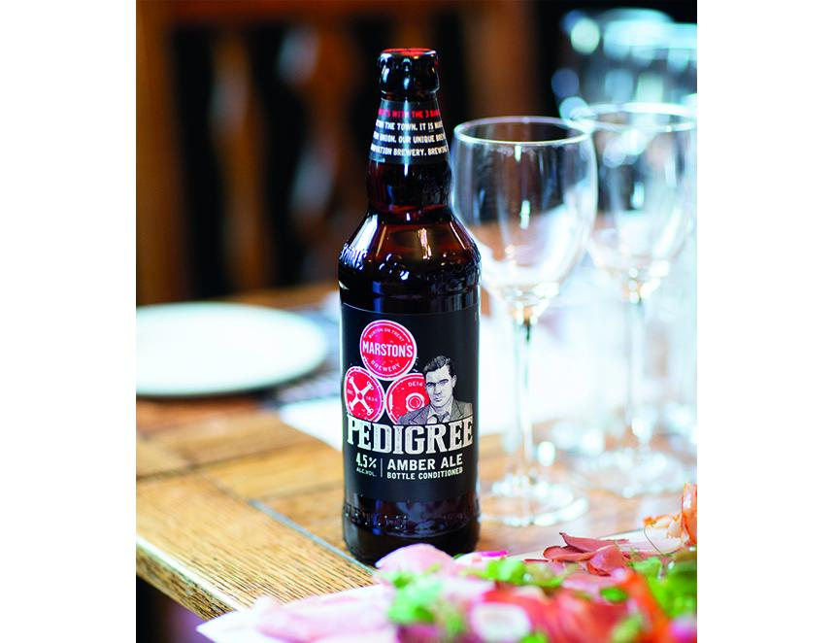

Marston’s has sold its 40 per cent stake in a brewing joint venture with Carlsberg for £206m. The group, which has its headquarters in Wolverhampton, will now focus entirely on operating pubs. It ends almost 200 years of brewing heritage, with Banks and Company first starting beer-making at Park brewery, Wolverhampton in 1875. Carlsberg Marston’s Brewing Company was created in November 2020 and has its headquarters at Marston's House, Brewery Road in the city. The stake has been bought by a subsidiary of Carlsberg in cash. Completion is aimed for the end of September. CMBC was set up to combine the drink portfolios and extensive distribution network of Marston’s and Carlsberg in a £780m merger. Marston's chief executive Justin Platt said this announcement represents a significant milestone for Marston’s as it realises its stake in CMBC. “In my first six months with the business, it has become very clear to me that our core capability and key opportunity to unlock value for shareholders is in driving a focused and successful pub business. “This deal further strengthens our balance sheet, significantly reducing our debt by more than £200m. In addition, CMBC remains valued strategic partners and we continue to benefit from our ongoing long-term brand distribution agreement with it. “Crucially, it allows us to become a pure play hospitality business and focus on what we do best – namely, giving our guests amazing pub experiences. I look forward to delivering on the opportunities a focused pub business will provide to ensure we maximise value for our shareholders.” Marston’s, which has circa 1,370 pubs, will retain a long-term brand distribution agreement with CMBC as a key supplier and strategic partner.