Pub and bar insolvencies jump 30 per cent

08/07/2024 by Timothy Hampson

Industry

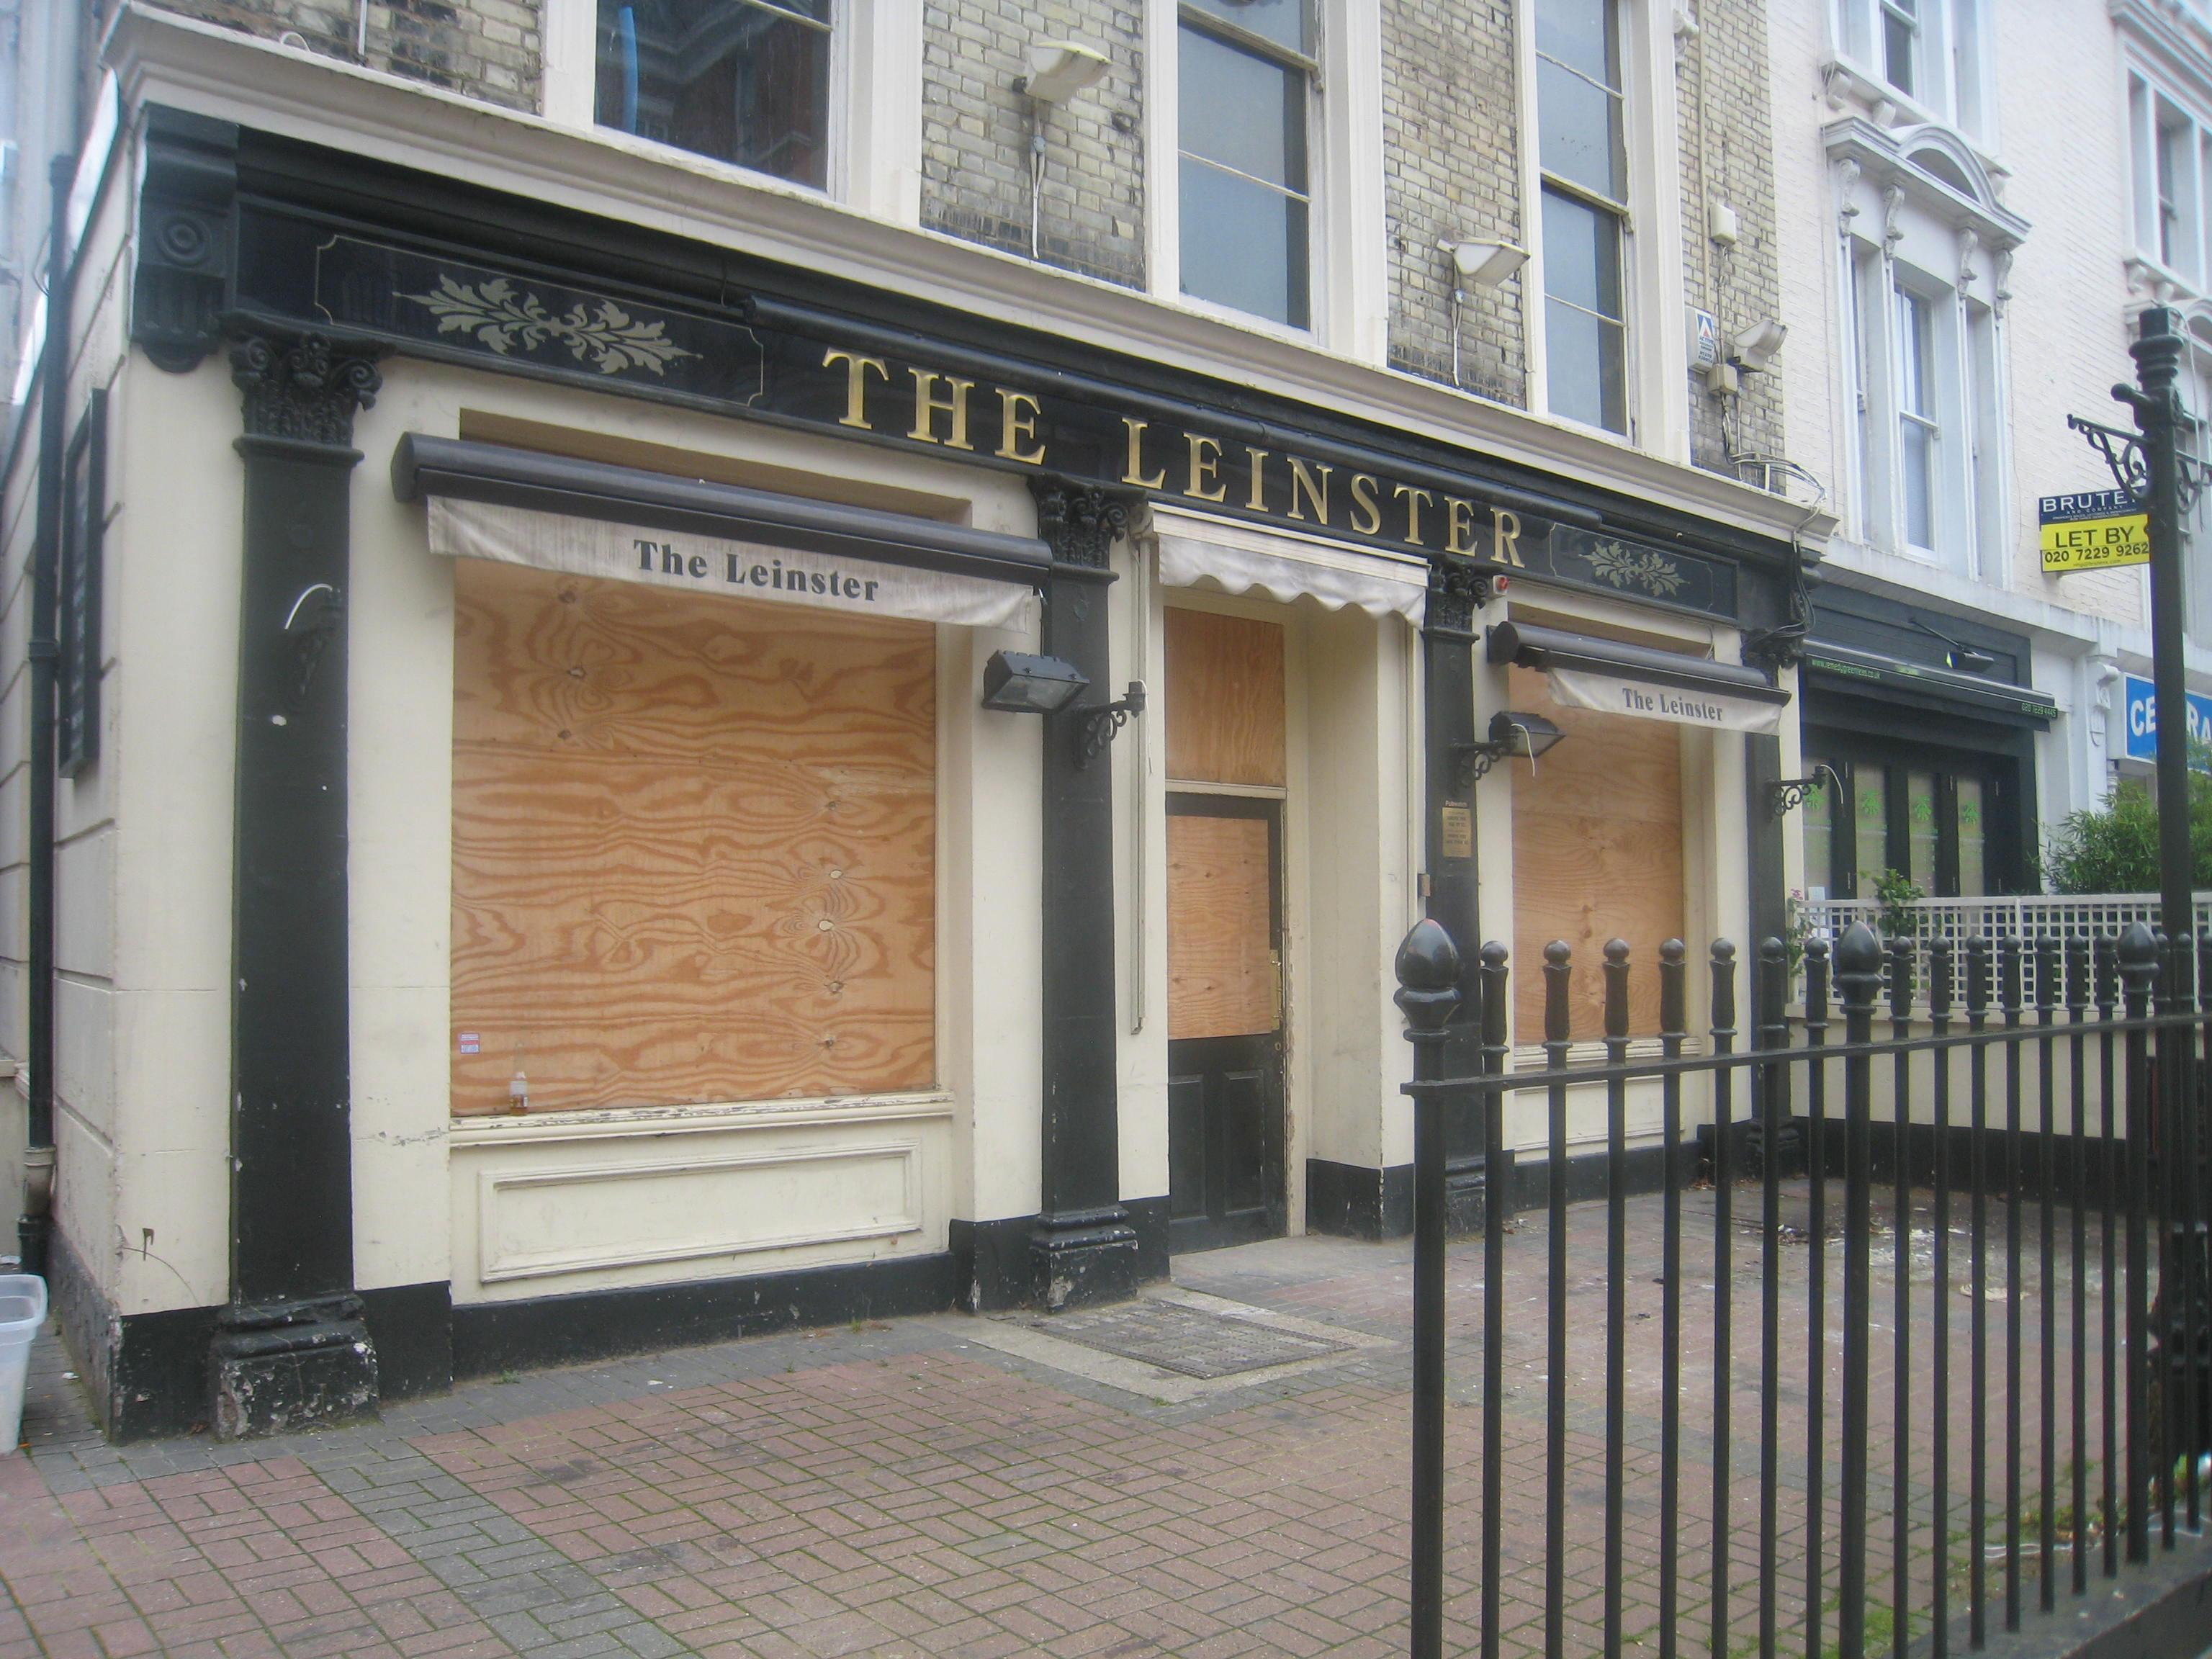

New figures reveal the number of pub and bar insolvencies has risen by 30 per cent as economic pressure continues to hit thousands of small businesses. Insolvencies of pub and bar companies are up from 602 in 2022/2023 to 784 in 2023/24 (up to April 30), said national accountancy group UHY Hacker Young. Pub and bar insolvencies continued to rise over the last year with fewer people willing or able to pay an average of £4.75 across the UK for a pint, with prices even steeper in city centres. The cost-of-living crisis continues to limit how much people are willing to spend on “non-essential” products, like alcohol. UHY Hacker Young partner Peter Kibik said: “With money tight for many households, current alcohol prices means more people are choosing to drink at home instead of going out. The pub and bar industry has struggled for a long time but the last two years have been particularly difficult.” Footfall for pubs is also being affected by the rising number of non-drinkers in the UK, with 26 per cent of people aged 16-24 now teetotal. This sharply impacts the number of alcoholic drinks sold. “The young in particular are drifting away from drinking after work or at the weekends, impacting pubs and bars. The demographic trends for pubs and bars in the long term are very concerning,” said Kubik He added: “The new government will have to overhaul the current rates system in order to help the high street.” “After a year of rising insolvencies, pubs and bars are hoping the boost of the Euros will mean a stronger summer of trading. That’s only likely to be transitory, however.”