Strawberry beer lollipops

07/07/2024 by Christian Gott

Uncategorised

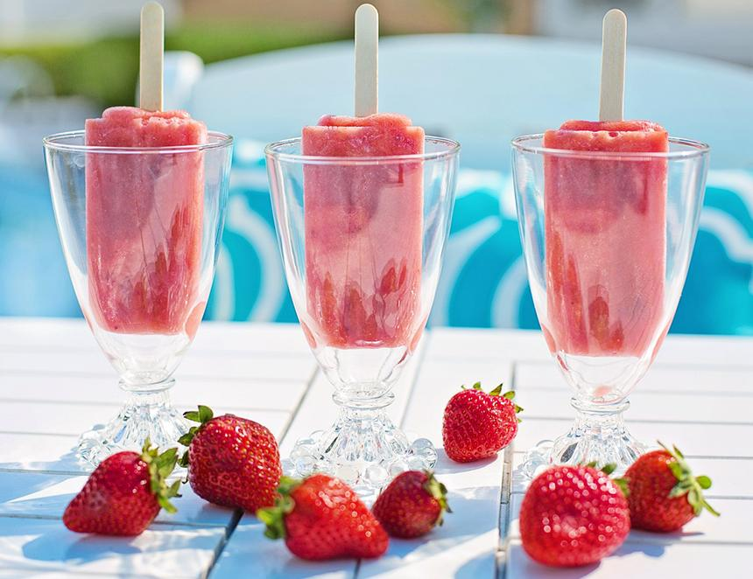

This month’s recipe is refreshing, fun and, best of all, as easy as pie. To be honest, a lot easier than baking a pie. To date, the recipes I’ve suggested have all had beer as a key element but with plenty of other ingredients – what else would you expect in What’s Brewing? The beer flavours were picked to balance and complement all the other parts of the dish. But in this recipe beer is very definitely the star of the show. The recent Wimbledon season made me think of strawberries and cream, so this recipe is all about a strawberry beer and it’s a super summer way of serving a Belgian-style wheat beer. In this case, the De Laet family, owner of the Huyghe brewery for more than 100 years, has done all the hard work for us by already adding a ton of strawberry flavour to its Fruli. You just need to enhance it with some pureed fruit and a splash of cream. Alternatively, you could choose one of any number of fruit-flavoured beers, a watermelon or mango sour or raspberry kriek perhaps and add the corresponding fruit puree. You might need to experiment a little with the recipe as the alcohol level will affect how well the mixture freezes. Both sugar content in any fruit puree and alcohol lowers the temperature at which the lollipop will freeze but adding a little thick cream helps solve this problem. Fruli is made by boiling a wheat and barley wort, flavoured with hops and the traditional coriander seeds and dried orange peel. It is then double fermented, first open-top fermentation, then again with the addition of the strawberry puree in stainless steel tanks, before a short maturation, filtering, and packaging. You can use over-ripe strawberries which will be sweet and full of flavour. The acidity in the lemon juice helps to balance out the flavours. You can leave the seeds in the finished lollipops, but I like to strain my mix through a fine sieve to leave a smooth finish. You can purchase lollipop moulds at most large supermarkets or specialist kitchenware retailers, alternatively, you can use plastic popsicle sleeves. Strawberry beer lollipops 330ml bottle Fruli strawberry beer 750g fresh strawberries, washed and hulled 150ml thick double cream Juice of half a lemon 30g caster sugar Place the strawberries, sugar, and lemon juice in a food processor and puree until smooth. Slowly add the beer and blend together on a slower setting.  Place a fine sieve over a bowl and pour in some of the strawberry beer mix. You may need to gently agitate the mixture with a spoon to ensure all the pureed fruit passes through. Repeat this until all of the mix has been transferred and the strawberry seeds removed. Stir in the cream and transfer to a jug. Place a couple of strawberry slices in each lollipop mould if desired, top up with the beer mix and add the lollipop sticks before carefully placing them in the freezer. Freeze and enjoy.