CAMRA vows to fight for beer consumers following election

06/07/2024 by Timothy Hampson

Campaign

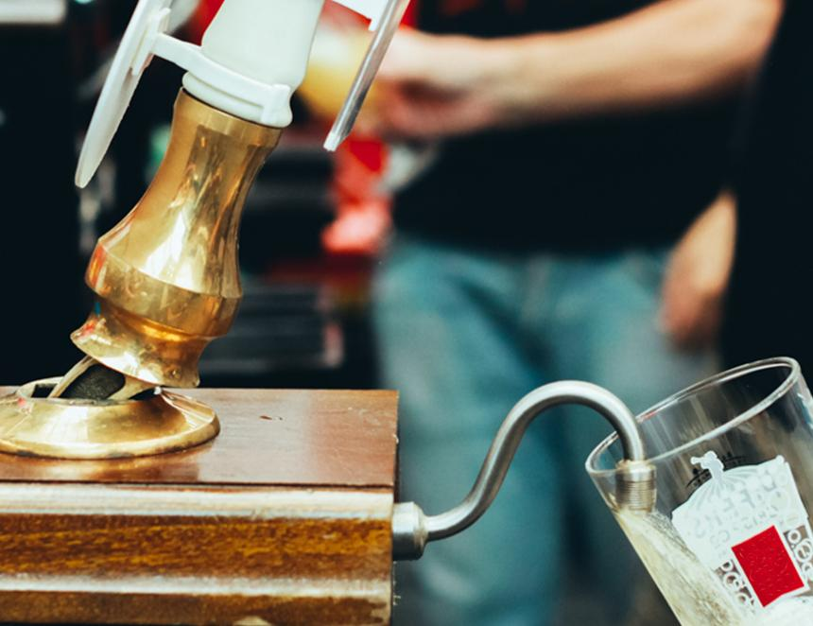

CAMRA has vowed to continue its fight for beer drinkers and pubs across the UK as Labour wins the seats necessary to form a government. CAMRA national chairman Nik Antona said: “CAMRA would like to welcome Labour as the new UK government. We look forward to working alongside it on the issues impacting consumers, pubs, social clubs and producers of beer, cider and perry. “It was heartening to hear Labour’s announcement of a five-point plan to ‘end the decline of British locals’ during its election campaigning, and I hope that Labour will implement these proposals as soon as possible.  “Throughout the UK, CAMRA will be campaigning to see progress in improving consumer rights, pushing for the government to give consumers a right to information about drinks on the bar and the introduction of a new consumer right to a full pint. “We hope the new Labour government will recognise the need for independent producers to have better access to the pub market, which is currently heavily dominated by larger corporations. “In the run up to the election, we heard Sir Keir Starmer and Rachel Reeves recognise the importance of beer duty to the trade. “CAMRA will continue to fight for fairer tax with an increase in the differential between draught and off-trade duty rates, and a VAT reduction on beer and cider sold in the on-trade so consumers can continue to receive all the social and wellbeing benefits pubs offer. “In England, CAMRA hopes the government will improve planning protection and enforcement to protect pubs and social clubs facing unfair demolition, and to order pubs to be rebuilt brick by brick if necessary. “CAMRA has long called for business rates to be reformed so pubs can avoid unfair overpayments. It's great to see that Labour is committed to changing the outdated business rates system to make it fairer between online enterprises and bricks-and-mortar businesses like pubs. “We also welcome plans to introduce a genuine community right to buy, which will help many loved pubs stay open and create exciting new opportunities for the sector to thrive.” The UK’s small brewers welcomed the new government. SIBA chief executive Andy Slee said: “The people of the UK have clearly spoken for the need for change. SIBA stands ready, and looks forward to working with the new government in Westminster and across the UK in helping independent brewers be a part of their plans for sustainable economic growth. “Independent breweries are a hugely valued force for good in local communities and right now, more than ever, need support to compete against the  global beer giants that control the market, as well a tax system which sets a level playing field for pub and brewing businesses to grow.”