Profits grow alongside rising demand for cask beer

04/07/2024 by Timothy Hampson

Industry

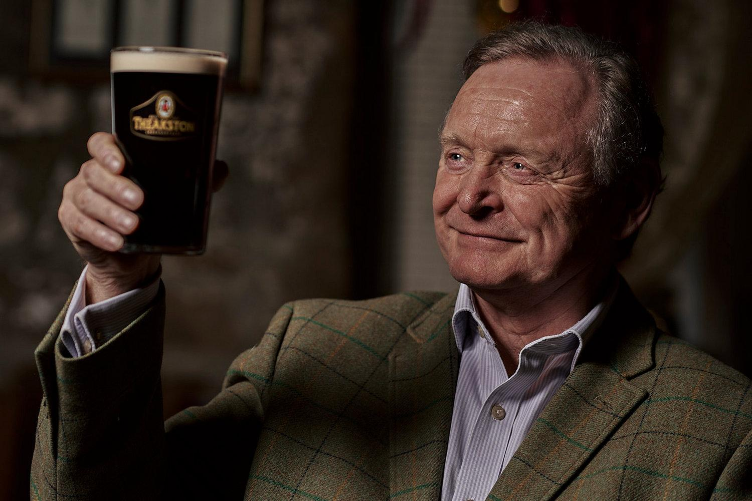

Yorkshire-based brewery, T&R Theakston has reported continued growth in its latest annual report for the year ending 31 December 2023, despite a tumultuous time for the industry. The family-controlled business, which has been brewing in Masham for almost 200 years, recorded a pre-tax profit of £248,000 for the period, an increase from £18,000 in the previous year. The increased profitability comes as the business also saw turnover increase by 21 per cent to £8.2m in the same period, despite the challenges of inflation on production costs, increased operational expense for customers and consumers feeling the pinch on their disposable income. The annual report highlights that although the business felt the effects of these factors, it achieved market share growth across all trade channels in 2023, with its two largest brands Best and Old Peculier both achieving volume growth. It notes taking a longer-term view of its pricing and avoid knee-jerk increases had supported this growth. This growth is being supported by investment into its operations, appointing the company’s first director of finance Scott Everett, and expanding the sales team in the North over the last year. Chairman Simon Theakston (pictured) said: “We’re pleased to report an increase in profitability, as demand for our high-quality beers among customers in both the on and off trade markets is high. “The last 12 months have proved to be a pivotal year for the business as we continue to navigate towards our 200th anniversary and we’re pleased to see that demand for cask ale has endured with volumes growing by five per cent The increased availability of our beers in both the on and off-trade, alongside Old Peculier’s triumphant return to the American market after a 10-year absence as well as the launch of exciting new products, including our 3.4 per cent ABV Theakston Quencher, have meant we’ve been able to continue our steady growth. “Quencher, a hop-forward cask ale, was designed to meet the demand for lower-alcohol beers and has gone from strength to strength since launch, now becoming our third best performing cask beer. This, alongside the continued strong performance of Old Peculier and our other brands has really underpinned our growth. “With a healthy balance sheet and secure financial arrangements, we remain focused on growing our revenue and are excited about what’s to come this year. Having renewed our sponsorship of the Old Peculier Crime Writing Festival until 2030 and agreed to host the main bar of the Great Yorkshire Show, we are all looking forward to meeting customers old and new as we continue to grow the Theakston community. “We have also welcomed the sixth generation of the family to the business, my son, William Theakston. “As a result of our strong start to 2024, the board of directors are confident that the pace of growth, which has been steadily increasing post-Covid, will accelerate this year thanks to our strong brands and our solid business foundations.”