City beer fest hits the road

03/07/2024 by Timothy Hampson

Campaign

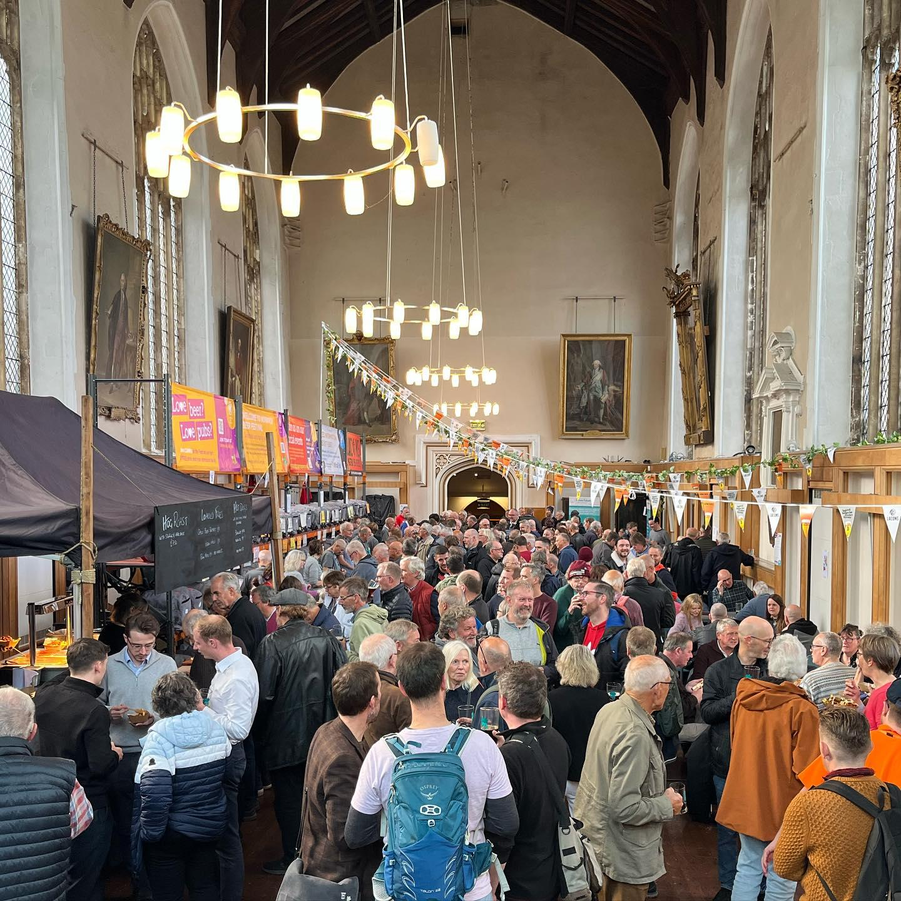

This year the popular Norwich Beer Festival is leaving its traditional home at The Halls and hitting the streets. This October, Norwich & District CAMRA are hosting a reimagined festival with a line-up of events and activities spread across the city. The organisers are unable to hold the traditional festival as The Halls (above) is undergoing major refurbishment, so they have crafted an exciting collection of alternative events across the city to ensure festival-goers still have a good time and plenty of beers to enjoy. Festival coordinator Lucy Cousins said: “It’s Norwich Beer Festival, but not as we know it. This year we’ve had to be creative, while our beloved venue is refurbished, and we’ve decided to have some fun with it.” Plus, it’s all for a good cause. With an emphasis on supporting charities, all proceeds from the CAMRA festivities will benefit local causes. Among them is BUILD Charity which is “making a difference so people with disabilities don't have to feel different” and Headway Norfolk & Waveney, which supports those affected by brain injury. The festivities kick off on Thursday, 24 October, spanning 12 days of tastings, live music, coach trips and more in partnership with Norwich’s top pubs and breweries. A highlight is the World Beer pop-up at Castle Social on level 3 of Castle Quarter. Inspired by the World Beer Bar from previous festivals, and sponsored by the World Beer Awards, this pop-up will feature an extensive selection of bottled brews from around the globe. Running from Thursday, 31 October to Sunday, 3 November, visitors can also enjoy the tasty treats from the surrounding food hall including giant Yorkshire pudding wraps and hot meat baguettes from Giant Yorkie Roast Co. Castle Social general manager Jo Aldridge said: “It’s a fantastic way to enjoy great drinks from across the globe, while bringing the community together to make a positive impact.” Pubs and breweries interested in participating are encouraged to get in touch via email at getinvolved@norwich.camra.org.uk