Search for brewers of tomorrow returns

02/07/2024 by Timothy Hampson

Campaign

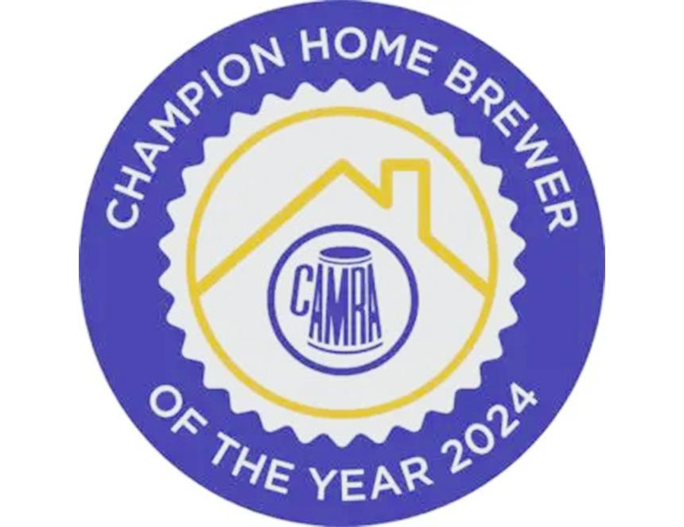

CAMRA has opened entries for its Champion Home Brewer of the Year competition. Now in its third year, the competition seeks out the best home brews and highlights the brightest brewers of the future.   Entrants can choose one of 11 beer styles which will be judged in September at Nailmaker Brewing Co. in Barnsley. From there, the best will then be judged at the Bohemia, home of the London Brewing Company, on 2 October, with the winner announced the same day.   The winner will be invited to brew their beer with the London Brewing Company with the support of the head brewer. Second place will get a case of eight craft beers every month for a year, courtesy of BEER52, and third will receive four tickets to the Great British Beer Festival 2025.   Senan Sexton, one of the owners of the Bohemia and a London Brewing Company director said: “I am delighted to be hosting this event, which is celebrating existing brewers and maybe brewers of the future. After all, many current brewers started their brewing careers as home brewers.”  Last year the judges crowned Patrick Davies’ Magnificent Frigate Strong Mild (6.2 per cent) the winner – an “end of a night beer”, which is rich and warming and smooth. With around 100 entries, the competition was fierce, and it is expected to be the same this year.   Competition judge Christine Cryne said: “The standard of brewing we have seen in the last two years of CAMRA’s Champion Home Brewer of the Year competition has been incredibly high. From luscious porters to fresh IPAs, the amateur brewing talent in the UK deserves to be recognised and we are incredibly proud to be shining a spotlight on these brewers.”  The competition this year is sponsored by The Malt Miller, BEER52 and Brew At Home.   Find out more about how to get involved here.