Maltings celebrates women in beer
01/07/2024 by Timothy Hampson
Industry

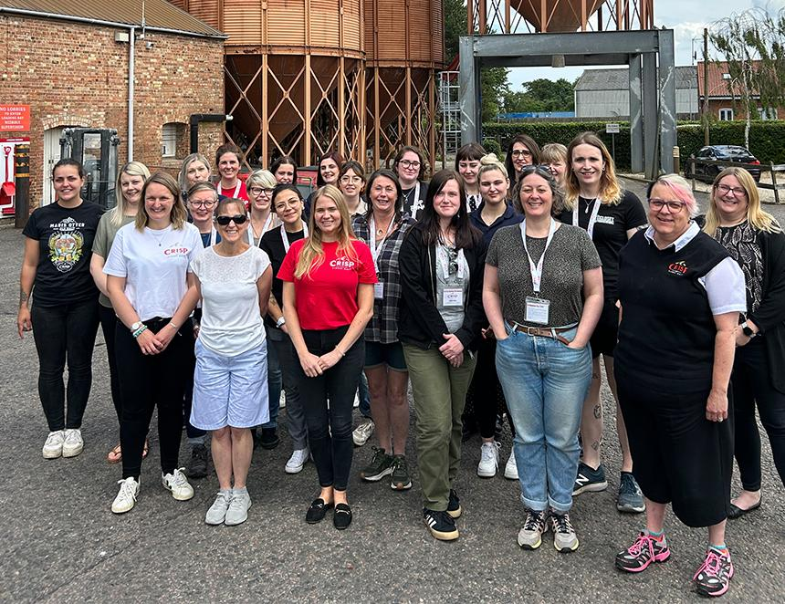

Crisp Malt welcomed Women in Beer UK to its Great Ryburgh maltings for a day of all things barley and malt. The visit (pictured) comes as part of the company’s commitment to supporting and celebrating women in the industry and it is one of seven sponsors of the group’s mentorship programme. This aims to give those starting their careers the chance to pair with more experienced women working in the industry who can help expand opportunities. Crisp Malt’s Colin Johnston said: “We supply a fantastic sector, but it is still a very male-dominated place. As an industry, we’ve come a long way in showing that there should be no barriers to those who consume beer and access beer-related spaces, so the same should be true for the people who make it. I’ve personally seen the power of mentorship in my career, as a place to learn and grow. “Since joining the Women in Beer mentorship programme as sponsors in September 2023, we have employed a number of incredible, skilled and talented women and have supported PhD research surrounding speciality malts in distilling.” Women are under-represented in managerial and brewing roles with fewer than 25 per cent of positions held by women, according to the campaigning organisation Dea Latis. A recent report by the Society of Independent Brewers (SIBA) also reported that 30 per cent of brewery employees are women with only three per cent in brewing roles. Crisp Malt grain procurement manager Rebecca Gee said: “Welcoming Women in Beer UK to Great Ryburgh for a day of in-depth tours with our passionate team was a fantastic opportunity to hear from aspiring women in the industry and pass on our knowledge and expertise. This is essential, not only to showcase the brewing industry as a viable option for women, but to give them the opportunity to build connections and find support in a sector that is typically male dominated. “It’s important to promote women’s interests in brewing and help other women get into the industry and the recent findings by Dea Latis emphasises this.”

