Plan your July festival trips now!
28/06/2024 by Matthew Rogers
Campaign

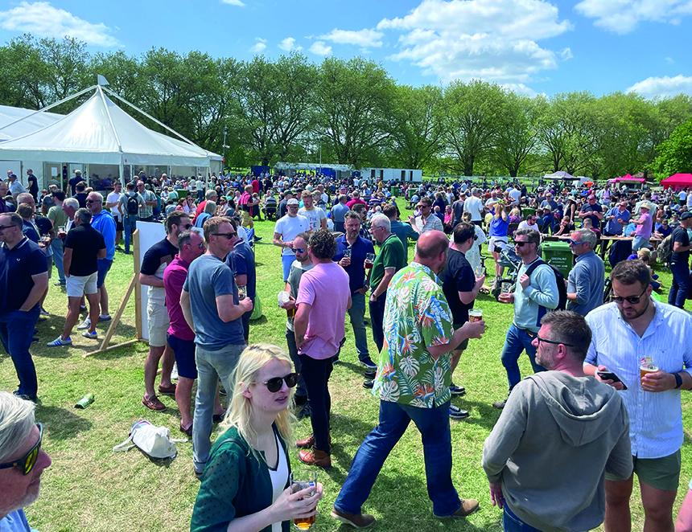

Plan your next festival trip by viewing the list below. To see all upcoming CAMRA events, visit https://events.camra.org.uk/ Derby Anniversary Beer Festival, 3-6 July Brunswick Inn, 1 Railway Terrace, Derby, DE1 2RU https://derby.camra.org.uk/Derby_Beer_Festival/index.html Leicester Beer Festival, 4-6 July Abbey Pumping Station, Corporation Road, Leicester, LE4 6NS https://leicester.camra.org.uk/events/leicester-beer-festival/ Chorlton Beer and Cider Festival, 4-6 July St Clements Church, Edge Lane, Chorlton, Manchester, M21 9AE https://chorltonbeerfestival.org.uk/ Maidenhead Beer and Cider Festival, 5-6 July Summerleaze Park, Summerleaze Road, Maidenhead, Sl6 8SP https://maidenheadbeerfest.camra.org.uk/ Ealing Beer Festival, 10-13 July Walpole Park, Ealing, W5 5EQ https://ebf.camra.org.uk/ Beer on the Wye, 12-14 July Hereford Rowing Club, 37 Greyfriars Ave, HR4 0BE https://beeronthewye.wixsite.com/beeronthewye Devizes CAMRA Beer and Cider Festival, 13 July Devizes Wharf, Devizes, SN10 1EB https://www.devizescamra.org.uk/ Chelmsford Summer Beer and Cider Festival, 16-20 July Admirals Park, Chelmsford, Essex, CM1 2PL https://cbcf.camra.org.uk/ Sunshine Beer and Cider Festival, 18-20 July Teignmouth Rugby Football Club, Teignmouth, TQ14 9DQ https://southdevon.camra.org.uk/ Hemel Old Town Beer Festival, 19-21 July St. Mary's Church, High Street, Hemel Hempstead, HP1 3AE https://midchilternscamra.org.uk/hemel-old-town-beer-festival/ Cotswold Beer Festival, 19-21 July Winchcombe, Cheltenham, GL54 5AQ https://postlip.camra.org.uk/ Wolverhampton Summer Festival of Beer and Cider, 25-27 July Dunkley Street, Wolverhampton, WV1 4AN https://wolverhampton.camra.org.uk/ Market Bosworth Rail Ale Festival, 26-28 July The Goods Shed, Station Road, Market Bosworth, CV13 0PF https://hinckleyandbosworth.camra.org.uk/viewnode.php?id=220913 Epping Ongar Railway Real Ale and Cider Festival, 26-28 July North Weald Station, North Weald Bassett, CM16 6BT https://www.eorailway.co.uk/events/real-ale-and-cider-festival/

