Champion pub hosts campaigners
26/06/2024 by Timothy Hampson
Campaign

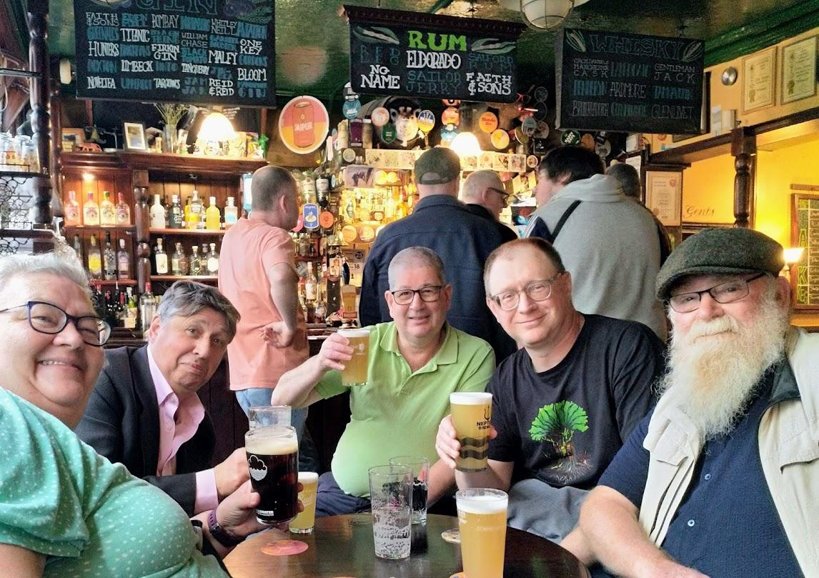

Campaigners Gillian Hough, Chris Welsh, Rick Pickup, Phil Moss and Dick Withecombe take a well-earned break after a Real Ale, Cider and Perry Campaigns Committee meeting in the Central Manchester Pub of the Year – the City Arms. The City is a traditional, compact, two-room, city-centre pub which is more than 190 years old and is widely regarded as the best real ale house in Manchester serving eight ever-changing cask beers.

