Britons’ protection delay
25/06/2024 by Steve Hobman
Industry

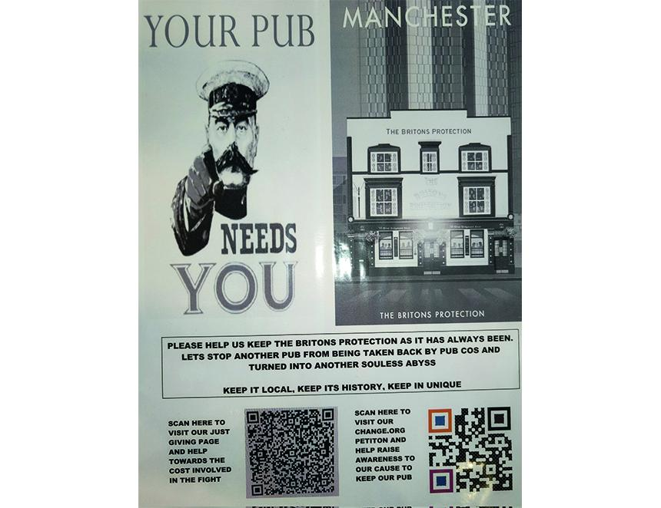

A court showdown to save a much-celebrated Manchester cask ale haven has been put on hold for several months. The leaseholders of the Britons Protection expected a five-day civic court hearing to begin on 17 June in their battle against a Star Pubs & Bars plan to end their tenure and take the historic pub in-house. On the second day of the hearing the case was adjourned on a procedural matter. Licensee Allan Hudd has successfully run the popular Great Bridgewater Street hostelry, which gave refuge to the Peterloo Massacre victims in 1819, for 12 years. With a free-of-tie, market-rent-only (MRO) agreement Allan created an eight handpull cask ale destination along with a 400-strong whisky collection. Under security of tenure legislation, Allan and his business partners were seeking to continue the lease for another 10 years. He previously told What's Brewing: “If it becomes a managed house the city will lose a much-loved venue for cask ale and whisky to yet another bland gastro pub.” A spokesperson for Heineken owned Star Pubs & Bars said: “This week, the judge made a decision relating to a technical point of procedure and we will fully comply with the judgement made. We remain confident in the fundamentals of our position as we move forward to the next stage in the legal process.”

