Rebuilt Vulcan lands on new site
24/06/2024 by Timothy Hampson
Pub

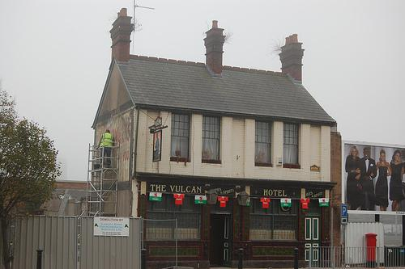

A one-time working-class pub, that can lay claim to being one of Cardiff's oldest and newest, has opened its doors once again. Amgueddfa Cymru-Museum Wales, which has seven sites across the country, has hit upon a novel way to raise money and attract visitors by opening a historic pub at its St Fagans site. The Vulcan Hotel (pictured before the move) has reopened its doors after being dismantled and reconstructed at the national museum of history, just outside Cardiff. The Vulcan was built on Adam Street in Cardiff in 1853 and served the predominantly Irish community of what was then called Newtown. The museum said: “During its long history it saw major changes as Cardiff grew to become an industrial powerhouse and then the nation’s capital, finally closing its doors for the last time in 2012.” A petition, started by campaign group Save the Vulcan, drew thousands of signatures – including actor Rhys Ifans and Manic Street Preachers frontman James Dean Bradfield – when it closed in 2012. In 2012, Vulcan owner Marcol Asset Management offered the building to Amgueddfa Cymru. In May of that year, curators from Amgueddfa Cymru and its historic buildings unit began the process of recording the Vulcan Hotel before starting the dismantling process. Rebuilding began in 2020 at St Fagans. The Vulcan will be displayed as it used to look in 1915, however, rather than in 2012. Amgueddfa Cymru-Museum Wales chief executive Jane Richardson said: “At St Fagans, we have done a brick-by-brick reconstruction of the Vulcan, Cardiff’s most famous pub. It will operate as a real pub inside the museum and generate new income for us.” The Vulcan will serve beer from the Glamorgan Brewing Co.

