Premier cru Vines takes top title
23/06/2024 by WB Reporter
Campaign

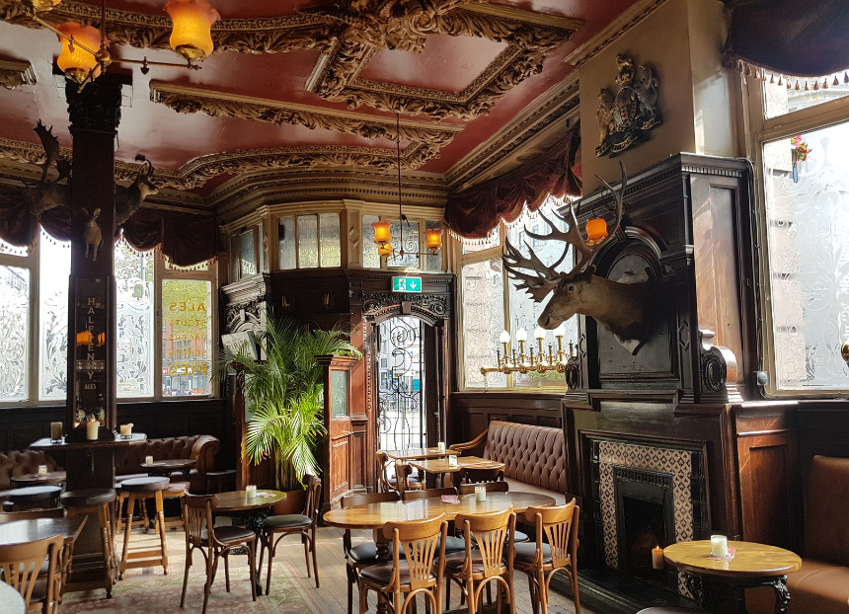

CAMRA has unveiled the winners of its prestigious Pub Design Awards at one of the winning designs – the Vines in Liverpool. The Pub Design Awards recognise the highest standards of architecture in the refurbishment and historic conservation of pubs across the UK, plus the most innovative construction and conversions of new venues. The awards are judged by a panel of experts in design and conservation. This year there are three winners, two highly commended and three commended pubs across categories ranging from refurbishment to new build. These include: Historic England Conservation Award: this celebrates work which conserves a pub’s architectural features, enhance the viability of a historic building, while restoring and updating the original facilities. The Vines, Liverpool (Winner, pictured) A full conservation and refurbishment of the interior of this iconic Grade II*-listed Edwardian pub has undone years of poor care. The conservation work on the historic gin palace included the restoration of the original 1907 tiling, stained glass ceiling dome and intricate theatrical plasterwork. The judges were impressed with the high quality of the restoration, which has brought the building back to life as a spectacular example of historic pub design and craftsmanship. New Build: this evaluates newly built pubs, where the owner has used imagination and flair to create a new, visually impressive venue, while recognising the traditional qualities of pub hospitality. Hall & Woodhouse Taplow, Buckinghamshire (Highly Commended) The latest Hall & Woodhouse pub is by the River Thames, with an expansive outdoor terrace that provides wonderful views over the landscape. The two-storey state-of-the-art building features striking architecture that complements the surrounding environment. The judges were particularly impressed by the exterior which draws on design themes taken from the sheds and warehouses associated with riverside locations. Conversion to Pub Use Award: this rewards outstanding conversions of buildings which were originally built for other uses and have now been transformed into a pub. The judges look for conversions which successfully create the pub ambience in a building not designed as one, but also those which bring out the character of the building that has been converted. bod Alsager, Cheshire East (Winner) Titanic brewery’s latest café bar, bod Alsager, was previously a former solicitors’ office, and needed considerable remodelling to be suitable as a hospitality venue. The pub features extensive use of recycled and repurposed materials, converting the original internal doors into the frontage of a bespoke bar and a chandelier made from Titanic beer bottles. Judges also praised the new light and airy conservatory which supplies a wow factor to the bar. Refurbishment: this is awarded to the best renovation of an existing pub building. This can range from a complete gutting and replacement, to enhancing the design of what was originally in the pub. As with the other awards, the judges are looking for originality and imagination in the way the building is treated. Kings Arms, Elham (Winner) The Kings Arms is an ancient inn and has been the social hub for the village of Elham for centuries. The pub undertook a creative makeover which has enhanced the atmosphere of the building, with glazed walls and doors bringing much-needed light into the previously rather gloomy interior. The total internal and external renovation and remodelling has resulted in a warm, welcoming and contemporary environment. Judges commented that the pub is “a lovely place for a drink or a meal”. Crown, Chislehurst (Highly Commended) The Shepherd Neame-owned pub, which dates back to 1874, underwent a 12-week renovation with care taken to retain its unique character, while introducing a more modern look and feel. An impressive central servery and a light and airy orangery leading out into the remodelled garden area are features of what is now a very contemporary interior. Bell, Tring (Commended) Farr Brew has given the 17th-century coaching inn a sensitive redesign and redecoration to provide a contemporary feel while enhancing its historic features, transforming the Bell from a sports bar into an important feature of Tring town centre. Sheep & Penguin, Wells (Commended) Having been closed for years and in a near-derelict condition, the pub (previously known as the Mermaid) appeared highly unlikely to ever reopen. A complete restoration has breathed new life into the pub, transforming it from an eyesore into a building that makes a positive contribution to the city’s streetscape. The judges described it as “a bright and welcoming place for a drink or a meal”. Community Local: this category is reserved for outstanding refurbished street-corner locals. Pipe Makers Arms, Broseley (Commended) Owner Kerry Ford took on the Pipe Makers Arms and single handedly renovated the pub herself. The refurbished pub has become the social hub for its community, providing attractive facilities for a range of local groups and activities, such as Creative Lives initiatives, book clubs and even its own football team. Chair of the Pub Design Awards judging panel Andrew Davison said: “Once again, the Pub Design Awards’ judges have had a hard job in selecting the winners from the entries submitted. Despite the pressures the hospitality industry is under, we are pleased to report that people are still prepared to invest time, money, and resources into conserving their buildings, and upgrading them to meet the latest challenges. “Our Pub Design Awards recognise the high standards of flair and imagination which have gone into these projects, and the ambitious craftsmanship involved in the repair and conservation work. Despite everything thrown at it, we believe that the pub has a key role to play in our communities, and that it will continue to flourish as an institution. The high quality of the entries for these Awards provides evidence to support that belief.” CAMRA awards director Laura Emson said: “It is only right that the blood, sweat and tears poured into these pubs is celebrated. I would like to raise a glass to all these award-worthy pubs! “We hope beer lovers across the country will seek out these breathtaking examples of how beautiful UK pubs can be, if given the appropriate love and care these much-loved establishments truly deserve.” You can find more about the Pub Design Awards here: https://www1.camra.org.uk/awards/pub-design?selected_year=2024

