CAMRA responds to party manifestos

22/06/2024 by Timothy Hampson

Campaign

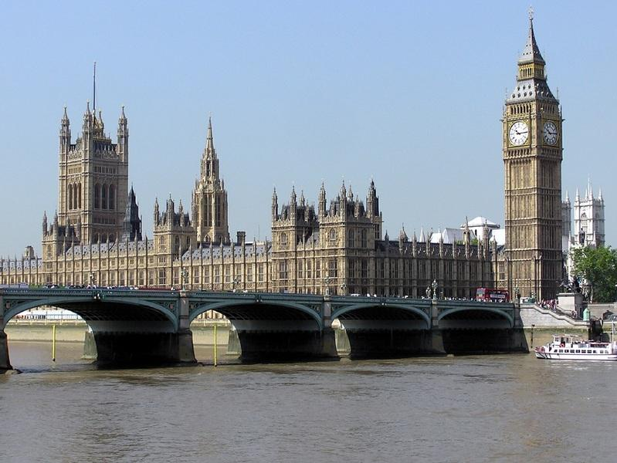

In the run up to the General Election, CAMRA has responded to election manifestos where they have relevant commitments. Conservative: CAMRA national chairman Nik Antona said: “It is encouraging to see the Conservative manifesto reconfirming the party’s commitment to the new system of alcohol taxation and the lower rate of duty charged on draught beer and cider served in our pubs, social clubs and brewery taprooms – so that tax on pints in pubs is always lower than that on supermarket alcohol. “CAMRA is calling on the next UK government to commit to extend the discount on tax for draught beer and cider to turbocharge this new alcohol duty system and give consumers, pubs and independent breweries the boost they need to survive and thrive. “Committing to extending the Community Ownership Fund is also a welcome pledge which would make sure that groups can access funding they need to save their local pub as a community hub if it is under threat of closure, conversion or demolition.  “In addition, the Conservative proposal to review the night-time economy in England with a view to reversing the decline in pub numbers would provide an opportunity to show how transforming tax, regulation and planning laws could help save the nation’s much-loved pubs being lost to the communities they serve.” Green Party: “CAMRA welcomes the Green Party’s continuing commitment to reducing VAT for the hospitality sector alongside its proposals to review planning regulations to protect the night-time economy and give councils the powers to exempt socially essential enterprises from paying business rates, which we would argue should definitely apply to pubs which are a vital part of our social fabric. “We look forward to working with Green parliamentarians and with the next UK government to explore how these ideas could be implemented to safeguard pubs and social clubs at the heart of community life up and down the country. “This should include cutting the rate of VAT specifically on beer and cider sold in pubs in recognition of their community value, including for traditional wet-led pubs that do not serve food. This would help to reduce the rate of pub and brewery closures which deprive consumers of their much-valued locals.” Labour: “CAMRA members will be pleased to see that Labour’s manifesto includes a commitment to change the outdated business rates system to make it fairer between online enterprises and bricks-and-mortar businesses like pubs which are massively penalised in the current system.  “Any changed system must make sure that pubs no longer pay a disproportionate share of rates and that a new, fairer business rate regime recognises their community value to help keep our locals open and thriving as a vital part of our social fabric.” “While it does not feature in the manifesto, CAMRA looks forward to working with Labour MPs in the next parliament to develop their policy for a ‘community right to buy’ giving communities in England a right in law to have first refusal on buying privately-owned community assets which would be a gamechanger for people who want to save and take over the running of their pubs if they are under threat of closure, conversion or demolition.” Liberal Democrat: “It is encouraging to see commitments to overhauling the broken business rates system in England, which is desperately needed to help save our pubs, as well as on strengthening powers to allow community assets like pubs to be protected and introducing a dedicated minister for hospitality and tourism. “While the devil will be in the detail, the Liberal Democrat plans to replace the current business rates system with a new commercial landowner levy based on land value rather than entire capital value could see more proportionate business taxes for the hospitality sector in many parts of the country and an end to the current system which disincentives investment in pubs. “It is vital that the next government radically reforms the business rates system to stop pubs overpaying by around £500m each and every year – and to make sure online businesses pay their fair share compared to bricks-and-mortar businesses like much-loved community pubs. “CAMRA looks forward to working with Lib Dem parliamentarians and those of all parties in the next Parliament to make sure that business rates and community ownership policies better support and protect the nation’s much-loved locals.” Plaid Cymru: “We are pleased to see Plaid’s manifesto commitment to provide more support to communities to keep pubs open and at the heart of communities across Wales, as well as the party’s support for changing the business rates system to better support hospitality businesses. “CAMRA looks forward to working with Plaid Cymru MPs in Westminster and with MSs in the Senedd to make sure pubs, social clubs, breweries and taprooms remain at the heart of community life.” SNP: “CAMRA welcomes the SNP’s commitment in its General Election manifesto for introducing a lower rate of VAT for hospitality businesses. “Cutting VAT, including on beer and cider served in pubs and social clubs in recognition of their community value, is undoubtedly the right thing to do. With many pubs and breweries are operating with extremely slim profit margins as a result of rising prices, costs and energy bills, cutting VAT specifically for beer and cider would ease financial burdens to help the beer and pubs sector survive and thrive, and stem the rate of business closures which deprives communities of their local. “We look forward to working with MPs in the next UK Parliament to push for a fairer tax system for pubs, social clubs, breweries and cider producers and the consumers that they serve.” Alliance Party: CAMRA chief executive Tom Stainer said: “CAMRA is pleased to see the Alliance Party’s manifesto supporting plans to reduce the rate of VAT for hospitality and tourism businesses. This is much needed to help and safeguard local pubs as a vital part of our social fabric which bring communities together, as well as assisting the great local and independent breweries and cider producers which showcase the best of local beer and cider.  “Cutting VAT, including on beer and cider served in pubs and social clubs in recognition of their community value, is undoubtedly the right thing to do. With many pubs and breweries operating with extremely slim profit margins as a result of rising prices, costs and energy bills, cutting VAT would ease financial burdens to help the beer and pubs sector survive and thrive, and stem the rate of business closures which deprives communities of their local.  “CAMRA NI looks forward to working with Alliance representatives in Parliament and at Stormont to stand up for consumers and to continue to protect and promote NI’s great local pubs, independent breweries and cider producers.”  CAMRA is urging members to contact their MP candidates in the run up to the General Election. Email your General Election candidates now with the Campaign's e-lobby: https://action.camra.org.uk/page/151385/action/1 CAMRA’s General Election manifesto and its campaigning priorities for the next UK government – including fairer tax, consumer rights, planning protections and better business rates for pubs – is now on the website. See its asks for the next UK government here: https://www1.camra.org.uk/take-action/general-election-2024