Beer campaigner meets Czech Republic president

20/06/2024 by Timothy Hampson

Campaign

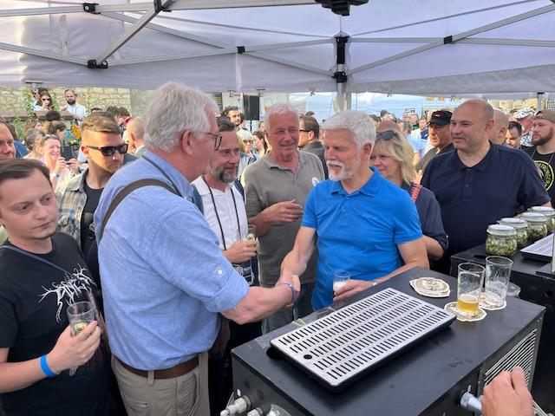

Beer campaigner and CAMRA author Tim Webb recently met Czech Republic president Petr Pavel at a beer festival in the grounds of Prague Castle. Tim said: “I was visiting the Festival Minipivovarů (Festival of Small Breweries) in the grounds of Prague Castle run by Jan Šuráň, head brewer and co-owner of the Břevnov monastery brewery in Prague. I have known Jan for maybe 15 years, and he introduced us.  “The president had promised to visit the festival, but nobody was sure he would turn up. When he did, his minders said he would only be there for 10 minutes but after the crowds backed off grabbing the selfies, he and his wife Eva decided to stay for another half an hour. “Unusually for a president he is quite a popular character.”  Pictured: Tim Webb, left, meets president Pavel and his wife.