CAMRA calls for full-pint guarantee

19/06/2024 by Timothy Hampson

Campaign

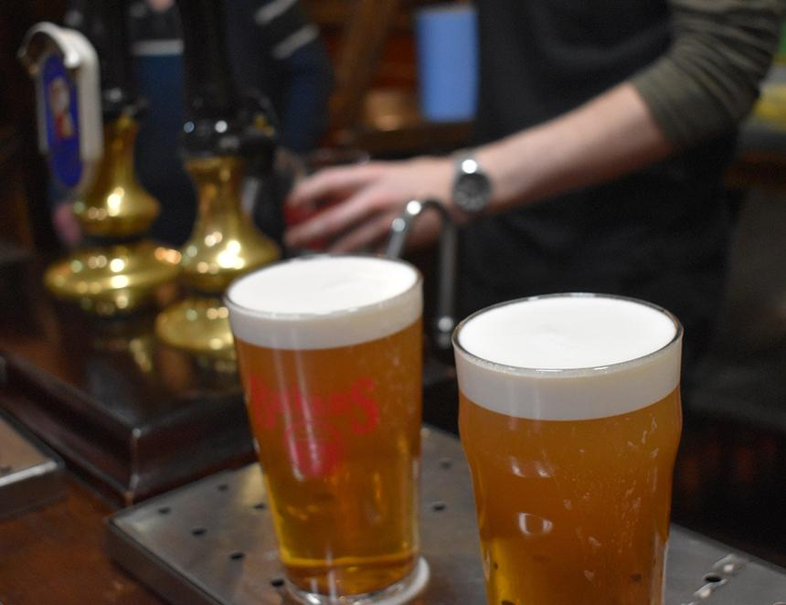

CAMRA is urging political parties to give their backing to a change in the law to guarantee drinkers a full pint. Monday marked the 200th anniversary of the passing of the Weights & Measures Act 1824 which defined a pint in British and Irish law for the first time. The Campaign marked the occasion by calling on all political parties to commit to changing the law in the next parliament to guarantee customers get a pint, not including the head, when they order one. Recent studies by the Chartered Institute of Trading Standards found 86 per cent of beer was short measured, and current laws leave consumers no recourse if they’re refused a top up. CAMRA national director Gillian Hough said: “The pint of beer or cider is part of our culture and heritage across these islands and it is right that we mark the 200th anniversary of the pint being defined in law in Britain and Ireland for the first time by raising a glass to our great pubs, social clubs, breweries and cider producers. “But with too many consumers receiving short measures at the bar, CAMRA wants the next UK government to introduce a legal right for pub-goers to receive a 100 per cent liquid pint each and every time they are served. “This would give drinkers a guarantee of getting what they pay for when they are supporting local pubs and breweries and would be a fitting way to mark the 200th anniversary of the great British and Irish pint.”