Robin Hood hoping for big score at Trent Bridge
18/06/2024 by Timothy Hampson
Campaign

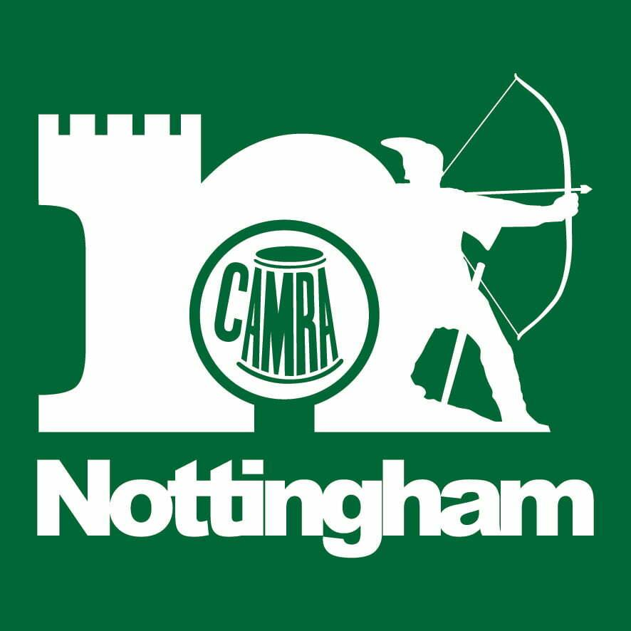

The popular Robin Hood Beer Festival is returning to Trent Bridge in 2024 running from 9-12 October with plans for it to be the biggest yet. Tickets will go on sale in early July with those keen to attend invited to pre-register for access to early bird pricing here. There will be brewery bars from Castle Rock, Blue Monkey, Black Iris, Bang the Elephant, Lincoln Green, Thornbridge, Nottingham Brewery, Lenton Lane, Shipstone’s plus real ales from many other UK brewers. Cider makers will also be in on the act with a wide choice as the festival returns with access to new areas and a jam-packed live music programme. “Last year’s festival was our best yet and we’re delighted to be back at Trent Bridge with plans to make more improvements to the scale, choice and entertainment,” said Nottingham CAMRA chair Steve Westby. “Nottingham has a great brewing heritage, and the newcomers are also making interesting beers which adds to the choice and variety. “We hope to attract more guests than ever before and while it certainly helps to be a beer or cider drinker, there really is something for everyone.” Venue commercial director Michael Temple said: “We really look forward to the beer festival and Steve and his team do a great job in making the event so authentic,” he said. “I would urge the regular followers of these events to book early and secure the discounted tickets while they can, while those who haven’t attended should disregard their perceptions of what a beer festival is because the scale, choice and detail put in place by CAMRA, its food vendors, retailers, bands and brewers is truly exceptional and makes for a great night out. “I’m yet to meet anyone that hasn’t been utterly charmed by the spirit of this event.” Opening hours are:– Wednesday 9 October, 4pm-11pm– Thursday 10 October, 11am-11pm – Friday 11 October, 11am-11pm– Saturday 12 October, 11am-11pm.

