Cask ales head to Sweden

17/06/2024 by Timothy Hampson

Industry

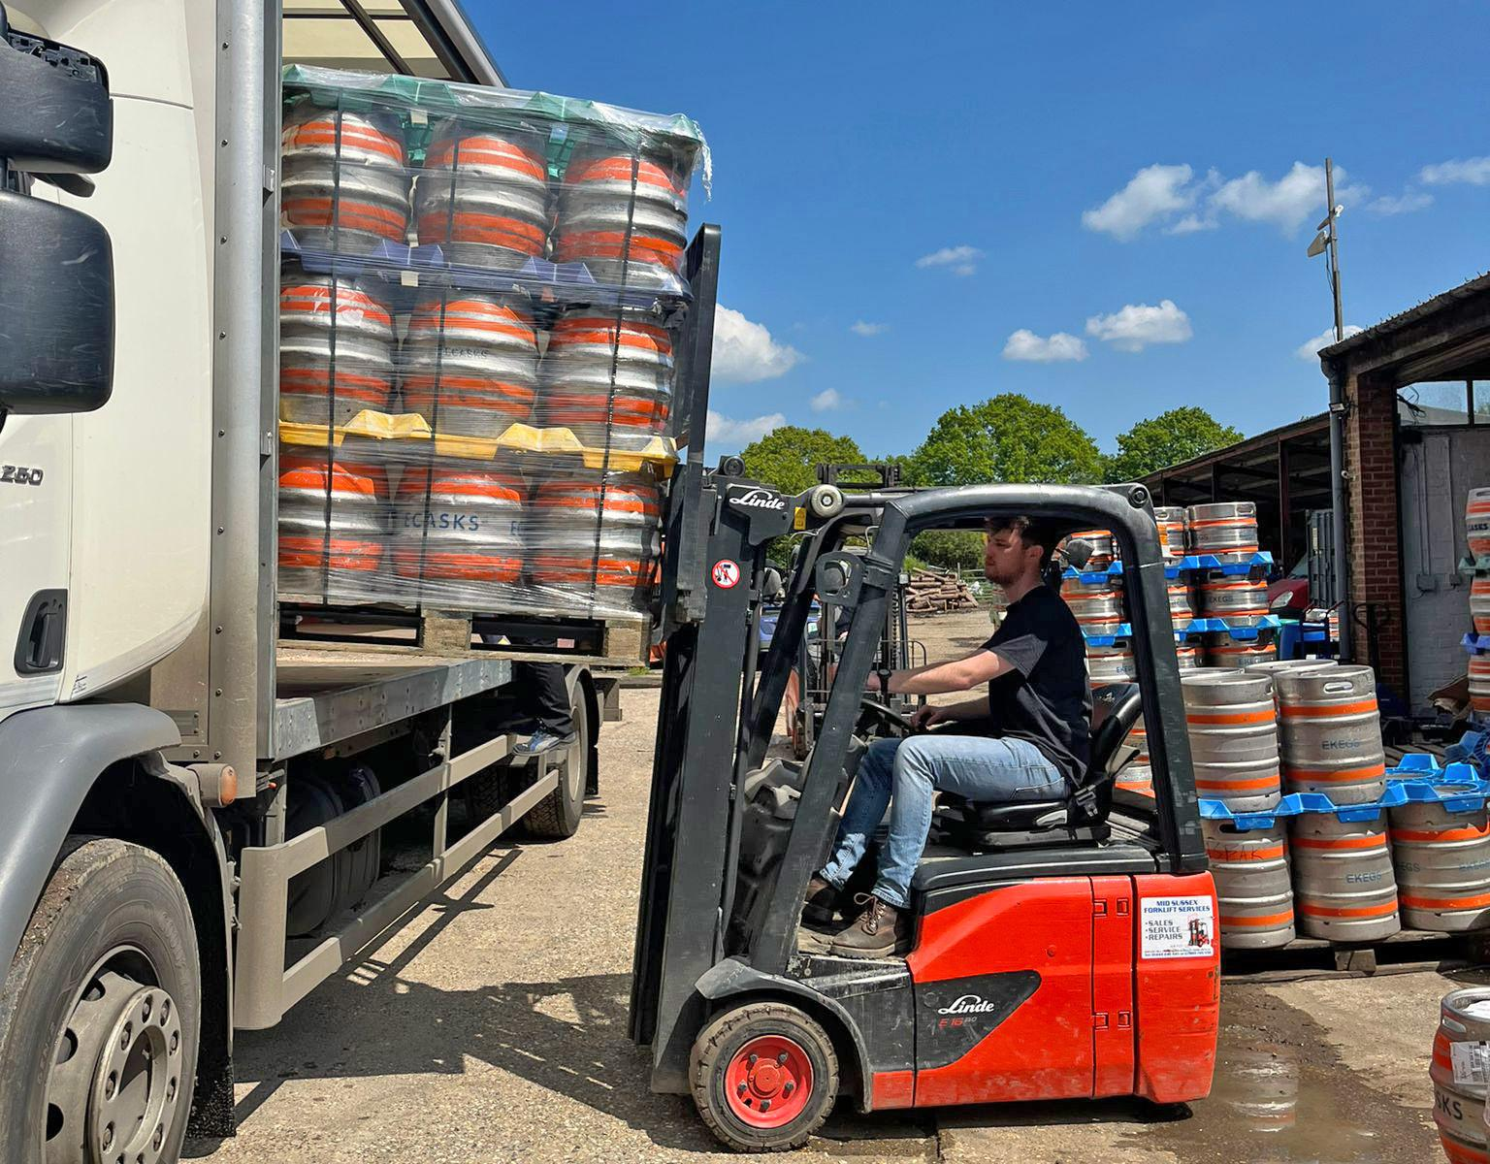

Sussex beer is about to go on sale in Scandinavia, as a brewery makes its first foray overseas into an emerging export market for traditional English cask-conditioned ale. Three Acre brewery, which is based in the East Sussex countryside near Heathfield, has sent 37 barrels to Sweden where drinkers there are set to sample its Best Bitter, Spring Golden and IPA brews. Cask-conditioned beer is relatively unknown outside the UK and there are very few other countries that drink real ale or where drinkers even know what it is. “Part of this is down to a lack of knowledge about the product overseas which can make it harder to keep properly and serve well,” said Three Acre’s marketing director Chester Broad. “It is exciting to witness cask ale gaining momentum in this export market and, who knows, perhaps real ale could snowball into something much bigger on the continent?” The Sussex brews are destined for five venues in Stockholm, including Akkurat restaurant in the Södermalm district, a popular venue known for its wide selection of beers and malt whiskies. Also being supplied are the Old Brewer pub and diner, plus an English pub, the Churchill Arms. Further afield, the beers will be on tap at three outlets in the university city of Uppsala as well as in the far reaches of Northern and South-Western Sweden as well as Gothenburg. “We are so excited to know that our beers, produced here in the Sussex Weald, are to be enjoyed by a larger-then-ever audience”, added Broad. “We already have a great working relationship with the distributor and hope that this will be the start of a wider spread into the region.” Three Acre has announced a summertime special beer in the shape of tropical fruit-influenced Pineapple Dream. “It’s packed with Azacca hops and real pineapple”, said head brewer Jamie Newton. “It’s what cask beer would taste like on a tropical desert island.”