B-Corp breweries – should we care?

16/06/2024 by Matthew Curtis

Opinion

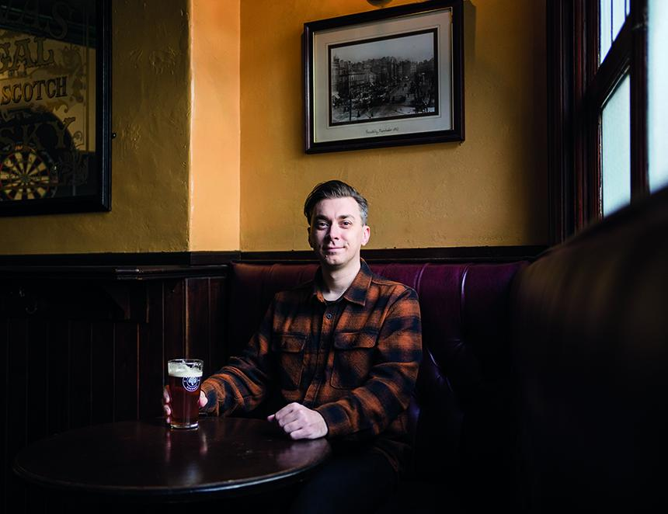

Newport’s Tiny Rebel has become the latest British brewery to achieve B-Corp status, receiving the coveted certification in April 2024. The Welsh business joins 2,000 other UK businesses that have met the high standards demanded by B-Corp’s certifying body, B-Lab, in order to attain the certification. Other British breweries to have earned the accolade include Toast Ale and Small Beer, both based in London. Gloucestershire's Stroud became the first UK brewery to become a B-Corp when it was certified in 2018. Other British brands with the certification include high-end restaurant chain Hawksmoor, and ethical clothing brand Finisterre. It is becoming increasingly important for modern businesses to advertise how invested they are in being good employers, as they are with regard to being environmentally sustainable. A growing number of consumers are becoming mindful of where they use their hard-earned cash as they seek to spend more ethically. A B-Corp certification, in theory, allows a brewery to advertise these credentials directly by advertising them on the side of a can or bottle, expressing their climate forward and people friendly ethos with ease. The big question is, however, with an increasing number of breweries achieving the certification, how many consumers actually care about it? Based in the USA, and founded as a not-for-profit in 2006, B-Lab developed the B-Corp certification to recognise the efforts of businesses who put a focus on trading ethically. In their own words it seeks to “transform the global economy to benefit all people, communities and the planet.” Attaining B-Corp status is notoriously difficult, with B-Lab asking applicants to score a minimum of 80 out of 100 on its B Impact Assessment, which looks at every aspect of how a business operates, including its approach towards sustainability, and how it looks after its staff, among other things. According to B-Lab the median score for UK businesses is 50.9, while Tiny Rebel passed with a score of 86.9. But businesses don’t just need to attain the high standards set by B-Lab in order to earn the accolade, they also need to meet the price tag. Applying for certification is a relatively affordable £250 plus VAT. But then you need to apply for B-Corp pending status while they review your application, this costs an additional £500 plus VAT. If successful, you need to pay an annual fee based on the size of your corporation, but the certification isn’t permanent, as it requires businesses to be reassessed every three years and pay for the privilege once again when the assessment is due. For members such as Tiny Rebel, the outlay is in the thousands, but with so many businesses seeking to attain the status, evidently it feels it’s a worthwhile investment. Founded in 2012, Tiny Rebel quickly earned a tightly knit fanbase by riding the wave of excitement that arose when stronger, more intense North American beer styles began to become more popular within the United Kingdom. It was not hop-forward IPA, however, but cask beer that saw the brewery rise to a more mainstream degree of prominence when it won CAMRA’s coveted Champion Beer of Britain award in 2015. The success of its flagship red ale, known as Cwtch (the Welsh word for cuddle) drove the brewery’s growth, which led to Tiny Rebel opening on premise retail sites in Cardiff and Newport town centres. It expanded to its current home in the latter following a £2.6m investment in 2016. The brewery has not been without its controversies, however. It’s playful, cartoon branding has often fallen within the firing line of branding regulator, the Portman Group. Typically, this has been on the grounds that it is appealing to underage drinkers. Complaints about Tiny Rebel’s branding was upheld by an independent panel in both 2021 and 2023. The brewery came under fire again in 2021 after a menu was published in one of its bars which contained what was considered by many to be inappropriate, and in some cases sexist references. Newport council expressed its disappointment in the business earlier this year, when it opted to close its bar in the city centre due to what the brewery described as “decreasing footfall and rising costs”. While its antics aren’t on quite the same scale, its brash attitude bears more than a passing resemblance to BrewDog. The Scottish brewing giant attained B-Corp status itself in 2021. However, following the publication of a televised documentary aired by BBC Scotland, which investigated claims of poor workplace practices, plus accusations of inappropriate behaviour in the workplace of its founder, James Watt, BrewDog saw its B-Corp status revoked the following year. The brewery complained about the inaccuracies of the documentary to broadcast regulator OFCOM, expressing that the BBC’s claims were untrue, but these were dismissed on all counts. Despite its own chequered past, Tiny Rebel should probably count itself fortunate to have scored as highly as it did, all things considered. It could be that the brewery has genuinely turned over a new leaf, despite a distinct lack of any public ownership of its past mistakes. It will fall to consumers, many of whom tend to have long memories, to decide if the brewery’s freshly earned B-Corp status will earn its beer a place in their fridges at home. All things considered, high impact assessment score or not, I’m yet convinced that slapping a logo on the side of a beer can is evidence that any business, brewery or otherwise, can genuinely be considered to be trading ethically. Especially if it is yet to take ownership of a potentially murky past.