Brewer turns to cask for Lightbulb moment

14/06/2024 by Timothy Hampson

Industry

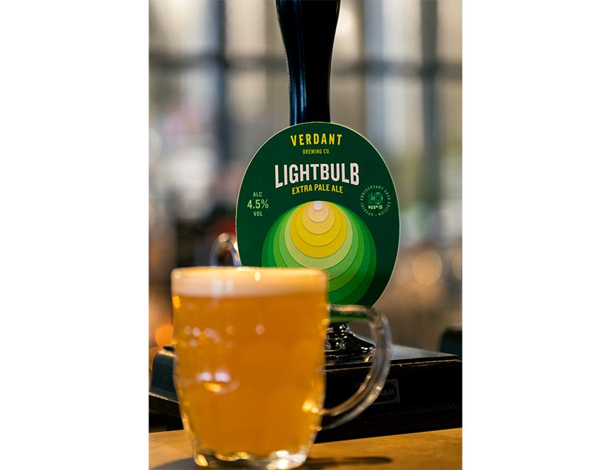

Cornish brewer Verdant Brewing Co is set to release a special 10th anniversary cask edition of its best-selling Extra Pale Ale Lightbulb. The 4.5 per cent XPA is being released on cask for the first time to celebrate a decade since the founding of Verdant, with pump clips set to boast a reimagined design of the label created by Falmouth University student Eathan Aktion. Verdant head brewer James Heffron said: “Lightbulb is an unchanged recipe for 10 years. To celebrate this amazing staple of the Verdant stable we are providing the exact same beer in cask format. “Expect a totally different drinking experience where the lemon sherbet character of Lightbulb rides atop an incredibly fluffy and smooth drinking experience far more akin to the softest of the soft New England pale ales with a rocky white head to match!” For the third year running Verdant teamed up with Falmouth University’s graphic design undergraduate course, this year providing a brief for students to reimagine the artwork of some of its most well-known beer labels. Displaying 10 rings of light signifying 10 years since the brewery was founded, the design will be used for the cask-only edition of Lightbulb. Aktion said: “Since becoming interested in design I’d always been interested in packaging and I used to work next to Verdant’s taproom as well, so I was aware of it, the beers and designs already. “It gave me the chance to work on a real live brief, get client feedback and develop my ideas in response, and the fact my design is going to be on the 10th anniversary edition of one of the beers is a huge bonus.” The anniversary edition will be available on cask in around 350 venues across the UK alongside beer mats with information about Ethan and his work.