Last push for Miners

11/06/2024 by Timothy Hampson

Pub

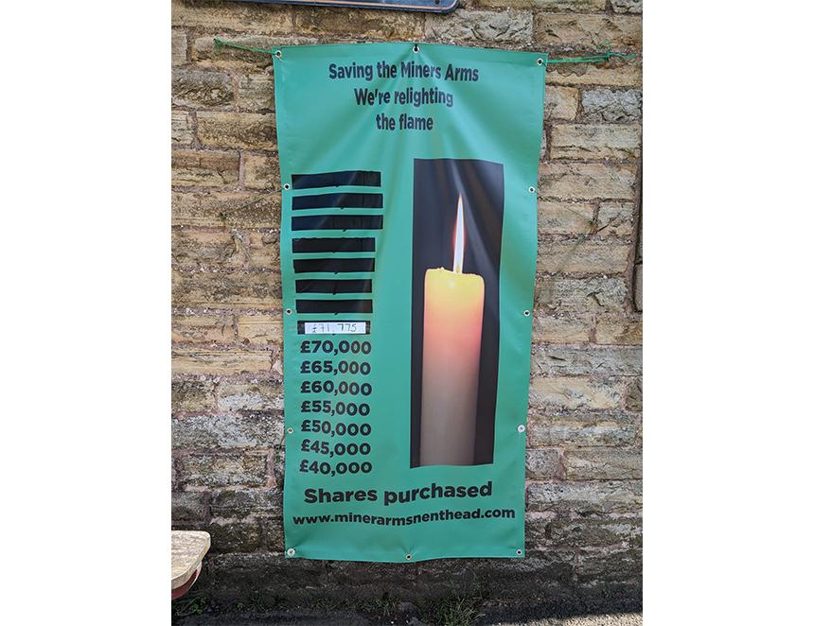

A community group hoping to buy the pub which has been at the heart of its village for almost 200 years has appealed for help with the final push to reach its target. The Miners Arms, Nenthead, Cumbria closed in 2020 and is now up for sale. Concerned residents of Nenthead came together and formed a community benefit society – the Miners Arms Community Pub Ltd (MACPL). The campaigners expected to hear this month if they will receive a government Community Ownership Fund (COF) grant. However, all announcements about the fund have been put on hold by the Department for Levelling Up, Housing and Communities after the General Election was announced. After raising more than two thirds of the money needed to buy the pub, the group is hoping to encourage people to invest in the project. Since launching last year, it has had pledges from across England and the rest of the world, with people investing from places such as Austria and Hungary. The group is now hoping to raise the last third of funds needed for the buyout. MACPL chair Simon Walker said: “Although it was disappointing to hear the result of our grant application will not now be known until a new government is formed, we are excited that the share offer is in full swing and already raised more than £70,000 of our £95,000 target.” The share offer has been awarded a Co-operatives UK Community Shares Standard Mark which ensures that community share offers are clear, honest, and transparent. It also ensures investors are presented with all the facts they need to make an informed decision and the facts are supported by a business plan. Walker added: “Our supporters have been fantastic so far but with less than two weeks until the share offer closes, we really need a final push towards our target. “We hope people who may have been waiting to hear the grant result will still come forward and purchase shares. If we are unable to buy the Miners for any reason all investments will be returned in full.” The share offer closes on Saturday 15 June. Shares are £1 each with a minimum investment of 100 shares. The MACPL business plan and share offer document are available at www.MinersArmsNenthead.com