CAMRA urges candidates’ support for pubs, pints and consumer rights
07/06/2024 by WB Reporter
Campaign

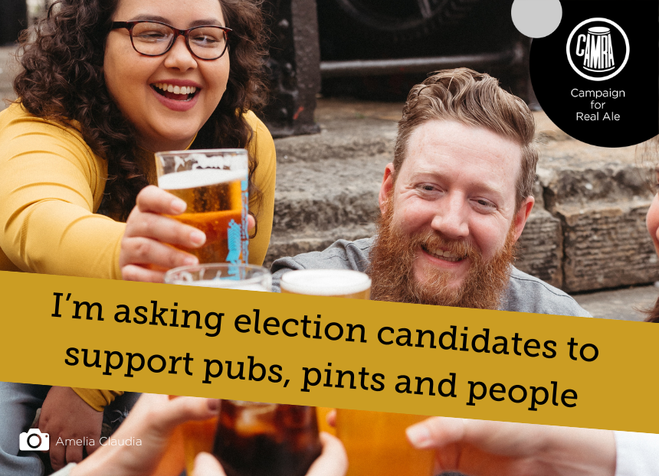

CAMRA is making its mark in the 2024 General Election with the launch of its manifesto and e-lobby campaign. The Campaign is calling on its members to lobby candidates in every constituency to make sure elected MPs are committed to protecting and promoting community pubs and great beer and cider. The manifesto outlines six key campaigning priorities: fair tax for beer and pubs more rights for beer drinkers and pub-goers access to market for small and independent breweries and cider producers recognising traditional cask ale under UNESCO’s Intangible Cultural Heritage of Humanity better planning protections for pubs (England-only) change the business rates system to make it fairer for pubs (England-only). Election campaigns are a prime opportunity for politicians to be seen pulling a pint behind the bar of their local, but this doesn’t always translate into action that supports pubs, social clubs, brewers, cider makers, and consumers. CAMRA is asking for candidates to commit to the campaigning priorities outlined in its manifesto, and back policy and legislation that can truly help the pub trade, producer and consumers. To ensure prospective MPs are pledging their support, CAMRA is enlisting its thousands of members to contact their local candidates to ask for their support for beer and pubs if elected. The e-lobby can be accessed here: https://action.camra.org.uk/page/151385/action/1 CAMRA is also providing a campaign pack for members and pub-goers to promote the manifesto and e-lobby, including election guidance and social media assets. As each party announces its manifesto, CAMRA will be letting consumers know what is being offered. To keep up with all CAMRA’s comments, news and social go to its Media Centre. For more information go to https://camra.org.uk/take-action/general-election-2024/ Photo by Amelia Claudia

