Companies back Pride Month

05/06/2024 by Timothy Hampson

Industry

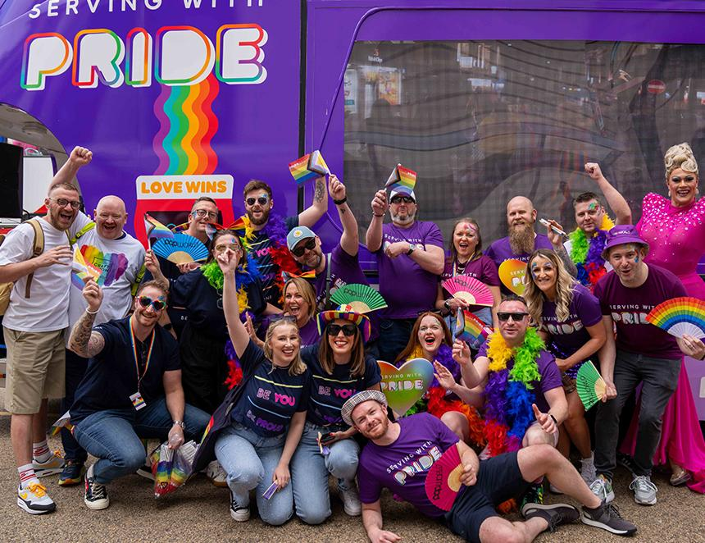

Stonegate Group, the UK’s largest operator of LGBTQIA+ venues, is launching its Serving With Pride campaign to coincide with this month’s Pride Month. The campaign highlights Stonegate’s commitment to inclusivity and builds on last year’s success, uniting all venues under a banner of allyship and celebration. The goal is clear – to ensure its spaces are safe and welcoming for everyone, allowing guests and teams to express their true selves without fear of prejudice. To celebrate, Stonegate venues will offer a range of Pride-themed drinks, both with and without alcohol. This year, Stonegate is partnering with Stonewall Housing, a leading national charity supporting LGBTQIA+ individuals facing homelessness or unsafe living conditions. For every sponsored drink sold during the campaign, 10p will be donated to Stonewall Housing, funding its essential services like housing advice, advocacy and specialised support. Stonegate CEO David McDowall said: “Here at Stonegate Group, our mission is to bring people together. We are truly proud to support the LGBTQIA+ community and to be able to bring them together in our venues during Pride and beyond. “Our month-long Serving with Pride campaign reflects our ongoing commitment to inclusivity and our dedication to providing safe, welcoming venues for everyone to enjoy.” St Austell brewery has announced a partnership with Cornwall Pride as part of the company’s commitment to promote equality, diversity and inclusion (EDI) across its business. To mark this, the two organisations have collaborated on a special charity beer for Pride Month. Cornwall Pride has been working closely with St Austell brewery to support plans which will ensure a safe and inclusive workplace. The company has set up an EDI steering committee, chaired by chief executive, Kevin Georgel and has also formed an advisory group of more than 20 volunteers from across the business to share feedback and ideas from across its pubs, head office, breweries, and depots. The volunteers joined Cornwall Pride last month in brewing a limited-edition Pride-themed beer, which is available in pubs across the South West now. Beer is Beer is a 4.2 per cent pale ale with citrus and papaya flavours. A 5p contribution from every pint sold will be donated to the charity. Beyond the limited-edition brew, the two organisations will also be co-hosting a Pride Inclusion Breakfast with Cornwall Chamber of Commerce at St Austell brewery’s Royal Cornwall Show stand on Thursday 6 July. St Austell people director Kate Price said: “As part of our growth strategy, we’re on a mission to become the number one employer of choice in the South West. A core part of this is looking at how we ensure all our workplaces – our pubs, breweries and depots – are places where people feel safe, included and accepted, welcoming everyone equally and from all backgrounds. “It’s key for us to form strong relationships with external organisations such as Cornwall Pride, which we can learn from to better understand minority communities in our region and how we can ensure total inclusion – for both our people and our customers.”