Campaigners save last pub in the village
04/06/2024 by Timothy Hampson
Pub

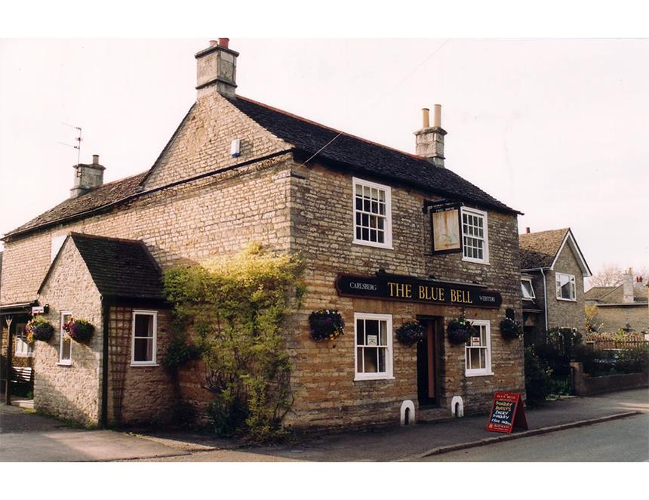

A community group in Helpston, near Peterborough, is the first to receive a capital grant in a programme being run by Plunkett UK in partnership with Cambridgeshire and Peterborough Combined Authority. The Bluebell Inn Community Hub Association has been awarded £45,000 to support its efforts to save the much-loved pub – the last in the village – and help it meet residents’ needs. The pub campaigners approached Plunkett UK in January for advice on taking the Bluebell into community ownership. Since then, the charity has offered Helpston business support on legal structures, business planning and fundraising, as well as providing cash to help with valuing the property and legal fees. Plunkett says evaluating its More Than A Pub programme has shown the average success rate for all pub enquiries is one in 10 but, when a group has received a small-scale grant and adviser support, this increases to one in three. Bluebell Inn Community Hub Association’s steering group member Tony Henthorn said: “When the last pub in the village was put up for sale, locals were galvanised and started looking into the possibility of buying the Bluebell Inn as a community asset. “The first port of call was a conversation with Plunkett UK and very quickly an action plan was created. Plunkett have become the eighth member of our pub steering group. “We successfully applied for a development grant which enabled us to undertake a professional valuation, conduct a building survey, pay for village consultation venues and create a campaign website. “We then successfully applied for further capital funding which will provide £45,000 towards the cost of purchasing the pub, should the association be successful in its application to the government’s Community Ownership Fund. “The team at Plunkett has been an incredible resource and their engagement with the combined authority has enabled us to feel confident that we can achieve a successful outcome for our village.” Plunkett UK project manager Susie Middleton said: “We would love to hear from any community groups in Cambridgeshire and Peterborough’s market towns and villages which are looking to save an asset that is closed, or which is at risk of closure, or are looking to restore lost services through community ownership.” Business support development grants of up to £5,000 and capital grants of up to £45,000 are available through Plunkett until March 2025.

