Multiple pub sales spark fears

03/06/2024 by Timothy Hampson

Pub

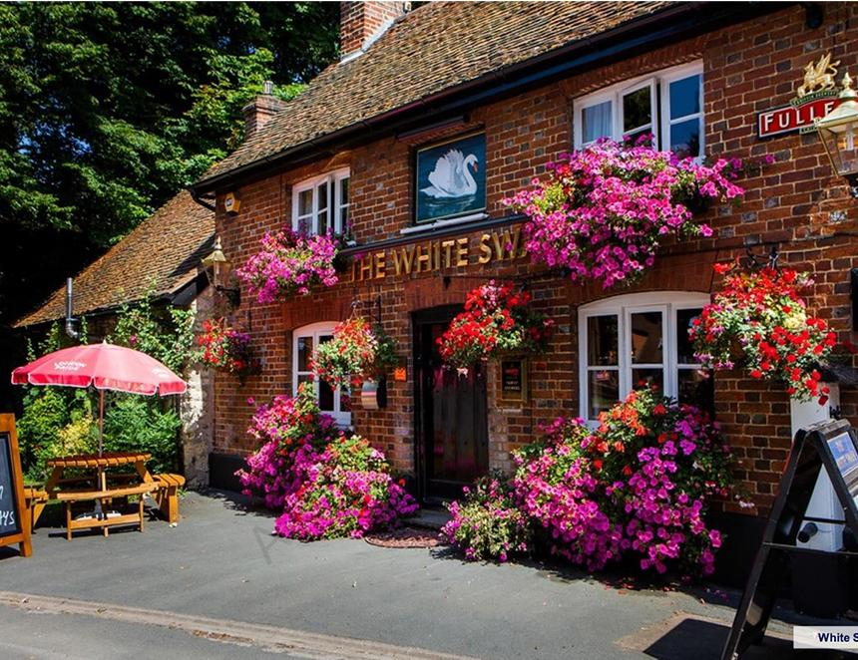

The churn of pubs continues with the sale of two tranches by national companies raising fears for consumer choice and the future of some tenancies. Fuller, Smith & Turner has agreed to sell 37 pubs in London and the South-East of England from its Tenanted Inns Division for £18.3m to Admiral Taverns. The 179-year-old business said the sale would help boost its balance sheet and provide funds for future acquisitions. The portfolio of London pubs generated a £1.3m profit before tax for the 52 weeks to 30 March 2024. Fuller’s said: “It is anticipated that the disposal will complete on 25 June 2024. Following completion, Fuller’s will have 154 pubs within its Tenanted Inns Division to complement the 179 properties in its managed pubs and hotels division.” It comes as the company reported strong trading in the 42 weeks to January, with like-for-like sales growth of 11.5 per cent. Admiral Taverns boss Chris Jowsey said: “Despite the complexities of the macro-economic environment, across our estate we are seeing community pubs, and specifically wet-led establishments, maintaining their popularity among locals as people continue to enjoy going out for an affordable treat with family and friends. “Wet-led, community pubs have demonstrated real resilience over recent times, and we remain optimistic that our nurturing ethos, entrepreneurial licensees and high-quality estate continues to position the group well to be at the forefront of opportunities in our wider market.” Admiral, backed by Proprium Capital Partners, has more than 1,400 pubs in Britain, including 300 in the South-East. Proprium partner Philipp Westermann said: “Since Proprium Capital Partners acquired Admiral in 2017, we have acquired over 1,000 pubs across the UK through several transactions, successfully investing into and profitably growing Admiral’s award-winning high-quality estate of individual wet-led community pubs. “We remain excited by the sustainable long-term opportunities for Admiral and look forward to continuing to support its successful growth.” Equity-owned Pubco Red Oak has bought 19 tied tenanted pubs from Marston’s, marking the third transaction between the two companies in the last 15 months. With this latest acquisition, Red Oak’s portfolio has now grown to 246 pubs, including 26 from Marston’s. Red Oak co-founder Mark Grunnell said: “We are delighted to have completed the purchase of these high-quality pubs in a third successful deal with Marston’s. The ability to deliver, especially in times where the cost of capital is high, is crucial between any seller and buyer, and we have built a strong relationship with the Marston’s team.” Grunnell said Red Oak is well-capitalised and continues to actively seek further opportunities to expand its presence in the market through both portfolio and single-site acquisitions. Pictured: sold – White Swan, Whitchurch