Progress to beer gender equality stalls

30/05/2024 by Timothy Hampson

Industry

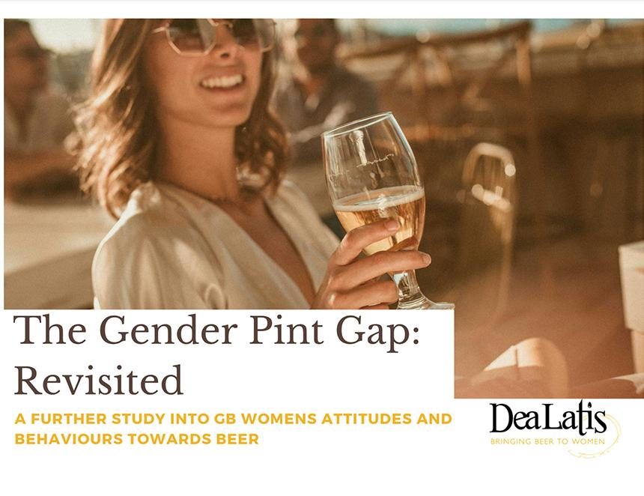

New research has shown fewer women think beer is for them compared to five years ago. The Gender Pint Gap: Revisited by UK women in beer campaigning organisation, Dea Latis, with The Drinks Business explores the results from a newly commissioned YouGov survey. Back in 2018 Dea Latis published the groundbreaking Gender Pint Gap report, which explored why the UK had the lowest percentage of female beer drinkers in the world. The latest findings show:– only 14 per cent of women drink beer weekly (compared to 50 per cent of men), a three per cent drop since 2018– beer advertising remains a key barrier for women– 70 per cent of women perceive beer as highly calorific with negative health implications– the way beer is presented and served is problematic for many women– women’s attitudes towards beer have remained largely unchanged since 2018, except in London where traditional views are being challenged– women are underrepresented in managerial and brewing roles: only three per cent of brewers are female, and less than a quarter of brewery management positions are held by women. Dea Latis co-founder and report author Annabel Smith said: “The report includes insights into women’s attitudes and opinions about the beer category, reflections on the data, and importantly, it also identifies numerous opportunities for brand owners and retailers. “The beer sector remains a traditionally male preserve in Britain, and the dial doesn’t appear to have moved very much since the last piece of research conducted by Dea Latis in 2018. “The report addresses some of the reasons behind this and concludes with a 10-point Dea Latis manifesto, offering practical steps to overcome the barriers and challenges faced by women who are disengaged and disenfranchised by the beer category. “The Gender Pint Gap: Revisited is a crucial piece of research which identifies ways in which the beer industry can truly move towards beer becoming a gender-neutral drink, benefiting the economy and creating a diverse, inclusive sector enjoyed by all.” The report, which is supported by a grant from the Brewing Research and Education Fund, is available at https://dealatisuk.wordpress.com/2024/05/23/thegenderpintgaprevisited/