Plan your June festival trips now!

29/05/2024 by Matthew Rogers

Campaign

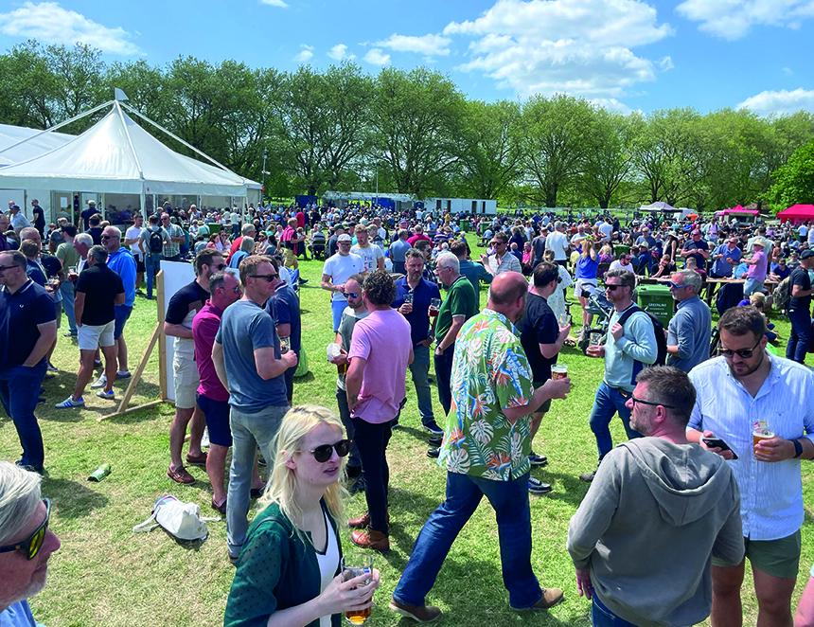

Plan your next festival trip by viewing the list below. To see all upcoming CAMRA events, visit https://events.camra.org.uk/   37th Colchester Real Ale and Cider Festival 2024, 29 May-1 June Colchester Arts Centre, Church Street, Colchester, CO1 1NF https://colchesterbeerfestivals.co.uk/   Thurrock Beer and Cider Festival, 4-8 June Thurrock Civic Hall, Grays, RM16 2JU https://www.facebook.com/CAMRAThurrock   19th Braintree Real Ale Festival, 6-8 June Bocking Arts Theatre, Bocking End, Braintree, CM7 9AE https://braintreebeerfestival.co.uk/   Glasgow Real Ale Festival (G-RAF 2024), 6-8 June 141 Bridgegate, Glasgow, G1 5HZ https://g-raf.camra.org.uk/   Hitchin Beer and Cider Festival, 6-8 June Hitchin Rugby Club, Old Hale Way, Hitchin, SG5 1XL https://hitchinbeerciderfestival.org.uk/   Winchester Beer and Cider Festival, 7-8 June University of Winchester Student Union, Sparkford Road, Winchester, SO22 4NR https://winchesterbeerfestival.camra.org.uk/2024/entertainment/   Abbots Bromley Beer and Music Festival, 8 June Abbots Bromley Sports Association, Mill Green, Off Lichfield Road, Abbots Bromley, WS15 3DR https://www.absasport.co.uk/absa-fest   26th South Downs Beer and Cider Festival, 14-15 June Corn Exchange, Lewes Town Hall, Fisher Street, Lewes, BN7 2QS https://brighton.camra.org.uk/viewnode.php?id=218535   KESR Railway Real Ale and Cider Festival, 14-15 June Tenterden Town Station, Station Road, Tenterden, TN30 6HE https://afrm.camra.org.uk/viewnode.php?id=189552   36th Stockport Beer Festival, 20-22 June Stockport Guildhall, 169-171 Wellington Road South, Stockport, SK1 3UA https://www.stockportfestival.org.uk/   Shakespeare CAMRA 16th Beer and Cider Festival, 21-22 June Stratford Racecourse, Luddington Road, Stratford Upon Avon, CV37 9SE https://www.stratfordbeerfestival.org.uk/   Salisbury Summerfest Beer Festival, 21-22 June The Guildhall, Market Place, Salisbury, SP1 1JH https://salisburycamra.org.uk/event/summerfest-2024-friday/   11th Rutland CAMRA Beer Festival, 21-23 June County Museum, Catmos Street, Oakham, LE15 6HW https://rutland.camra.org.uk/   Canterbury CAMRA Cricket Tent, 23-26 June Spitfire Ground, Old Dover Road, Canterbury, CT1 3NZ https://kent.camra.org.uk/viewnode.php?id=218359   Bromsgrove Beer and Cider Festival, 27-29 June Bromsgrove Rugby Club, Finstall Road, Aston Fields, Bromsgrove, B60 3DH https://bromsgrovebeerfestival.org.uk/