Norfolk brewer turns author

25/05/2024 by Timothy Hampson

Industry

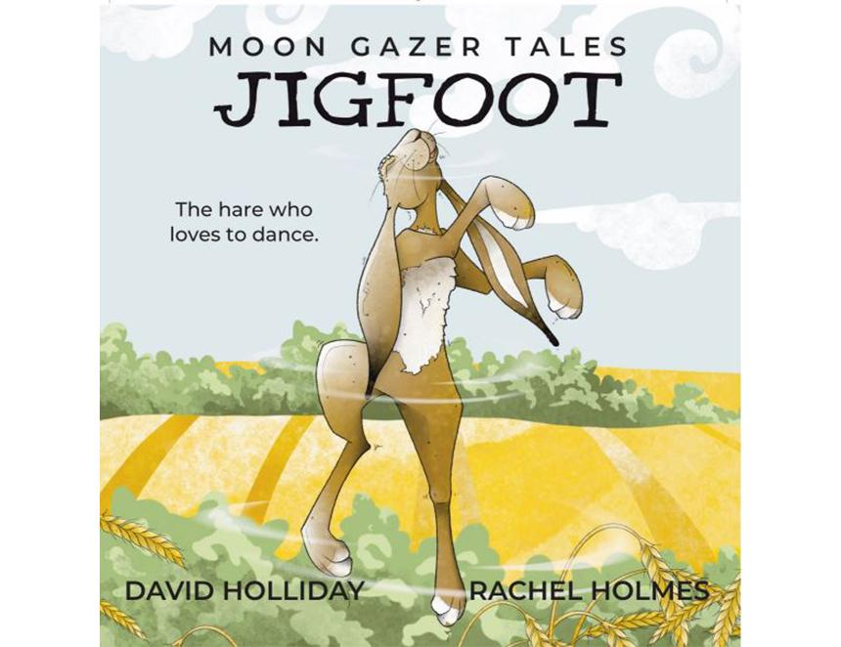

David Holliday, who co-owns Moon Gazer Ales, in Hindringham, has added writing to his brewing skills as he launches an illustrated book which celebrates hares and the wildlife of north Norfolk. The brewery is known for its beers who are all named after hares. Jigfoot, Pintail and Nibbler all reflect local hare names dating back centuries. Now Holliday has brought the hares to life, working alongside Norfolk illustrator Rachel Holmes to create the first in a series of books – starting with Jigfoot The Hare Who Loves to Dance. Holliday said: “Hares have always had a special place in our hearts at Moon Gazer and its long been an ambition to try and bring them to life, and to give them all a distinctive character.” “However, I also wanted to use the characters to explore the countryside in which they live – the beautiful county of Norfolk. It was during lockdown when I couldn’t brew that I started jotting down ideas and words.” Holmes said: “When I read David’s writing I was transported into their world, so I couldn’t help myself – I could envisage the characters David had created and the personalities he wanted for them, be it the dancing Jigfoot or the mischievous Pintail or the wise old Bouchart. So, I started to draw them, and they came alive in front of me.” “My suggestion of the book was a bit tongue in cheek, but it felt so right, and I was thrilled when David got straight back to me and said yes.” The pair have spent the best part of two years creating the first book, fitting it in alongside their existing jobs. As an illustrated book it will appeal to children, but they are also keen to stress it is for children of all ages from seven to 70. The book also includes poetry from local poet Lewis Buxton. Although having never published before, the pair secured the help of the Self-Publishing Partnership and Brown Dog Books which helped turn their dreams to print. The book is available now at www.moongazertales.co.uk and also via Amazon, Waterstones and other bookstores.