More than two thirds of UK beer is served short

24/05/2024 by WB Reporter

Industry

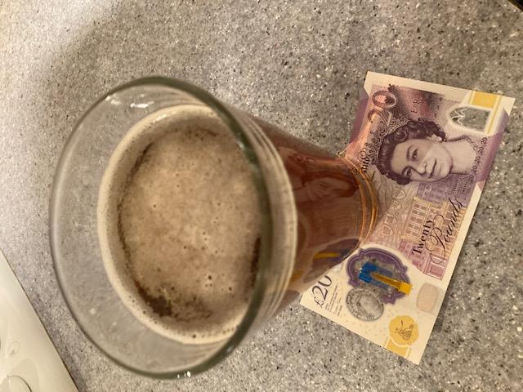

New research published today by the Chartered Trading Standards Institute (CTSI) has found 70 per cent of beer and wine is short measured. The national fieldwork was undertaken by Local Authorities Trading Standards professionals across the UK. The findings come at a time when the price of alcoholic drinks is at an all-time high. According to the Office of National Statistics (ONS), the average price of a bottle of red wine has increased eight per cent in the last year, while the average cost of a pint of lager is up 5.6 per cent. The CTSI’s findings show there is more work to be done in ensuring customers get what they pay for when they order a pint, or a glass of wine, in British pubs, bars, and other establishments. The fieldwork and new public polling found: 96 short measures out of 137 test purchases, approximately 70 per cent out of the short measures, 41 were five per cent or more short – 29 per cent of the drinks tested when broken down between beer and wine, 86 per cent of beer was short compared to 43 per cent of wine the average deficit for short-measured beer was four per cent, while for wine it was five. For the average beer drinker, this equates to a loss of £1.70 a week, or £88.40 a year. For the wine drinker in the UK, this jumps to £2.20 per week and £114.40 per year the largest short measure was a deficit of 15 per cent found on a £3.20 175ml glass of wine in Walsall the next largest short measures were a deficit of 13.4 per cent found in Belfast, on a glass of wine costing £7.20, and the third largest was 12 per cent on a £5.75 175ml glass of wine in Havering new public polling from CTSI also found a generational divide with three times as many people aged under 45 supporting bars and pubs being able to pour spirits without a spirit measure, compared to those more than 45 years old. A short measure means the beer or wine the customer receives is less than the prescribed quantity required by the Weights and Measures (Intoxicating Liquor) Order 1988. These quantities vary depending on the drink served but include pints and half pints for beer plus 175ml glasses for wine. There has been an ongoing discussion around whether a pint of beer should include the head or not. Legally, the head is included, however CTSI’s new public polling found more than a third of the 2,000 people (35 per cent) polled felt the head should not be in the pint measure – higher than the quarter (23 per cent) who believed the head should be included. CAMRA maintains the pint measure should not include the head, and consumers should have a right to a 100 per cent liquid pint. CTSI chief executive John Herriman said: “While this is a snapshot, it is the first time we have been able to build a national picture of how widespread short measuring of alcoholic drinks is, and the potential detriment to the average consumer of around £115 every year suggests there is the need for more comprehensive research to better understand the impact of short measures, not just for alcoholic drinks but across a broader spectrum of consumer goods. Weights and measures is a key role for Local Authority Trading Standards, but right now we simply don’t have the resources to allocate, and even the equipment to use, to undertake spot checks that ensure consumers are getting what they pay for. “We are calling on the hospitality sector to ensure consumers get value for money by making sure they are correctly measuring the drinks they are serving to customers in the nation’s pubs and bars and for further research in this area.” CAMRA national chairman Nik Antona said: “Consumers shouldn’t have to feel short changed when they support their favourite pubs, social clubs, and taprooms. The idea that 70 per cent of all beer bought at the bar is being short measured in the UK is extremely concerning.  “CAMRA wants the government to make sure pub-goers have a legal right to receive a 100 per cent liquid pint every time they are being served. This latest study is another worrying indication of an issue that has been affecting consumers for a number of years now and should hopefully provide a catalyst for change.  “For anything that is short measured, and particularly anything more than five per cent short, you should ask the bar staff for an immediate top-up. You are well within your rights to do this, and the staff should comply and fulfil this request.  “If you get a negative reaction when you do this, you can get in contact with Trading Standards to report the incident.” In just the first week of the 2023 Christmas period, 35.9m pints were sold in the UK, and if the CTSI findings are replicated across the UK, this would amount to £6.8m loss to consumers. In 2021, the British Beer and Pub Association reported that on-trade sales of beer alone brought in £5.7bn, equivalent at the time to 1.4bn pints per year or 26m a week. At today’s prices, this means a huge £264m potential loss to consumers a year. This beer and wine research is part of a broader research report CTSI is publishing later in the year which highlight the importance of Weights and Measures for UK consumers, economy, and wider society.