Hogs’ hops’ holy help

18/05/2024 by Timothy Hampson

Industry

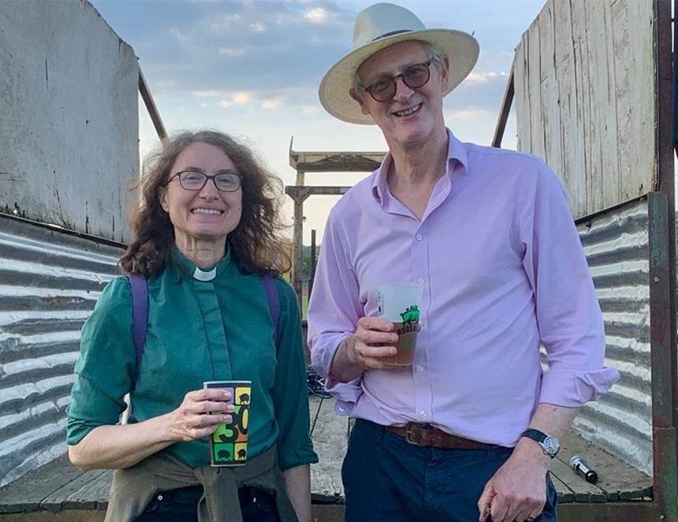

Hogs Back brewery MD Rupert Thompson had his hops blessed in an effort to improve the harvest as growers face a challenging time with a wet spring potentially leading to a smaller crop. The blessing took place on Ascension Day, the day when crop blessings have been traditionally held. Rev Claire Holt, of St Paul’s Church in Tongham, did the honours before Thompson led guests on a walk around the 8.5-acre hop garden. Hogs Back revived the tradition in 2014 when it planted its original hop garden over the road from the brewery and continued it when it relocated to the current larger site.  Currently, the 6,000 hop plants in the Hogs Back garden are climbing strings, spurred by the recent rainfall, and the brewery is hoping for a decent crop to harvest in late August. Holt said: “Blessing the Hogs Back hop garden continues a tradition that would certainly have been part of the cycle of hop growing in Farnham for centuries. It gave me great joy to lead the prayers for the Hogs Back hop garden, the brewery, and all who work in it, for this year and long into the future.” Thompson said: “The hop blessing is always a wonderful event, bringing together the local community to remember how important hop farming was to this region. We’re grateful, as ever, to Claire for blessing our hops and delighted to see so many people enjoying the ‘beating the bounds’ walk and a pint or two back at the brewery. “Clearly most people today don’t need to know where their parish boundaries lie, but centuries on from that, there is still a desire to connect with the local community and a large part of what we’re doing at Hogs Back is about building those connections, which is shown by the many local residents who volunteer to ‘twiddle’ our hop plants up the strings now, or to bring in the harvest later in the year. “We’re enormously grateful to this army of Hogs Back Hoppers, and also to Matthew King, our garden manager, for his skill and dedication in tending to the hops.” Three varieties are being grown: Fuggles – used in the brewer’s flagship Tongham TEA; English Cascade – used in its Hogstar lager; and Farnham White Bine – a local variety that Hogs Back revived from near-extinction. Pictured: Rev Claire Holt with Rupert Thompson