Union set on the move

09/05/2024 by Timothy Hampson

Industry

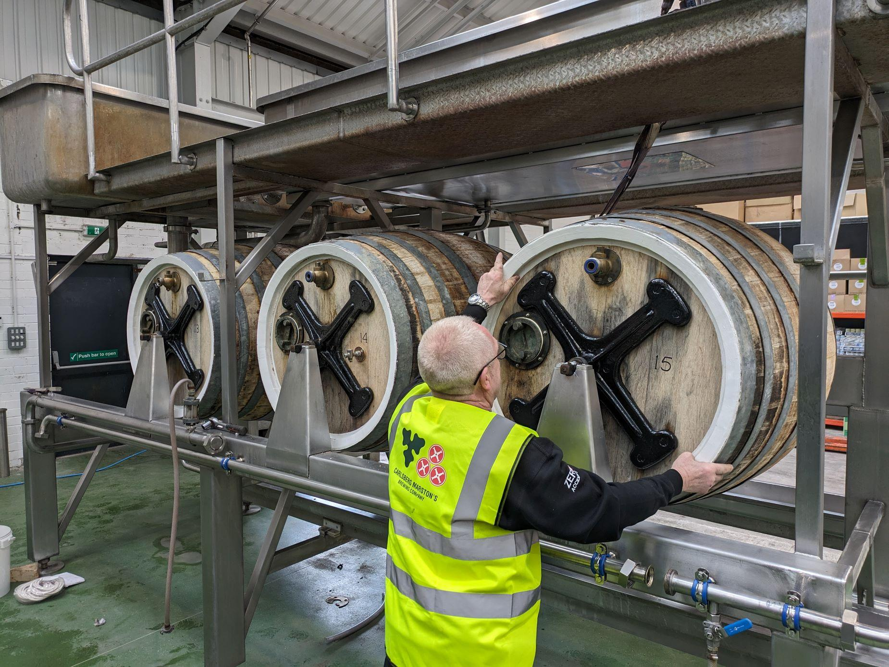

Part of Carlsberg’s (CBMC) Burton union is to be relocated from Burton-upon-Trent to the Thornbridge brewery. The two breweries have partnered on a special project to establish a union system in Bakewell, using redundant sets from Marston’s brewery. Discussions between CMBC and Thornbridge began in February. CMBC gifted the set of union barrels to Thornbridge and has also provided guidance and advice on maintenance and set-up for the system being developed at Thornbridge, which is set to be completed in May. The sets will be used for brewing special-edition cask beers using this historic method first created in Burton in the 19th century to collect excess yeast. CMBC head of brewing Emma Gilleland said: “This collaboration is a perfect showcase for the ways brewers can come together to deliver something special, for the love of beer and Britain’s incredible brewing heritage. “We’ve been proud to support Thornbridge through the process by sharing our time and expertise to help set up its own Union system, and we are confident it will be a fantastic custodian for our union sets.” Thornbridge head brewer Rob Lovatt said: “This project is a dream come true for Thornbridge, and we’re grateful to CMBC for their generosity in giving these union sets to us to brew with going forwards. “While there are challenges yet to get the system up and running, we’re thrilled to have the opportunity to preserve these beautiful icons of British brewing. “Every process, detail and recipe change in a union system has an effect on the beer’s flavour, and I’m excited to see what we can create with the new system here in Bakewell.” Marston’s cooper Mark Newton said: “It’s been a huge privilege to have spent so many years caring for and maintaining these historic sets at Marston’s, and I’m so pleased to have been part of the CMBC team working with Thornbridge to help it prepare for setting up its own union system. “It’s heartening to know that, alongside the set we are preserving at our brewery, our union sets will have a new home with the brilliant brewers at Thornbridge.” CMBC has invested in the preservation of the remaining union sets at Marston’s, which will be on display to celebrate the brewery’s heritage and the system’s remarkable history. It is expected that the preservation work will be completed by the end of May and is being overseen by CMBC’s cooper before he retires.