The slaughtered orchard
08/05/2024 by Laura Hadland
Opinion

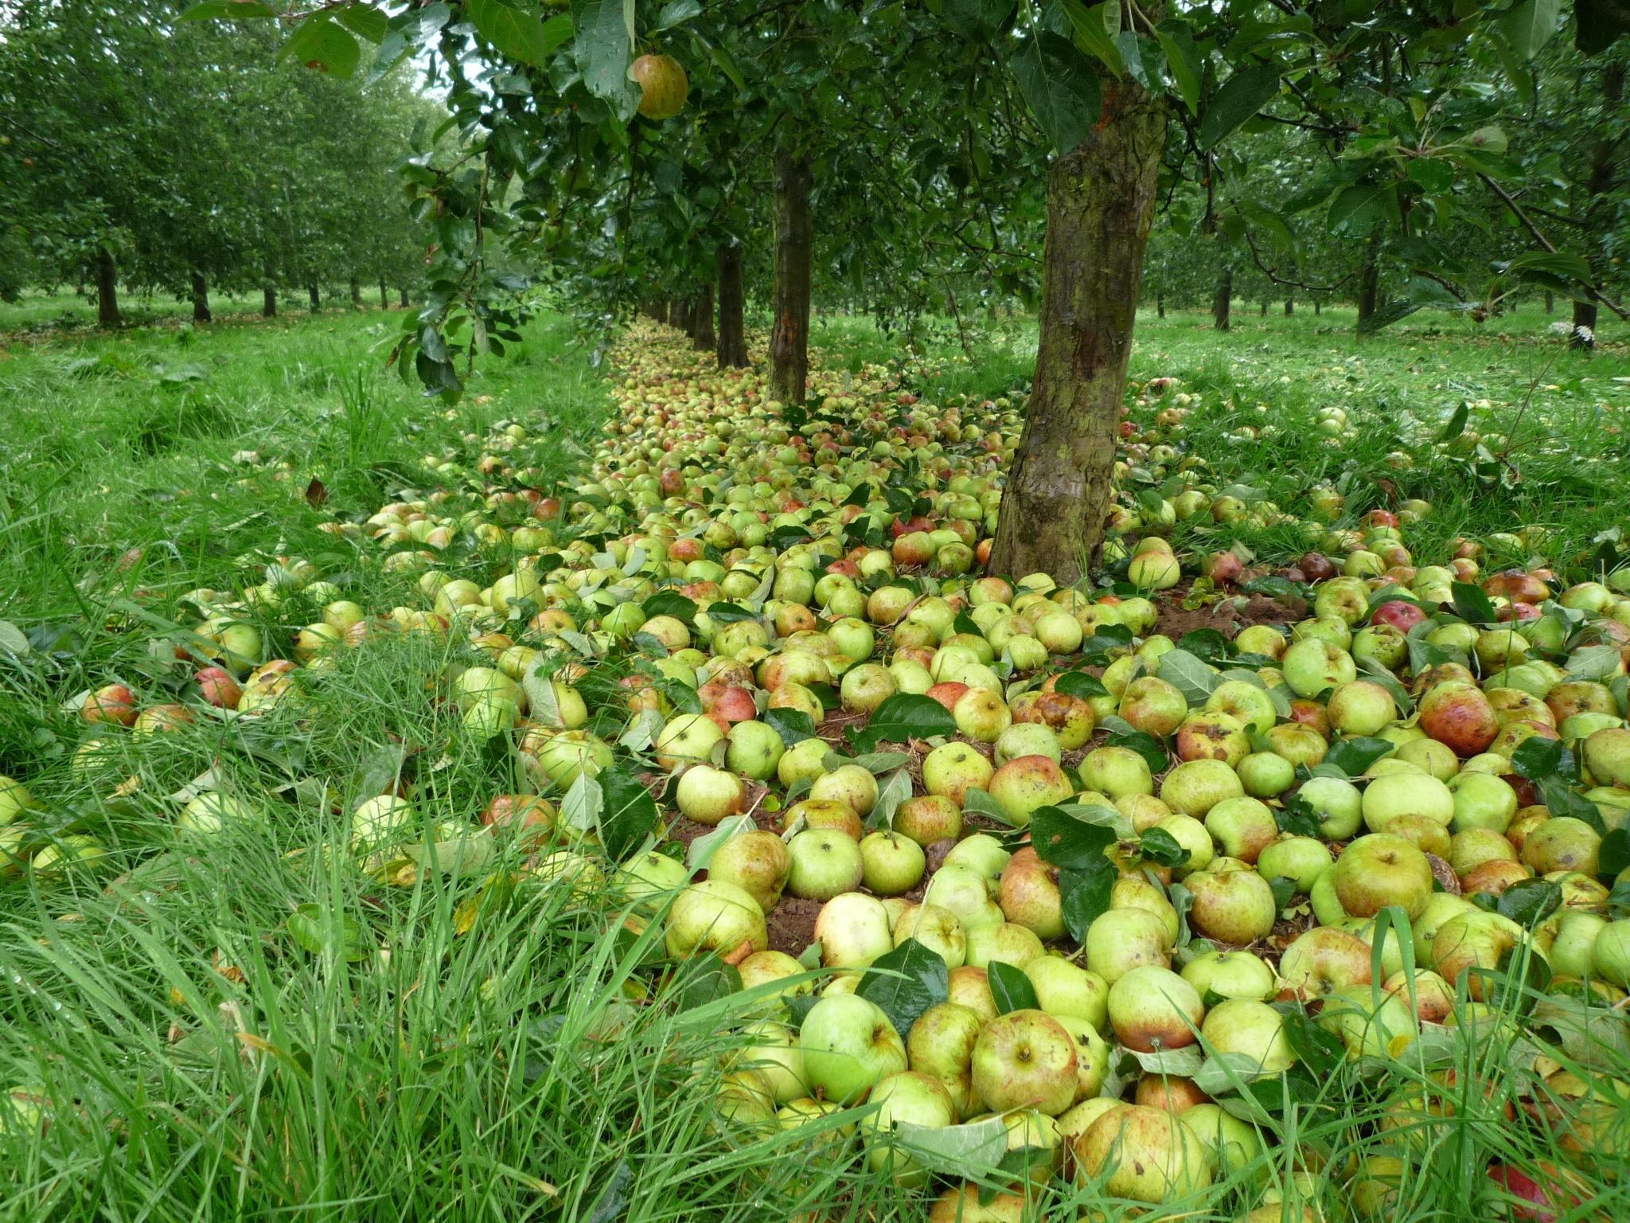

It’s Cider & Perry Month. Let’s talk about Heineken grubbing up 300 acres of cider apple trees in Llantilio Crossenny, near Abergavenny. It’s taken longer than I expected to unpick the story. I’ve chatted with local residents. I had a word with a few craft cider producers. Obviously, I’ve picked Ciderologist Gabe Cook’s brain. I’ve even tried to get hold of employees of Heineken and Bulmers, but they don’t return my messages. We can all agree that chopping down tens of thousands of trees is not good for biodiversity. It’s not pleasant to think about that scale of environmental destruction. But what has confused me is that it seems like the fruits of this particular labour were rarely, if ever, used. HP Bulmer planted the trees as part of a £15m investment into Penrhos Farm in 1997. But by the time the trees were due to give their first full harvest in 2003, Bulmer was experiencing difficulties. Scottish & Newcastle bought the company and then Heineken acquired S&N in 2008. Local resident Les Taylor sent me a photo (above) he took in October 2009. It shows the orchard floor piled high with windfall apples. “At this point, the apples were not being used,” Les told me. “I am not sure if they were ever used.” Another source on the ground thought Heineken prioritised apples from its contract growers elsewhere. This orchard was harvested late or not at all. There was even a whisper – unsubstantiated and anecdotal – that at least once, the blossoms were sprayed off the trees to prevent fruit set. It seems unhinged that the country’s biggest cider manufacturer didn’t use the fruit from its own orchard. Of all the products in the Heineken portfolio, bittersweet apples would be useful for making Bulmers. And, conveniently, five years after the trees reached maturity, the Magner’s Effect hit. Sales of Bulmers went up with the rising tide. The photo of abandoned apples dates to when demand could never have been higher. I have no evidence of how many apples from this orchard were ever used by Heineken. But why did HP Bulmer bother to plant at all? It made this huge investment years before the “cider over ice” marketing craze happened. Press reports from the time talk proudly about the great investment in planting new trees. It makes the whole exercise feel like greenwashing. I mean, it did plant lots of healthy trees that lived for more than 25 years. It’s an improvement on some ruthless corporations I won’t mention. But if the apples weren’t used, isn’t it just posturing to tick the corporate sustainability box? Interestingly, there were local grumbles when the orchard was first proposed. “It’s a superb piece of land,” one Monmouthshire resident said. “Some of the farming community were sad a super arable farm was being taken out of production. The general public worried about traffic and how much they would be spraying. But they were just voicing concerns, there was no concerted opposition.” Farmers in the area accept that Heineken is a commercial operation. They understand it has every right to change its farming policy. The biggest disappointment is that people can't walk their dogs through the orchard anymore. Perhaps they’re right. Heineken is a multinational corporation, accountable only to its shareholders. It doesn’t have the same concern for the land and the expression of the fruit as craft cidermakers. The great tanker of big business won’t be turned by our appeals. This orchard wasn’t rich with heritage. It was less than a generation old and it was an asset. This isn’t the first change. In 2017, Heineken felled 50 acres of trees to let out the land for arable cropping. Nobody seemed to notice. It replaced some varieties with juicy, mild Katy apples. Mainstream tastes have moved to favour medium sweet, low tannin and flavoured cider products. Traditional cider apple varieties are increasingly redundant in the Heineken portfolio. What alternative was there to grubbing up the trees? The 300 acres will likely be sold for arable. We could hope Heineken champions higher juice products. That would use more apples. But it won’t because it’s not good for the bottom line. No aspirational cidermaker, irrespective of ambition, could take on even part of an orchard of that scale. Little Pomona in Bromyard has 4.5 acres, which covers about 10 per cent of its fruit needs. It sources the rest from 10 trusted growers. Ty Gwyn Cider on the Welsh-English border is the nearest craft producer to Penrhos. It is also a good size, using fruit from 30 acres. By bringing in apples from third parties, Ty Gwyn protects cider varieties that are no longer in vogue for global corporations. Ty Gwyn’s Alex Culpin told me many of his suppliers are former Heineken contractors. Without him, they would have no reason to maintain their trees. Susanna Forbes of Little Pomona said: “By cherishing the fruit, we create demand for ciders and perries, and orchardists have a reason to not just sustain their orchards but also to plant new trees.” These are the cidermakers that matter. They are the ones who care passionately about flavour, tradition and joy. Without wishing to insult anyone, the key aim of global brands is to make as much profit as possible. They market cider-adjacent liquids that don't contain enough flavour to put anyone off. They don’t deserve to be in the same category as Ty Gwyn and Little Pomona. They aren’t playing the same game. If we want to save cider apple trees, consumer tastes need revolutionising. The new trend must be higher juice content, discernible varietal characteristics and complexity. We need Strongbow drinkers to want those things. This is all depressing stuff, but we can make a change. We can campaign for higher juice ciders in more visible positions. Ask for them in pubs, bottle shops and restaurants. Buy them and enjoy them. In 12 months, bees will buzz happily across newly planted fields in rural Monmouthshire. All will be well with the world, the apple trees forgotten. Heineken will have done no more and no less to promote our great British cider traditions than it ever did. Photo: Les Taylor

