Celebrate cider and perry with CAMRA

06/05/2024 by Timothy Hampson

Campaign

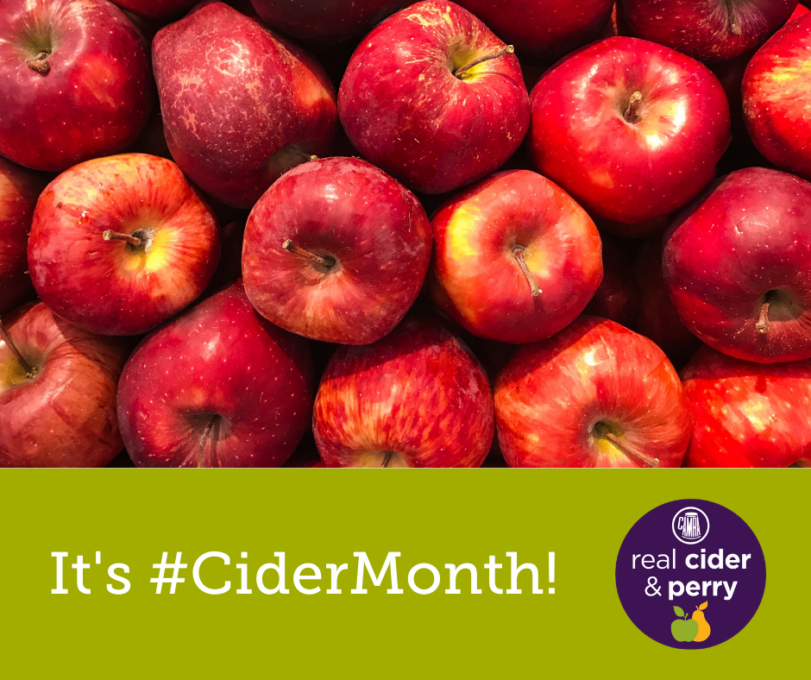

Each May and October CAMRA celebrates cider and perry to coincide with the production cycle of apples and pears. This May’s Cider and Perry Month begins in the wake of the sobering news of Heineken’s decision to cut down almost 300 acres of orchards. Heineken – which manufactures products including Bulmers, Strongbow and Inch’s – has felled the trees ahead of its planned sale of the Monmouthshire land. Heineken’s actions mean cider apple trees that occupied the space of 140 football pitches and had been productive for decades have now been lost forever, causing a massive impact on local communities and the environment. CAMRA’s real ale, cider and perry campaigns director, Gillian Hough, said: “This is an act of needless environmental vandalism by Heineken, and it is simply shocking. “Orchards provide a unique habitat for wildlife, including species that can only make their homes in trees of this kind. The beginning of May usually marks the blossoming of orchards across the country and birds are nesting. To see images of these trees uprooted, lying in piles like toothpicks is very upsetting. “Given Heineken’s recent Brew a Better World sustainability campaign, and its many claims in the media about its wide-ranging environmental commitments, tearing out this orchard feels especially cynical. If it was sincere about these claims, it would be investing in orchards, and in producing high-quality, high-juice content ciders, not wreaking destruction.” To offset the news, CAMRA has a month of celebration planned. This kicks off with the publication of Adam Wells’ groundbreaking new title Perry: A Drinker’s Guide which tells the full story of the drink for the first time. Funded by a hugely successful Kickstarter campaign, the guide charts the drink’s remarkable history and walks the reader through perry’s three great heartlands in the UK, Normandy and Austria’s Mostviertel. The release of the book will be accompanied by online content for CAMRA’s Learn & Discover platform. More information about CAMRA’s Cider and Perry Month can be found here: https://camra.org.uk/what-we-do/cider-and-perry-months/ Order your copy of Perry: A Drinker’s Guide by Adam Wells here: https://shop1.camra.org.uk/product/perry-a-drinkers-guide/