Beer writer takes top campaigner crown

03/05/2024 by Timothy Hampson

Campaign

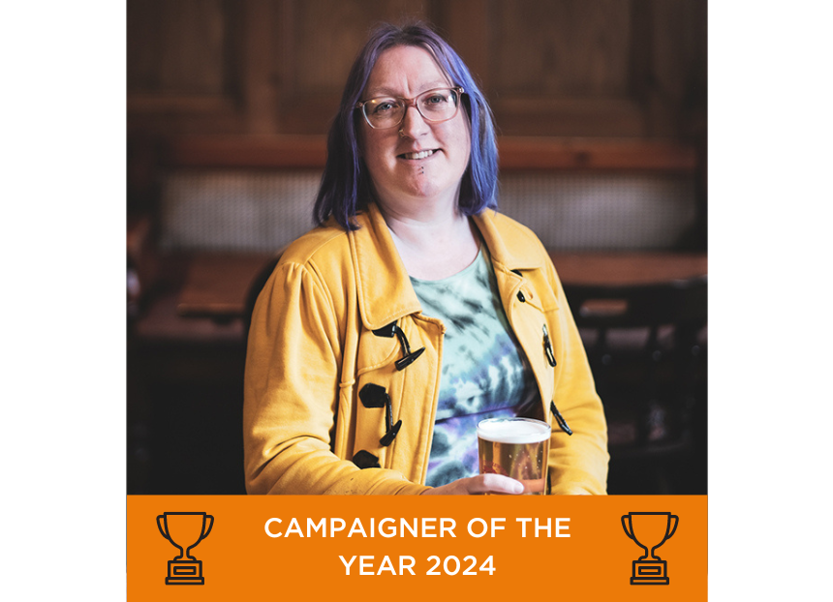

Drinks writer Laura Hadland was crowned CAMRA’s top campaigner at its Members’ Weekend, AGM and Conference in Dundee. Her nomination included a long list of achievements this year, particularly her commitment to inclusiveness, responsible drinking and her work championing small producers and venues. Laura was a key voice in calling national attention to the destruction of the Crooked House through her blog, interviews about pub protection for radio stations across the country, and on social media. The Crooked House case began in August of last year, when the famously wonky 260-year-old pub near Himley in the West Midlands was heavily damaged in a fire and then abruptly bulldozed without authorisation by its new owner. Through Laura’s campaigning, more people were made aware of this scandal and in February the owner was ordered to rebuild the pub. Her nomination also praised her award-winning book, 50 years of CAMRA, where members’ stories and memories of the Campaign were recorded. The nominator highlighted that this research preserved oral histories which would otherwise have been lost. The award also recognised her championing of cask beer, introducing it to new audiences through her advocacy, and by hosting beer tastings including the first dedicated cask tasting at Ludlow Slow Food Festival last summer. She is also a beer judge for national and international competitions, including the Champion Beer of Britain, SIBA and Great Taste awards.    CAMRA campaigning awards director Laura Emson said: “Laura was the clear winner, even with all the other fantastic nominations this year. Her campaigning has been a fantastic help in raising awareness for the Crooked House scandal as well as consistently putting her voice out there via local radio stations to help protect our pubs. “It’s a pleasure to formally recognise her hard work and dedication to making sure that pubs are protected in this most challenging of times for the industry. “This Campaigner of the Year Award is a testament to the positive impact that Laura has had on the industry, and I look forward to seeing her work in the years to come.”   Accepting the award, Laura Hadland said: “Just got to say a huge thank you for bestowing this amazing honour on me. It’s just wonderful how I’ve been welcomed into the CAMRA community. “Back in 2019, when I first got the commission to write 50 Years of CAMRA, I never expected that my involvement with the organisation would really become so all consuming, but it’s just a huge part of my life now. I think because the CAMRA ethos, the support for cask ale, for pubs and for independent brewers is really something that’s a huge focus for me as well. “It is fantastic to be a part of writing regularly for What’s Brewing and BEER, but also, despite all the research that I did, no one really warned me to not make eye contact with my branch chair when they were looking for volunteers. So now I am on the ground as well, helping out with my branch, volunteering nationally, doing things like the Learn & Discover bar at GBBF (Great British Beer Festival), which I will be sad to miss at this year’s festival. “I hope that we can all keep spreading the good word about cask ale. I have been doing lots of talks, tastings, pub tours here in Shropshire, at food festivals all around Shrewsbury, making sure that people know that cask ale is something fantastic, delicious and special. “I am trying really hard to help keep pub heritage in the public eye. So, keeping a good check on what’s happening with the Crooked House for example, and also trying to big up that campaign to get the local pub interiors recorded by branches. “I think there is loads of great work we can all continue to do, and it’s really, really kind that you’ve recognised the work that I have been doing up until now. I hope that all of you within CAMRA keeps supporting diverse voices talking about great beer. Thank you!” Photo: Lily Waite