CAMRA urges minister to act over misleading Fresh Ale
29/04/2024 by Timothy Hampson
Campaign

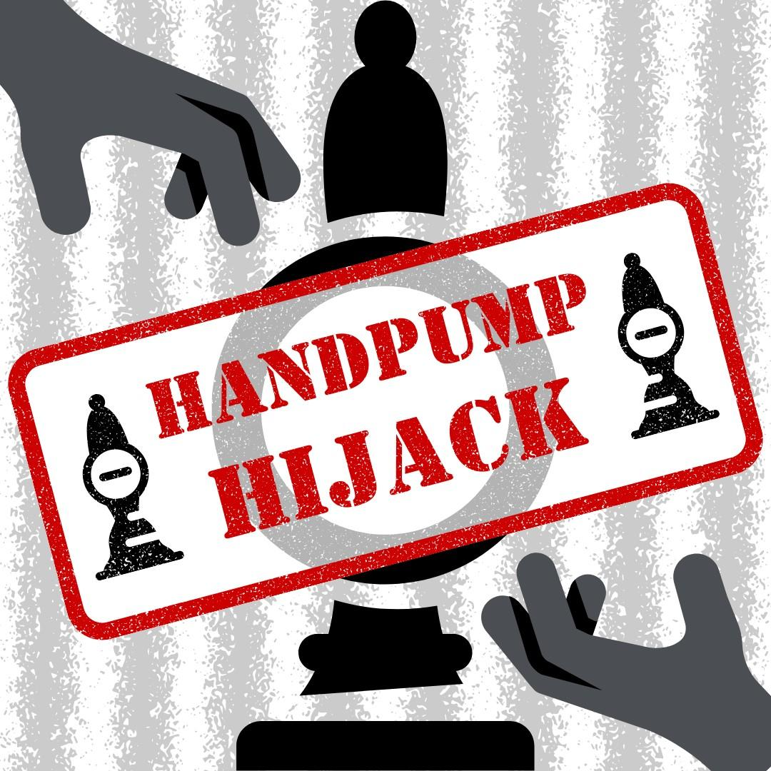

CAMRA has written to business secretary Kemi Badenoch urging her to step in to stop Carlsberg Marston’s Fresh Ale handpump hijack. In the letter, the Campaign explains that National Trading Standards has said it doesn’t have the powers to investigate the Fresh Ale concept launched by Carlsberg Marston’s Brewing Company, which involves serving filtered and kegged beer through handpumps usually used exclusively for cask-conditioned beer. This is despite its predecessor agency, the Local Authority Co-ordinating Body on Trading Standards (LACOTS), carrying out a similar investigation in the 1980s. The investigation by LACOTS found that using handpumps to dispense kegged beer was misleading to consumers and issued advice to all local Trading Standards officers. The Campaign has also submitted a formal complaint to West Northamptonshire Trading Standards, which is believed to have a primary authority agreement with Carlsberg Ltd, the global brewer forming just over half of the CMBC joint venture. In the letter to Badenoch, CAMRA’s real ale, cider and perry campaigns director Gillian Hough said: “The impact of this perniciously misleading form of dispense will affect the reputation and availability of cask-conditioned beer in all pubs and social clubs – an integral part of British heritage and pub culture. “It is a self-evident fact that consumers should be as fully informed as possible about the product they are buying at the point of dispense. CAMRA is deeply concerned because, for beer drinkers, the use of a handpump to dispense beer is an indication that the beer is cask-conditioned, which these products are not.” CAMRA national chairman Nik Antona said: “We are now asking the business secretary to step in and allow National Trading Standards to investigate Carlsberg Marston’s misleading Fresh Ale dispense method at a national level. “Of course, if Carlsberg Marston's was interested in being transparent, it could simply serve its Fresh Ales from keg fonts and be proud and clear about the characteristics of the beers.”

