New world for troubled Mondo

27/04/2024 by Timothy Hampson

Industry

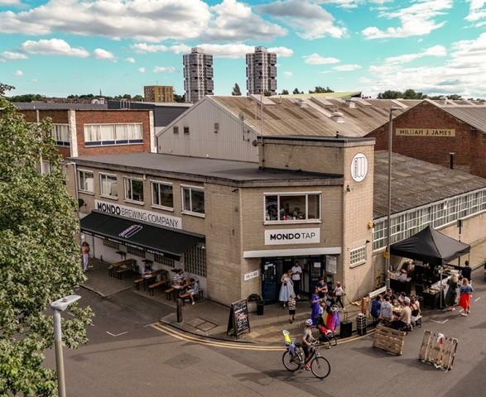

Brewing industry veteran Rupert Thompson has agreed an investment deal with Mondo, which secures the future of its brands, as well as its brewery and taproom in Battersea, London. Following a pre-pack administration, the deal will see brewing continue at Mondo's South London site (above). As well as delivering a fresh injection of capital for the Mondo brands including Dennis Hopp'r, Road Soda and Little Victories, the financing will allow investment to be made in the taproom, and in additional sales and marketing. Thompson, owner of TEA brewer Hogs Back, becomes chairman of a new company, Mondo Beer, working to support the management team led by founder and MD Todd Matteson. Under the agreement, Hogs Back will support Mondo as a sister business in areas such as packaging, sales and marketing, while Mondo will be the exclusive distributor in London of beers from Hogs Back new subsidiary One Planet Brewing, launched last year and brewing with 100 per cent solar power. Thompson said: “I’ve known and respected the founders of Mondo, Todd and Tom, for several years. We’ve sold their beers in our brewery shop, and we brewed a collaboration beer in 2022. “It is a challenging market, but despite that Mondo has been growing. The beers and branding are excellent, and I think it has a bright future. Customers want to see imaginative independent and local brands that are not owned by global brewers.” Matteson said: “We found ourselves in a situation where there is strong demand for our beers, but we were hit by all the challenges that have beset so many small brewers. “So, it’s wonderful that Rupert has been able to help, and this allows us to move forward. His experience of developing successful beer brands will be invaluable and we’re delighted to have him working with us at Mondo Beer, and to have the back up of Hogs Back brewery. “We are also excited to have exclusivity for One Planet beers in London. The 100 per cent solar brewed commitment is completely different, and we think it will really resonate with our customers.” With a growing number of independent brewers having closed over recent months, Thompson believes alliances such as the new one between Hogs Back and Mondo offer a way forward for the sector. He said: “I firmly believe that, now more than ever, brewers with similar outlooks and independence of spirit need to work together to maintain the diversity at the heart of British beer culture. “Although Mondo Beer is a standalone business, in terms of synergies with Hogs Back, this is a real town-and-country alliance. By leveraging Mondo’s existing distribution strength in London, more pubs and bars will have direct access to Hogs Back beers including the flagship cask ale Tongham TEA. Crucially, we can also now meet demand from the London market for One Planet beers. “Partnerships such as this new agreement are one way that smaller brewers can continue to compete. Global players have taken a lot of share from London’s craft beer market through acquisition, but consumers still want choice. “I expect to see more businesses focused on craft and quality, as both Hogs Back and Mondo are, working together and I hope to continue be part of that process.”    Thompson began his career at Bass where he became brand director on Carling. He then joined the board of Morland, developing Old Speckled Hen before its sale to Greene King. He went on to establish Refresh UK at the Wychwood brewery in Oxfordshire, developing brands including Hobgoblin before selling the business to Marston’s in 2008. Thompson bought the multi-award winning TEA brewer Hogs Back brewery in 2011.