Desi Pubs hits the big screen at Members’ Weekend

26/04/2024 by Timothy Hampson

Campaign

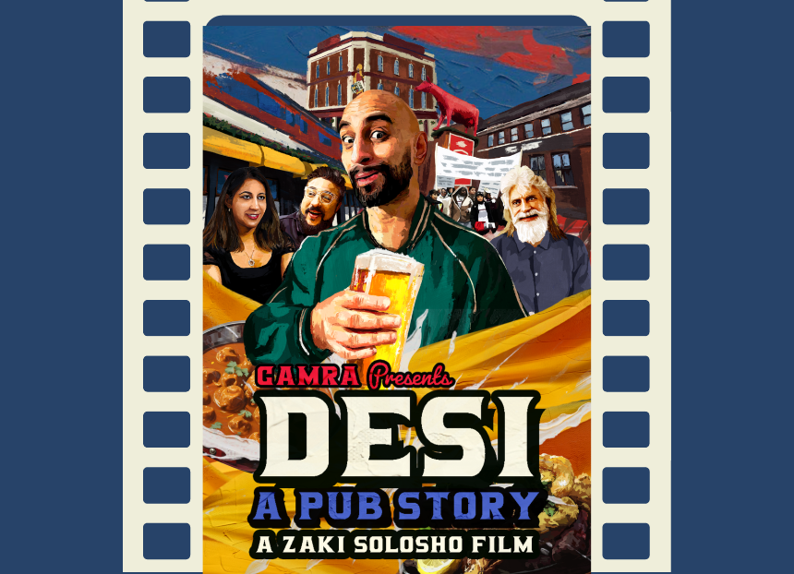

Desi: A Pub Story, a documentary film directed by Zaki Solosho made for CAMRA’s Learn & Discover platform, will make its debut at CAMRA’s Members’ Weekend today. The film is a fascinating guide to British-Indian pubs and a celebration of our modern multi-cultural country. A poignant and human story of pubs becoming the heart of their communities, the documentary tackles the ugly history of racial segregation in British pubs and the story of resistance which led to the rise of the desi pub. Desi: A Pub Story features interviews with publicans, pub-goers and guests including radio DJ and TV presenter Bobby Friction The film expands on CAMRA’s award-winning Desi Pubs book by David Jesudason.  The screening will start at 7pm followed by a Q&A with the director. The session is free, and the audience can bring a drink from the Members’ Bar to enjoy during the film. Book your spot at the screening here. Along with the private showing, public premieres in both Birmingham and London will feature later in the year.  Zaki Solosho is an award-winning filmmaker and founder of London-based creative video production company Element Move. You can view his showreel and portfolio here: https://www.zakisolosho.com/