Campaign to protect cherished pub steps up

22/04/2024 by Timothy Hampson

Campaign

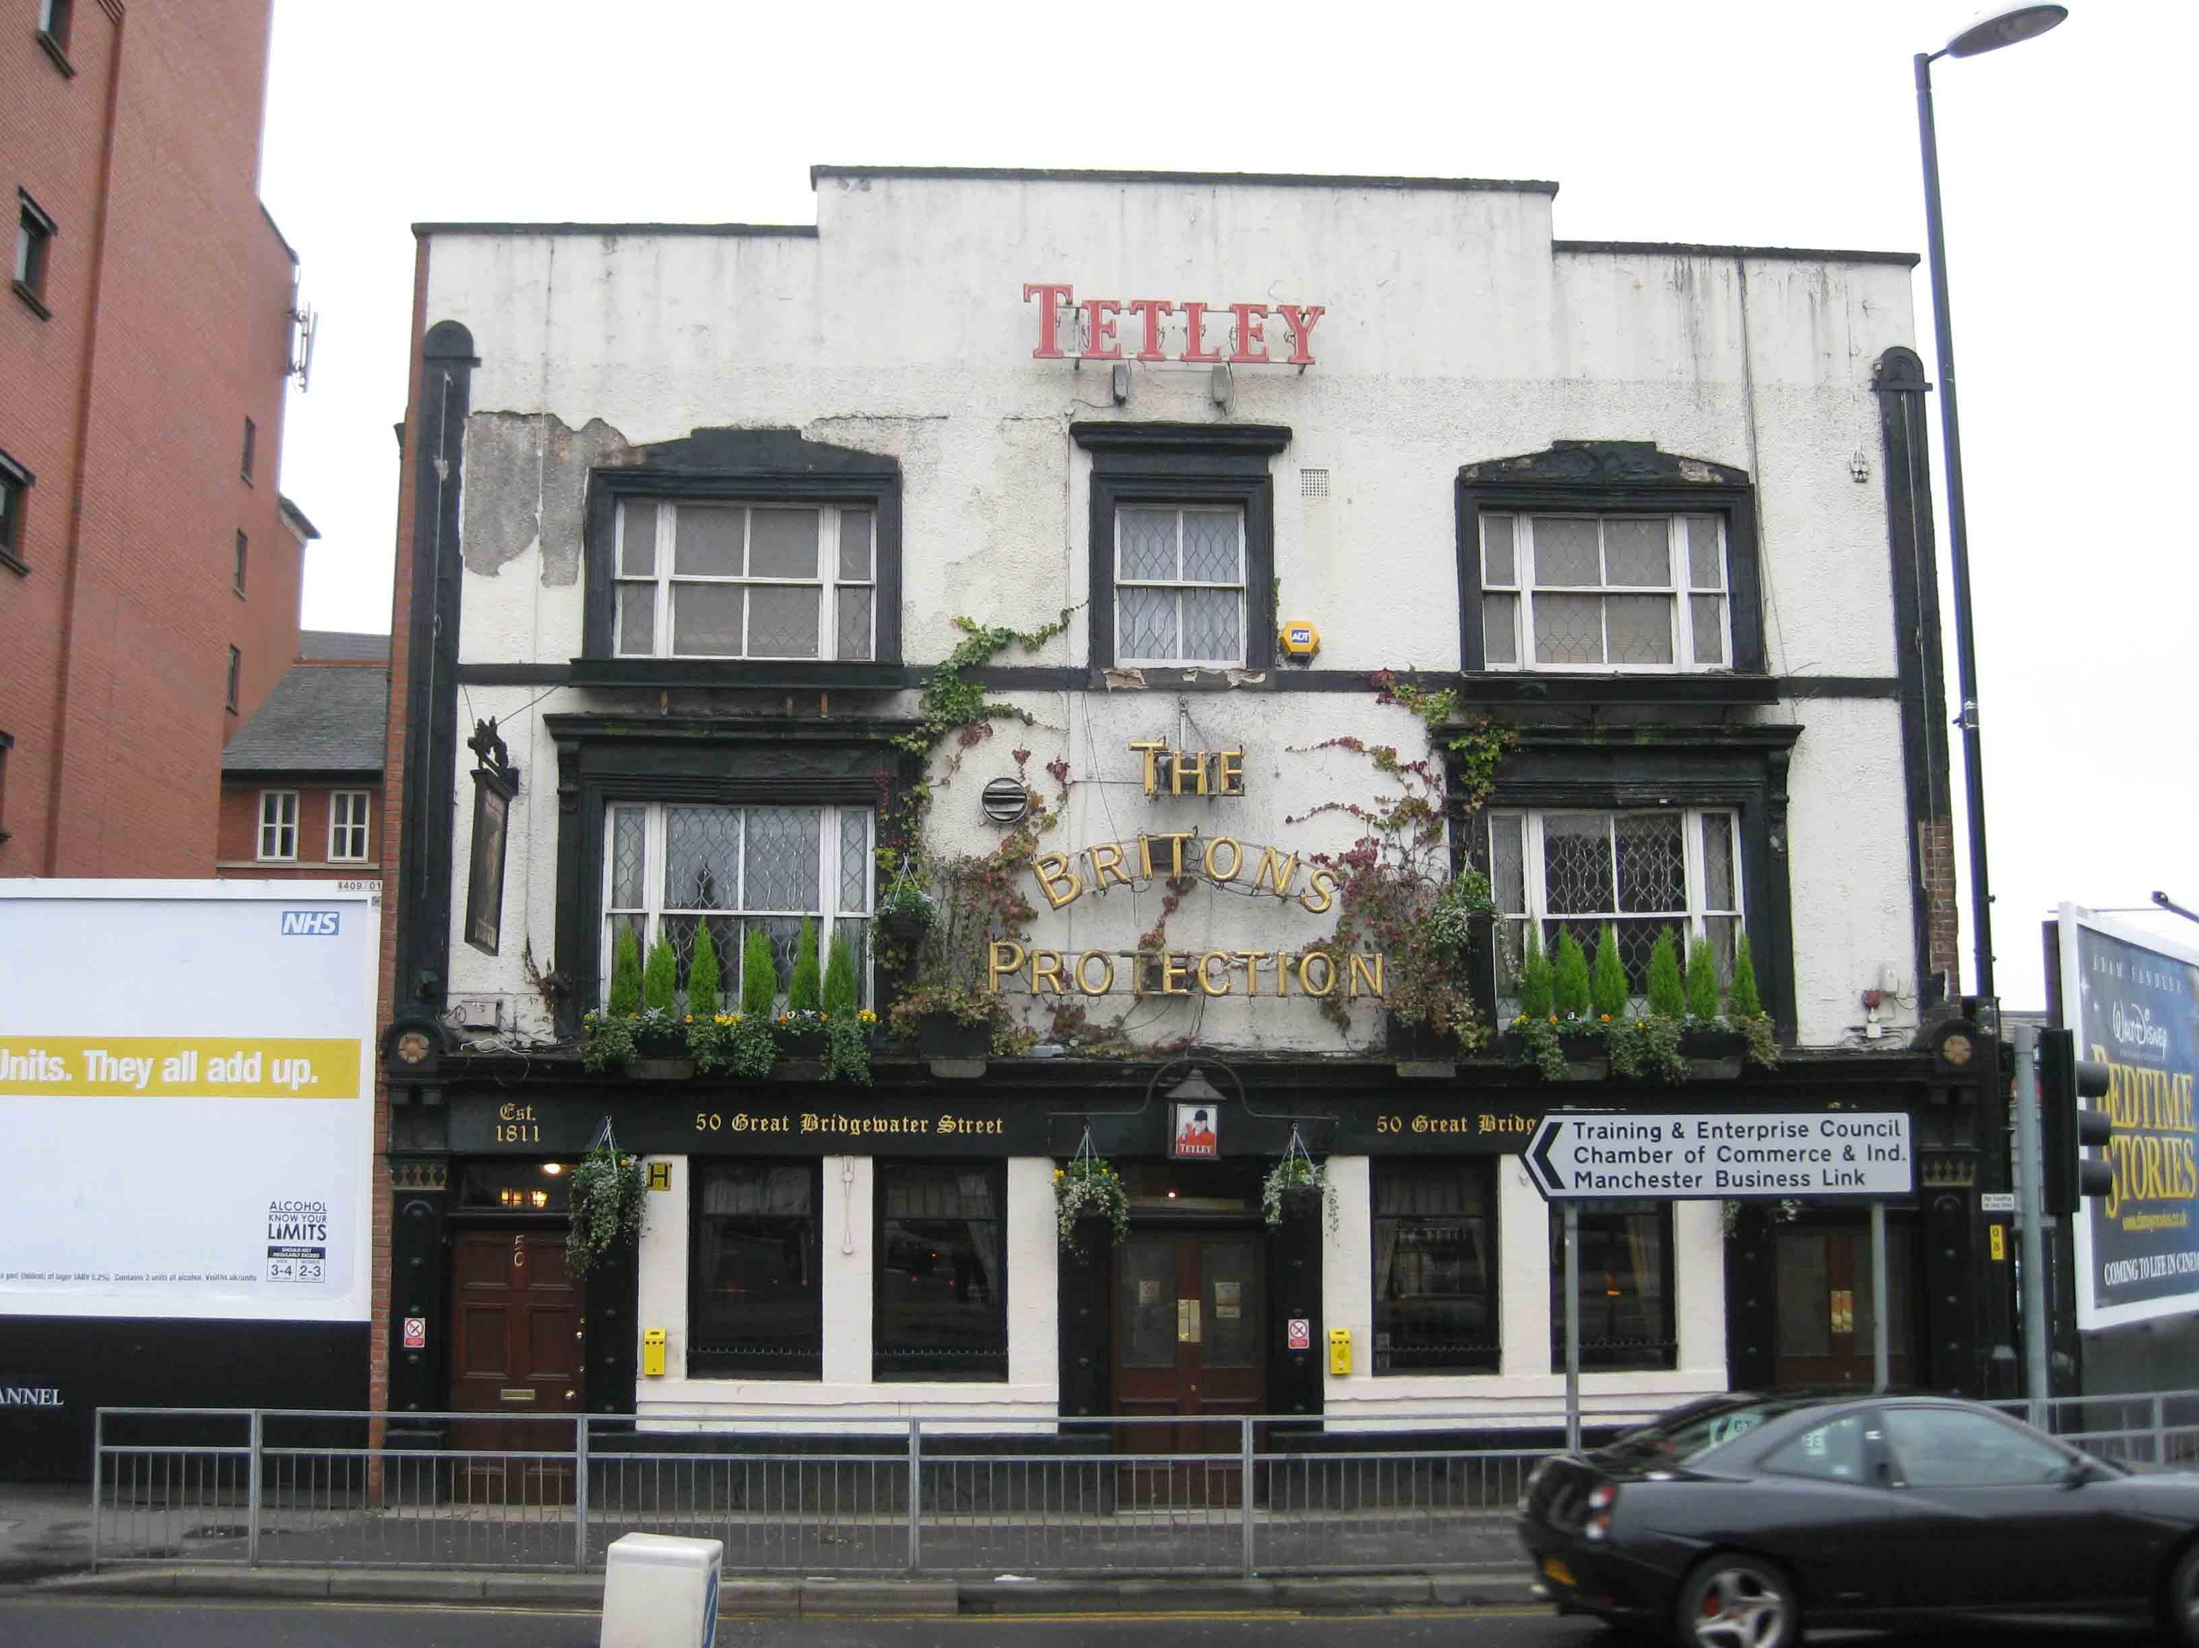

Campaigners fighting to save one of Manchester’s most historic pubs are taking their battle to its leaseholder. CAMRA’s Manchester Central branch has reaffirmed its continued support for the management team and staff at the Grade II-listed Britons Protection (BP) pub, which is facing two unwelcome changes. Owner Heineken’s Star Pubs wants to take the pub back from the leaseholders, plus a proposed property development will enclose and overshadow the historic building. Branch pub preservation officer Steve Ingham said: “As a community hub, it is used by the branch for meetings. It is also used by the Manchester Civic Society, Peterloo Memorial Campaign and the Manchester Whisky Club. “The BP has a good vibe and atmosphere and is also used by visitors and musicians who attend the Bridgewater Hall opposite - a premier Manchester venue for music of all types. Many others also happen upon the pub on their visits to Manchester. “If the BP is taken back by Star, the nature and spirit of this facility will evaporate for a potentially homogeneous offering of the same old culprits in terms of the drink offer and much more importantly the atmosphere of a cracking local.” The pub has set up a crowdfunding page to raise money to help defray its legal costs in its fight with Star justgiving.com/crowdfunding/savethebritonsprotection People can also sign the save-our-pub petition here: change.org/p/save-our-pub-the-britons-protection/psf/share?share=1&source_location=combo_psf A protest outside Heineken’s Manchester HQ is also planned. The branch said: “CAMRA fully supports the protest to be held outside the Heineken brewery in Moss Side, Manchester at 10am on Wednesday 1 May as a way of highlighting the unjust result that could well prevail if Star is successful in taking back the pub and attempting to profit by the years of hard work by Allan and Mark and the staff at the BP to build a fine offering to all.”  “CAMRA says a firm ‘no’ to Heineken and big ‘yes’ in support of the current staff and management team at the BP and hopes to see the BP included in the list of successful campaigns which has seen cherished pubs like the Abercromby and Peveril of the Peak preserved against efforts to remove them from the pub landscape of central Manchester.” Please note that since publishing this article, the peaceful protest on Wednesday 1 May has now been postponed.