Plan your May festival trips now!

21/04/2024 by Matthew Rogers

Campaign

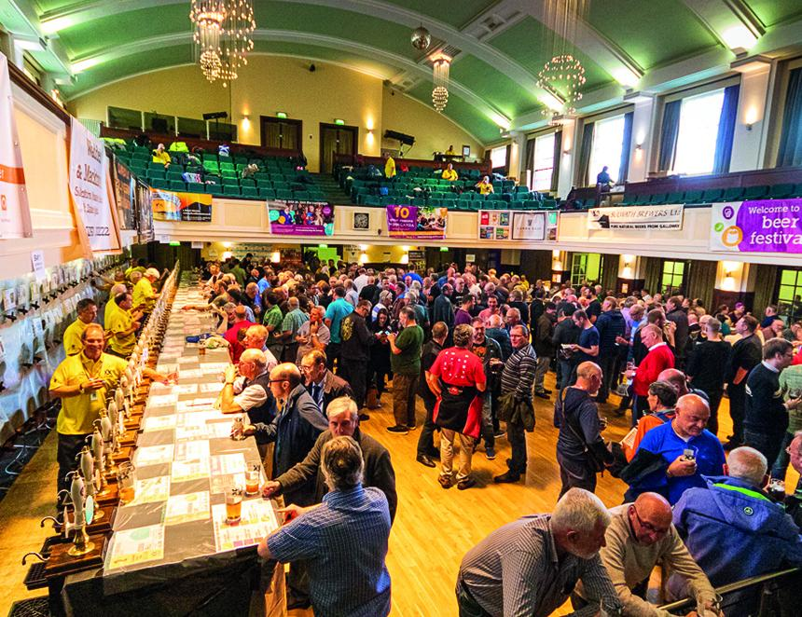

Plan your next festival trip by viewing the list below. To see all upcoming CAMRA events, visit https://events.camra.org.uk/   Second Biggleswade Beer Festival, 9-11 May Biggleswade & District Conservative Club, 1 St Andrews Street, Biggleswade, SG18 8BA https://biggleswadeconclub.com/home/whats-on/bbf/   17th Bexley Beer Festival, 9-11 May War Memorial Ground, Bourne Road, Bexley, DA5 1LW https://bexley.camra.org.uk/beer_festival.html   15th Clitheroe Beer Festival, 9-11 May Assembly Hall of St Michael & St John’s, Lowergate, Clitheroe, BB7 1AG https://clitheroebeerfestival.co.uk/   Tredegar House Folk Festival, 10-12 May Pencarn Way, Newport, NP10 8YW https://tredegarhousefestival.org.uk/   Macclesfield Beer Festival, 10-11 May Priory Park, Priory Lane, Macclesfield, SK10 4AF https://maccbeerfest.co.uk/   32nd Yapton Beerex, 17-19 May Yapton and Ford Village Hall, Main Road, Yapton, BN18 0ET https://westernsussexcamra.org.uk/pages/yapton-beerex-2024   Eastbourne Beer and Cider by the Sea, 17-19 May The Western Lawns, King Edward Parade, Eastbourne, BN21 4EH https://www.visiteastbourne.com/beer-festivals/beer-and-cider-by-the-sea   Cambridge Beer Festival, 20-25 May Jesus Green, Cambridge, CB4 3BN https://www.cambridgebeerfestival.com/   Skipton Beer Festival, 23-25 May High Street, Skipton, BD23 1AH https://skiptonbeerfestival.camra.org.uk/   Dulwich Beer Festival, 23-25 May Dulwich Hamlet FC, Dog Kennel Hill, East Dulwich, SE22 8BD https://sel.camra.org.uk/diary/festivals/   42nd Lincoln Beer Festival, 23-25 May The Drill, Free School Lane, Lincoln, LN2 1EY https://lincoln.camra.org.uk/   Newark Beer and Cider Festival, 24-26 May Newark Castle, Castlegate, Newark, NG24 1BG https://newarkcamra.org.uk/beer-festival-2024/