Branch chairman takes CAMRA message to Number 10
19/03/2024 by Timothy Hampson
Campaign

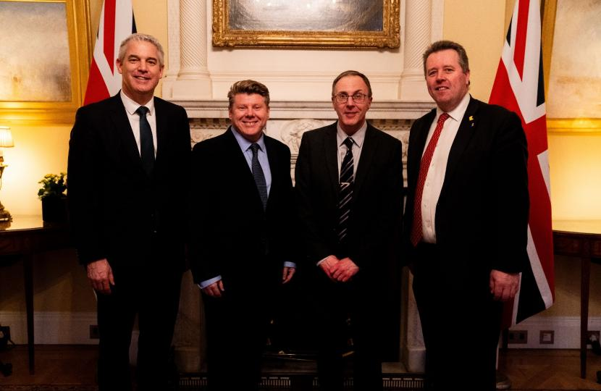

Watford & District branch’s work promoting pubs and cask beer in its area has been recognised by a visit to Downing Street for chairman Andrew Vaughan, following an invite from his MP Dean Russell. Russell said: “I was delighted to invite Andrew to meet ministers Steve Barclay and Mark Spencer at Number 10. Watford’s hospitality industry is so important, and I proudly support it at every opportunity. The night-time economy is fundamental to our town as it boosts businesses and creates a thriving place to visit beyond the usual traditional working hours. “I was pleased Andrew’s hard work could be acknowledged by the ministers as I know how much he does, along with his committee, to promote real ale in Watford and the surrounding areas. The branch is committed to promoting the long-standing tradition of real ale and also supports our hard-working hospitality industry.” Andrew said: “It was a very interesting afternoon during which I met businesspeople and politicians with a shared interest in supporting local producers and protecting pubs and made some valuable contacts.” Pictured, from left, Steve Barclay, Dean Russell, Andrew Vaughan and Mark Spencer.

